CHARACTERISTICS OF LIFE

1. composed of ________ – either uni/multi
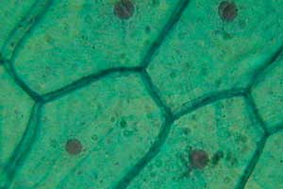
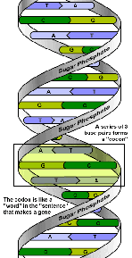
2. _____________ – sexual and/or asexual
3. contain __________ in cells
4. __________ and ______________
5. use material/energy in ____________________
6. ____________ to environment
7. maintain an internal balance - _____________
8. change over time – ___________ as a population

ORGANIZATION OF LIFE
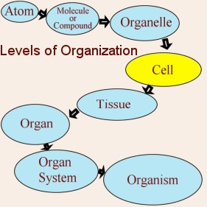
- _________ are the basic unit of life.
- Groups of cells that perform a similar function are ____________.
- At least two tissues combine to form an ___________.
- Organs that carry out similar functions are organized into _____________.



CELL THEORY TIMELINE
Before the 17th century, no one knew cells existed. Most cells are too small to be seen with the unaided eye.
1600’s – Microscopes were invented.
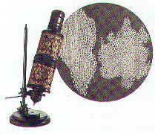
Robert Hooke, an English scientist, made an improved microscope and viewed thin slices of cork viewing plant cell walls. Hooke __________ what he saw “________”.
Anton Von Leeuwenhoek, a Dutchman, developed ____________ with a stronger magnification to view microscopic organisms.
1800’s – Cell theory was formed. Matthias Schleiden (German botanist) & Theodore Schwann (German zoologist) stated that ____________________________ were made of _________.
Rudolf Virchow (German physician) stated that cells only arise from _______________. Virchow’s idea contradicted the idea of spontaneous generation (idea that nonliving things could give rise to organisms).
Principles of the Cell Theory 1. All living things are made of one or more cells. 2. Cells are the basic unit of structure & function in organisms. 3. Cells come only from the reproduction of existing cells.

TYPES OF CELLS
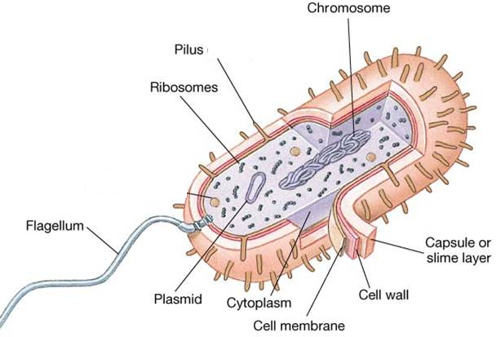
Only Example -
____________
PROKARYOTES
- ________ nucleus
- ________ organelles
- ________ unicellular

EUKARYOTES
- Have _________
- Have membrane
bound ________
Cells differ in size, shape and function. ALL cells have these components – BOTH prokaryotic and eukaryotic cells:
Examples -
animal, plant, fungi, protist
- Uni-/Multicellular

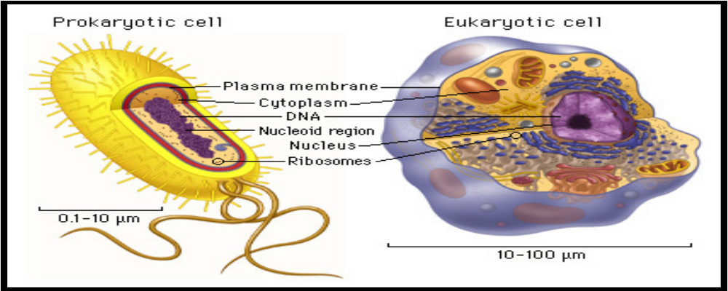

Endosymbiosis theory: All organelles seem to share many properties with bacteria. Lynn Margulis proposed endosymbiosis hypothesis: that organelles derived from ancient colonization of large bacteria (became the eukaryotic cell) by smaller bacteria (became the mitochondria, chloroplast, etc.) Symbiosis = "living together". In other words ---- eukaryotic cells evolved when prokaryote cells engulfed or absorbed other cells!
CELL STRUCTURE AND FUNCTION
Organelles are specialized structures INSIDE the cell that have their own functions. Although the cytoplasm and ribosome are not considered organelles, they are still structures found in the cell. Organelles function together to help the cell carry out all of life’s activities.
Remember: ONLY EUKARYOTIC CELLS HAVE ORGANELLES!!!!
STRUCTURE | FUNCTIONS
Cell or Plasma Membrane  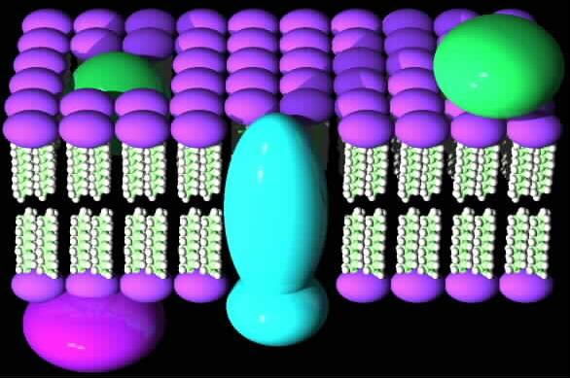 | - Serves as ___________ between cell & its environment  - ________________________ of materials in/out of cell to maintain homeostasis  - Double layer of phospholipids and proteins
Cell Wall  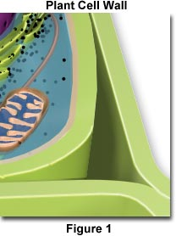 | - Thick, inflexible outer layer surrounding the cell membrane that provides ________________________________  - Made of _______________  - Found in all cells BUT animal cells
Cytoplasm  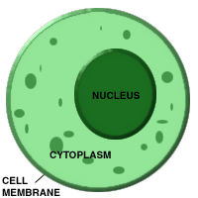 | - ________________________ (cytosol) containing organelles  - Provides support and protection for organelles
Chromosomes (Chromatin)  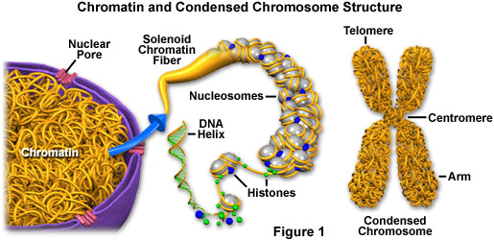 | - ____________________________ found in the nucleus (of eukaryotic cells) and found in the nucleoid region (of prokaryotic cells)
Nucleus  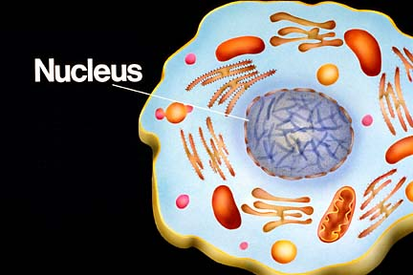 | - __________ the genetic information in __________  - __________________________ such as protein synthesis
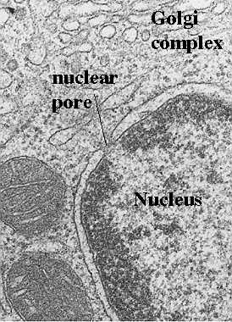  Nuclear Membrane | - Double membrane ________________ __________________  - _____________________________ of materials in/out of nucleus
Nucleolus  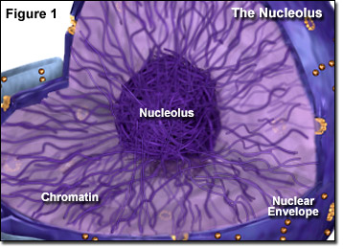 | - Non-membrane structure located in nucleus  - Dense cluster of RNA and proteins that will be assembled into subunits of ribosomes – _________________________________!
Ribosomes  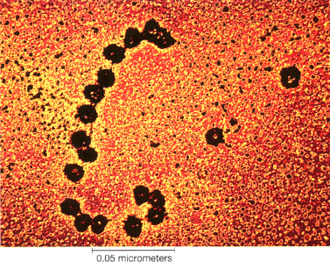 | - Non-membrane structures that are attached to the Rough ER or free in the cytoplasm  - Synthesizes proteins – _______________ _________________________!
Endoplasmic Reticulum (ER)  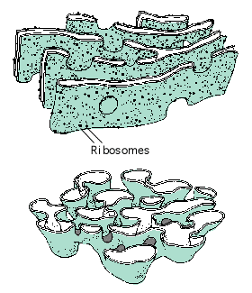 | - Membrane system of _____________ and flatten _______ that is continuous with the nuclear membrane and extends through cytoplasm  - Aids protein synthesis and ___________ of materials  - Rough ER – has ribosomes on surface; makes secretory proteins that will be wrapped in transport vesicles for outside transport  - Smooth ER – no ribosomes on surface; involved in lipids synthesis
Golgi Apparatus  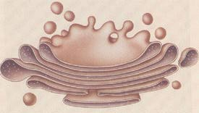 | - Flattened sacs that contain enzymes for ___________________ of proteins and lipids produced in ER then _______________ proteins inside __________________ vesicles and sends them to their destination
Vacuole  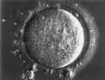 | - Saclike structures (vesicle) that ________ amino acids, sugars, metabolic and toxic waste  - Stores water absorbed by the cell  - Plant cells have a large vacuole
Lysosomes  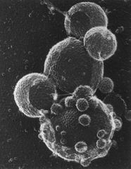 | - Vesicle containing ___________________ ____________ that break down and recycle organic compounds  - _____________ cell parts, the entire cell or pathogens  - RARELY found in plant cells
Peroxisomes  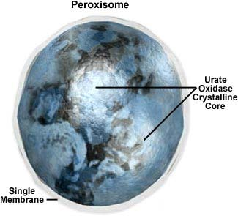 | - Vesicles containing ______________ that break down fatty acids and amino acids – H₂O₂ forms during this reaction and enzymes convert H₂O₂ into H₂O and O₂
Chloroplast  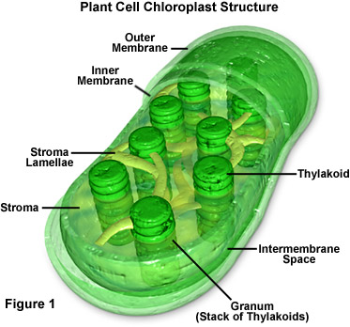 | - Plastid only found in plants and algae  - Site of _____________________ - transforming sunlight energy directly into food  - Contains green pigment called _________  - Has own DNA & can self replicate  - NOT found in animal or fungi cells
Mitochondria  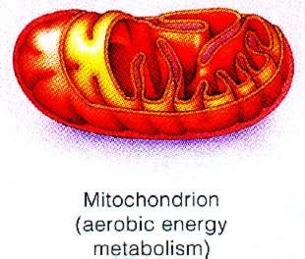 | - Site of ___________________________ - Uses ___________ from food to make ATP (adenosine triphosphate) that the cell can use to grow, develop and move  - Has own DNA and can self replicate  - Very active cells have more mitochondria
Cytoskeleton  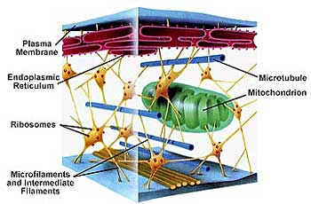 | - Network of protein filaments - microtubules and microfilaments  - Help give the _______________, movement of organelles inside cell and provide support/strength
Centrioles  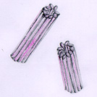 | - Microtubules grow out of centrosome (central area of cell) and form centrioles  - Aid in __________________________ during cell division
Cilia  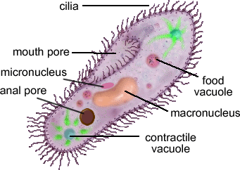 | - Short, more numerous hair like structures made of bundles of microtubules located outside cell  - Assist in ________________________ or propelling foreign substances around the cell
Flagella  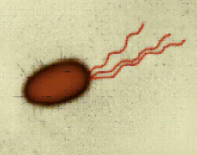 | - Long whip like tail of microtubule bundles located outside cell  - Used for _________________________; usually 1-3 in number

