Name _______________________________ Period _____ Date _______________

Cell Transport Review TWO

Below are animal cells placed in beakers of various concentrations.
- Draw and arrow to show which way the water would move by osmosis
- Fill in any missing percentages (water or solute – remember should equal 100%)
- Identify the type of solution (Isotonic, Hypotonic, Hypertonic)

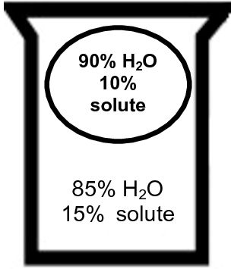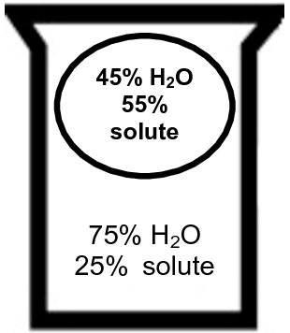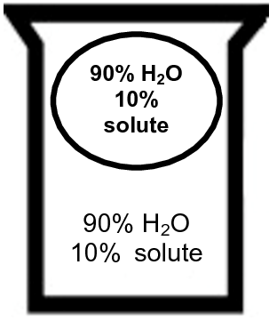

- ____________________ 2. ____________________ 3. ______________________ 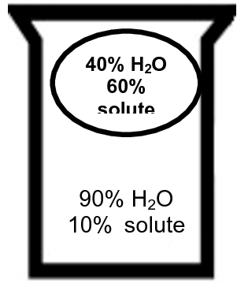 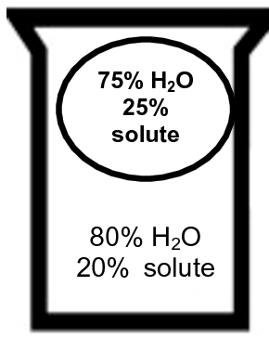 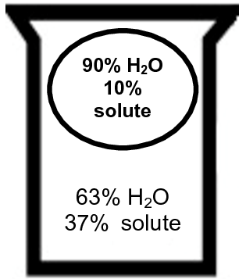

- _____________________ 5. _____________________ 6. ______________________
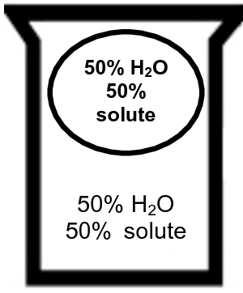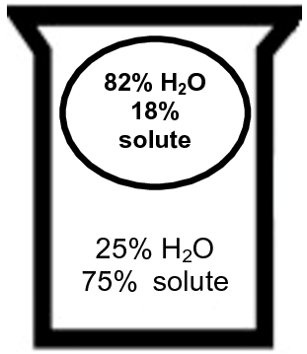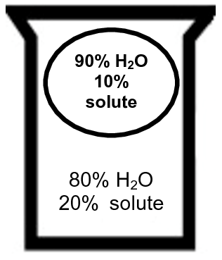

7. ______________________ 8. _______________________ 9. ____________________

Fill in the following table as completely as possible.
Type of Movement | E. Required?  Active or Passive Transport? | What type of particle is moved? | What part of the membrane does the particle travel through? | How does it work? Explain.
10. Diffusion

11. Osmosis

12. Facilitated Diffusion

13. Membrane Transport Protein
14. Endocytosis

15. Exocytosis

Correctly color and identify the name for each part of the cell membrane and then match the structure to its function using the correct letter from the cell membrane diagram.

_____ 16. Phospholipid bilayer (no color)
_____ 17. Integral protein (pink)
_____ 18. Fatty acid tails (orange)
_____ 19. Phosphate heads (yellow)
_____ 20. Peripheral protein (red)
_____ 21. Cholesterol (blue)
_____ 22. Glycoprotein (green)
_____ 23. Glycolipids (purple)
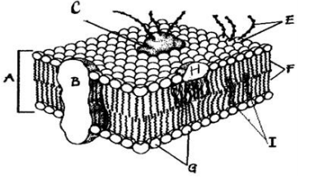
_____ 24. Attracts water
_____ 25. Helps maintain flexibility of membrane
_____ 26. Involved in cell-to-cell recognition
_____ 27. Repels water
_____ 28. Makes up the bilayer
_____ 29. Helps transport certain materials across the cell membrane

