Name __________________________________ Period _____ Date ____________________
HEATING CURVE

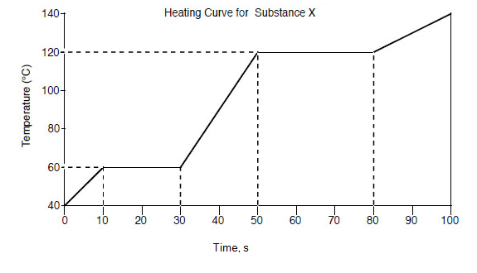
Use the heating curve to answer the questions below.
- What is the freezing point of the substance? ____________________
- What is the boiling point of the substance? ___________________
- What is the melting point of the substance? ____________________
- What letter represents the range where the solid is being warmed? ____________
- What letter represents the range where the liquid is being warmed? ____________
- What letter represents the range where the gas is being warmed? ____________
- What letter represents the melting of the solid? ____________
- What letter represents the vaporization of the liquid? ____________
- What letter(s) shows a change in potential energy? ____________
- What letter(s) shows a change in kinetic energy? ____________
- What letter represents condensation? ____________
- What letter represents crystallization? ____________
- Does the temperature change during a phase change? ___________
- When this substance is melting, the temperature of the ice-water mixture remains constant because:
- Heat is not being absorbed
- The ice is colder that the water
- Heat energy is being converted to potential energy
- Heat energy is being converted to kinetic energy
PHASE DIAGRAM
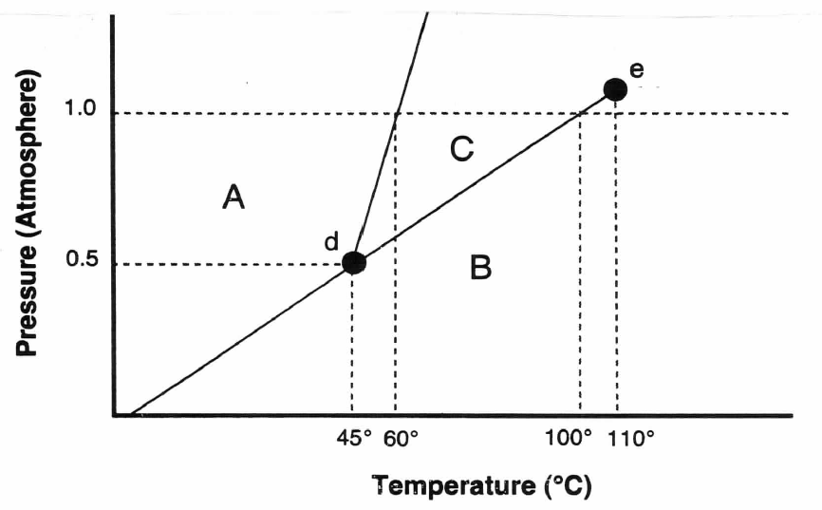

Answer the following questions using the phase diagram above.
- What section letter represents the solid phase? ____________
- What section letter represents the liquid phase? ____________
- What section letter represents the gas phase? ____________
- What letter represents the triple point? ____________
- What is the temperature at the triple point? ____________
- What is the pressure at the triple point? ____________
- At what temperature and pressure do all three phases exist? _______________________
- What phase is present at 0.8atm pressure and 35°C? ____________
- What phase is present at 1.0atm pressure and 45°C? ____________
- What phase is present at 0.4atm pressure and 120°C? ____________
- Would an increase in pressure cause this substance to melt or freeze? ________________

