Mutations & DNA Technology Worksheet Name____________________

Section A: Mutations
Mutations are changes in DNA. Somatic mutations occur in non-reproductive cells and won't be passed onto offspring. Mutations that occur in reproductive cells like eggs and sperm (germ-line mutations) can be passed onto offspring.
Effects of germ line mutations: A single germ line mutation can have a range of effects: No change, small change or big change occurs in phenotype.
Little mutations with big effects: Mutations to control genes --- Some regions of DNA control other genes, determining when and where other genes are turned "on". Mutations in these parts of the genome can substantially change the way the organism is built and have a greater impact. For example, Hox genes are found in many animals and designate where the head goes and which regions of the body grow appendages.
Mutations are RANDOM: Mutations can be beneficial, neutral, or harmful for the organism, but mutations do not "try" to supply what the organism "needs." Factors in the environment may influence the rate of mutation but are not generally thought to influence the direction of mutation. For example, exposure to harmful chemicals may increase the mutation rate, but will not cause more mutations that make the organism resistant to those chemicals. In this respect, mutations are random — whether a particular mutation happens or not is unrelated to how useful that mutation would be. (http://evolution.berkeley.edu/)

QUESTIONS:
- What are mutations? _____________________________________________________________
- What type of mutation can be passed on to offspring? __________________________________
- What are HOX genes? ___________________________________________________________ ______________________________________________________________________________
- How could a mutation in a HOX gene affect an organism? _______________________________ ______________________________________________________________________________
- What is meant by “mutations are random”? ___________________________________________ ______________________________________________________________________________

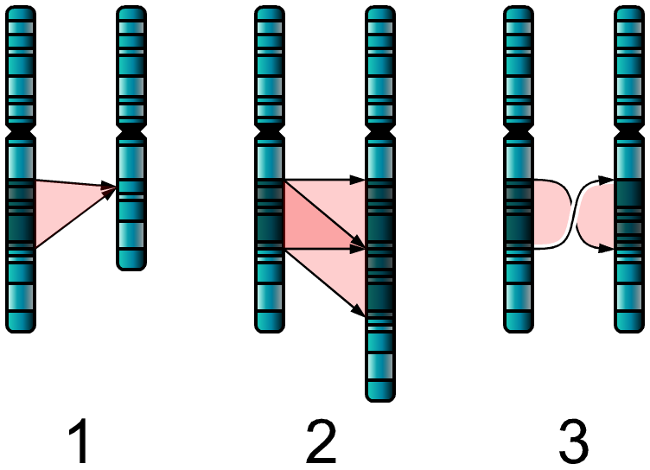
Section B: Chromosomal Mutations
- Identify the type of chromosomal mutation that has occurred in the examples.
1.______________________
2.______________________
3.______________________
- Cru-du-chat Syndrome is a chromosomal condition that results when a piece of chromosome 5 is missing. What type of mutation has occurred? _______________________
- What type of mutation is occurring in the diagram sequence below? ______________________
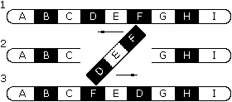

- These disorders are caused by nondisjunction. What is nondisjunction? _____________________ ______________________________________________________________________________

Condition | Nomenclature | Phenotype
Down's Syndrome | 47,+21 | Round, broad head; narrow, high palette; low IQ
Edward's Syndrome | 47,+18 | Mental retardation; multiple congenital defects of all organs; death within 6 months
Patau Syndrome | 47,+13 | Similar to Edward’s Syndrome; death within 3 months
Turner's Syndrome | 45,X | Retarded development of female >sex organs; sterility
Klinefelter's  Syndrome | 47,XXY | Poor male sex organ development; breast development; subfertility….extra X or extra Y
http://www.ndsu.edu/pubweb/~mcclean/plsc431/chromnumber/number3.htm

- Additional Reading: http://biology.about.com/od/genetics/ss/chromosome-mutation.htm

Section C: Gene Mutations
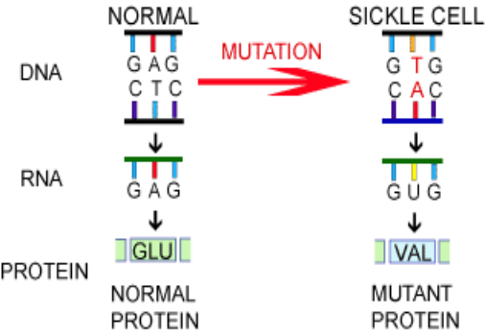
- CASE STUDY: Sickle cell anemia is a genetic disease with severe symptoms, including pain and anemia. The disease is caused by a mutated version of the gene that helps make hemoglobin — a protein that carries oxygen in red blood cells. People with two copies of the sickle cell gene have the disease. People who carry only one copy of the sickle cell gene do not have the disease, but may pass the gene on to their children. A change in DNA results in a protein change. The hemoglobin protein in the RBC can’t function properly resulting in the sickle shaped RBC.
  - What type of point (gene) mutation has occurred in the DNA of a person diagnosed with sickle-cell anemia? ___________________________
  - What happens as a result of the sickle-cell anemia mutation? _______________________ ________________________________________________________________________
- Diabetes is a disease characterized by the inability to break down sugars. Often a person with diabetes has a defective DNA sequence that codes for the making of the insulin protein. This mutation is called a gene mutation (aka. point mutation), because only a few bases are changed. Suppose a person has a mutation in their DNA and the first triplet coding for insulin is CCC instead of CCA. Determine the mRNA and the amino acid. Will this person be a diabetic? __________ What if the DNA triplet mutated to CAA, would this person be diabetic? _________ How did you come to these conclusions? ___________________________________________ ____________________________________________________________________________

Normal DNA CCA Mutated DNA CCC Mutated DNA CAA
mRNA mRNA mRNA
Amino Acid Amino Acid Amino Acid

- What type of point (gene) mutations has occurred in the DNA of a person diagnosed with diabetes? _________________________
- External sources, such as radiation or chemicals, can cause mutations in genes or entire chromosomes. For a mutation to pass on to offspring, it must occur in a _______________________ cell.
- Identify the mutation that occurred in the DNA strands below.
  - Normal ATC CCG GAT Mutated ATT CCC GGA T _____________________
  - Normal AGT TGA AAA Mutated ATT GAA AA _____________________
  - Normal CCG TAA GAG Mutated CCG GAA GAG _____________________
- Using DNA sequencing, you discover that a bacterium has experienced a deletion mutation that removed three nucleotides. The bacterium appears completely unaffected in all its functions. Where is the mostly likely location for the mutation? ___________________________ ______________________________________________________________________________
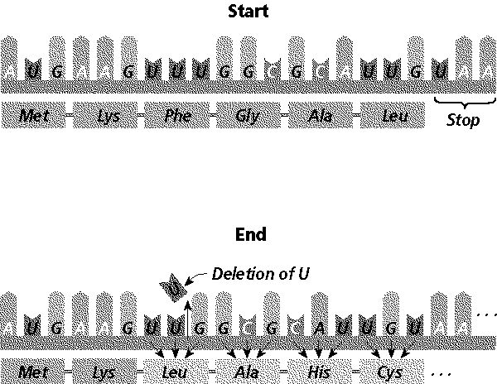
- What type of mutation has occurred in the diagram? __________________________________
- What happens to the mRNA strand and the amino acid chain? ________________________________ __________________________________________ __________________________________________
- Suppose that part of an amino acid sequence of a protein changed from “gly-ala-pro-threo” to “gly-ala-his-threo”. This change was most likely caused by a ___________________________.
Section D: Mutation Webquest
On the ‘Websites-Genetics’ page, click on “Genetics Science Learning Center” ---- click on ‘Genetic Variation’….under the mutation column click on the titles and answer the questions.
What is Mutation?
- What is a mutation? _____________________________________________________________
- How often do mutations usually occur? ______________________________________________
- What is the most common mutation that occurs during replication? _________________________
- Are all mutations bad? Explain your answer. __________________________________________ ______________________________________________________________________________
- Mutations can create slight different versions of the same gene, called alleles. How are these variations beneficial? ____________________________________________________________ ______________________________________________________________________________
- Using the example of lactose, explain how mutations can create variations in the genes to turn them on or off. __________________________________________________________________ ____________________________________________________________________________________________________________________________________________________________
- List environmental factors the can cause mutations. ____________________________________ ______________________________________________________________________________
- Explain how DNA repair of mutations occur and when some mutations are beyond repair. ______________________________________________________________________________ ______________________________________________________________________________ ______________________________________________________________________________
The Outcome of Mutation
- Go through each example and read about the mutations. List the mutation and the effects from one of the examples. _____________________________________________________________ ______________________________________________________________________________ ______________________________________________________________________________
Mutations and Haplotypes
- Watch the video. How can mutations provide information about our common ancestry? ______________________________________________________________________________ ______________________________________________________________________________

Section E: Human Genome Project
- What was the purpose of the Human Genome Project? _________________________________ ______________________________________________________________________________ ______________________________________________________________________________
______________________________________________________________________________
- According to the HGP, how many genes do humans have? ______________________________

Section F: Gene Therapy
On the ‘Websites-Genetics’ page, click on “Genetics Science Learning Center” ---- click on ‘Gene Therapy’ and go through the tutorial.
What is Gene Therapy?
- Gene therapy provides a way to fix a problem at its source. How is this accomplished? ______________________________________________________________________________ ______________________________________________________________________________
- What vectors are used in gene therapy? ________________
- What is the purpose of a vector? ___________________________________________________
- What is Cystic Fibrosis? __________________________________________________________ ______________________________________________________________________________
- What are the symptoms associated with CF? __________________________________________ ______________________________________________________________________________
- What chromosome and gene is mutated? ____________________________________________
- How does this mutation affect the amino acid? ________________________________________ ______________________________________________________________________________
- How does the mutation affect the ability of these cells to function properly? __________________ ______________________________________________________________________________ ______________________________________________________________________________
Challenges in Gene Therapy?
- Briefly explain some of the challenges of gene therapy.
  - ________________________________________________________________________ ________________________________________________________________________
  - ________________________________________________________________________________________________________________________________________________
  - ________________________________________________________________________ ________________________________________________________________________
  - ________________________________________________________________________ ________________________________________________________________________

Section G: DNA Fingerprinting
On the ‘Websites-Genetics’ page, click on “Genetics Science Learning Center” ---- click on ‘Virtual Labs’ and click on ‘Gel Electrophoresis’. Go through the animation and answer the questions.

- What lab procedure allows scientists to sort pieces of DNA? ______________________________
- Where do you place the DNA? ___________________________________________________
- What makes the DNA move? ____________________________________________________
- Which strands move the quickest? __________________________________________________
- Why do we stain the DNA? ________________________________________________________
- What was the purpose of putting the combs into the gel? ________________________________
- What is the purpose of the loading buffer? ____________________________________________
- What was the purpose of the size standard? __________________________________________
- What do you think the charge on a DNA molecule is? ___________________________________
- Why did you stain the gel? _______________________________________________________
- What are the sizes of the 3 pieces of DNA that you ran? _________________________________
- Give an example of the usefulness of gel electrophoresis. ________________________________ _____________________________________________________________________________

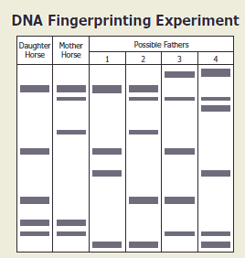
Section H: Sample Gels
- The diagram shows DNA fingerprints from a daughter horse, the mother horse, and four possible fathers. Which horse is most likely the father? ________________________________
- Who committed the crime? How did you determine this? ____________________________________________ ____________________________________________
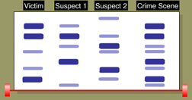

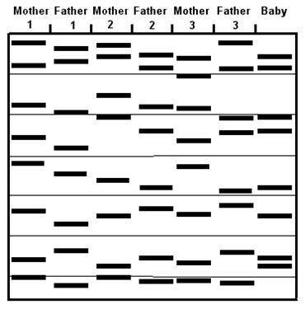

- Let’s suppose that a tsunami devastates a coastal city, and afterward a baby gets rescued. Use the DNA testing to match the baby to one of three pairs of parents.
  - Explain how the DNA data shown are obtained. _____________________________________ _____________________________________ _____________________________________ _____________________________________
  - Which set of parents does the baby belong to? Explain how you determined this. ____________________________________ ____________________________________ ____________________________________

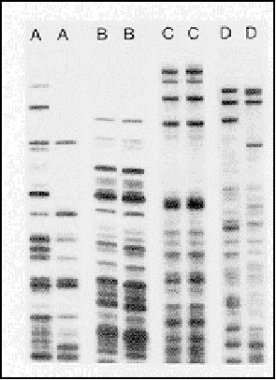
- This gel contains DNA banding patterns from four sets of twins. Which set of twins is identical? ___________________

- Which of these statements is correct?
  - Longer DNA fragments migrate farther than shorter fragments.
  - Migration distance is inversely proportional to the fragment size.
  - Positively charged DNA migrates more rapidly than negatively charged DNA.
  - Uncut DNA migrates farther than DNA cut with restriction enzymes.

Section I: Genetic Engineering
On the “Websites-Genetics” page, click on GMO ---read the article and answer the questions.
- Numerous agriculture plants have been genetically modified. List examples and benefits of genetic engineering in agriculture.
Plants
Animals

- The pharmaceutical industry is another area where genetic engineering is prevalent. List examples and benefits for genetic engineering in this area. _______________________________ ______________________________________________________________________________ ______________________________________________________________________________ ______________________________________________________________________________ ______________________________________________________________________________ ______________________________________________________________________________ ______________________________________________________________________________
- List some examples of potential GMO applications. _____________________________________ ______________________________________________________________________________ ______________________________________________________________________________
- Explain some of the risk and controversy surrounding the use of GMOs. ____________________
______________________________________________________________________________ ______________________________________________________________________________ ______________________________________________________________________________ ______________________________________________________________________________

Test Review Questions:
- What is a mutation and what causes mutations?
- List and describe chromosomal mutations. List examples of common aneuploidy mutations.
- What is a gene mutation? How does it change the code? Describe the two types of gene mutations.
- What is the purpose of the human genome project?
- Define gene therapy and cloning.
- What is DNA fingerprinting? What is the function of restriction enzymes and the gel electrophoresis? Describe the process of Gel Electrophoresis. What is it used for? What is PCR used for?
- What is genetic engineering? Define recombinant DNA and transgenic organisms.
- Describe how transgenic organisms are formed. Include restriction enzymes in your explanation.
- Give examples (at least 3) of some genetically modified organisms. Why did scientist genetically modify them?
- What are some concerns for genetically modified organisms?
- How is DNA technology used in forensic, medicine, and agriculture?

