DNA & Protein Synthesis Worksheet Name________________________

Section A: DNA Timeline
On the ‘Websites-Genetics’ page, click on ‘DNA Interactive’…..then click on ‘Timeline’. Select the following scientist and briefly explain their contribution to Genetics.
Pre 1920s | Friedrich Miescher
1920-1949 | Oswald Avery
Early 50s | Erwin Chargaff
 | Rosalind Franklin
 | Alfred Hershey & Martha Chase
 | James Watson & Francis Crick
Late 50s | Francis Crick
 | Matthew Meselson & Franklin Stahl
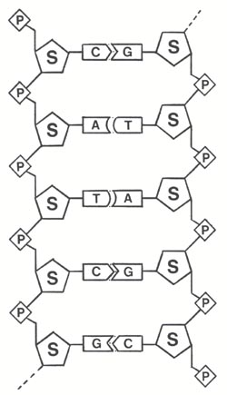
Section B: DNA Structure
The structure of DNA is a double helix. The sides of the helix are made of alternating sugar and phosphate molecules. The sugar (S) is deoxyribose – color it blue. Color the phosphates (P) red.
The bases are adenine (A), guanine (G), thymine (T) and cytosine (C). These bases always bond in a certain way. Adenine will only bond with thymine and guanine will only bond with cytosine. The bases can occur in any order along a strand of DNA and this order is the code that contains instructions. Color the ‘T’ orange, the ‘A’ green, the ‘G’ purple, the ‘C’ yellow.
The two sides of the DNA helix are held together loosely by hydrogen bonds. The DNA can actually "unzip" when it needs to replicate - or make a copy of itself. DNA needs to copy itself when a cell divides, so that the new cells each contain a copy of the DNA. Without these instructions, the new cells wouldn't have the correct information. Draw in the correct number of Hydrogen bonds.

Section C: Concept Check
- Watson & Crick determined the shape of DNA is a _____________________.
- What is the backbone of DNA composed of? _________________________
- What part of the “backbone” connects to the nitrogen bases? ____________________
- What is the monomer of DNA? ____________________________
- What are the 3 components of a nucleotide? __________________________________________
- What is the sugar found in DNA? ___________________________
- What are the 4 bases found in DNA? _______________________________________________
- What is the name of the bond found between the bases? __________________________
- How many strands make up DNA? _______________
- If a DNA strand contains 20% thymine, how many guanine molecules are present? __________
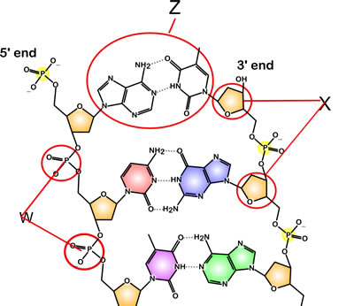
- Label the parts of DNA.
  - X =________________________
  - W =________________________
  - Z = _______________________

- The DNA strand is antiparallel. What does this mean? ___________________________________________ ___________________________________________ ___________________________________________
- How many hydrogen bonds are found between the bases C&G? _______ the bases A&T? _______
- Structurally, how are purines and pyrimidines different? ___________________________________________ ___________________________________________
- Which bases are purines? ___________ Which bases are pyrimidines? ___________
- Explain how the DNA code works. __________________________________________________ ______________________________________________________________________________
- Fill in the missing bases for the complimentary strand of DNA.
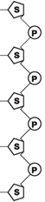
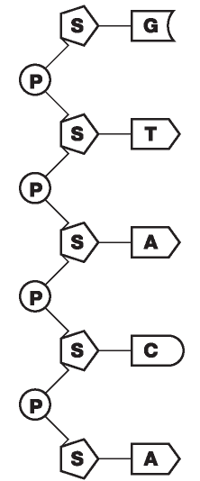

Play the DNA Game - On the ‘Websites-Genetics’ page, click on “DNA game”. Play the game.

What is Organism 1? ___________________________
What is Organism 2? ___________________________ What is Organism 3? ___________________________
What was your final score? ______________________

Build a DNA molecule – On the ‘Websites-Genetics’ page, click on “Genetics Science Learning Center”….then click on ‘Molecules of Inheritance’ – Click on ‘Build a DNA molecule’. Drag the bases to complete the DNA.

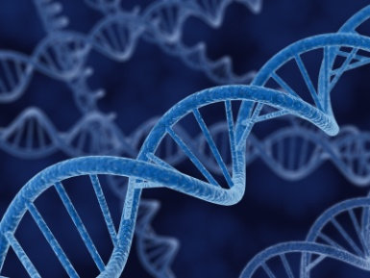
Section D: Spitting DNA --- DNA extraction from your cells
DNA is found in the nucleus of your cells and is only about 50 trillionths of an inch long. The reason it can be seen in this activity is because you are releasing DNA from a number of cells. One strand of DNA is so thin you would never be able to see it without using a microscope.
What are you doing to your DNA?
The “secret cell lysis” solution is used to lyse or break open the cell membrane and nuclear membrane. The enzyme in meat tenderizer releases the DNA from the proteins it’s wrapped around. The alcohol causes the DNA to precipitate or settle out of the solution.
Materials: “secret cell lysis” solution (15 g salt, 1000 water & 100 ml clear shampoo), test tubes, alcohol, meat tenderizer, graduated cylinder, pipettes

Procedure:
- Swish water in your mouth and spit in your tube. Make sure you scrap your teeth on your cheeks while swishing.
- Add 3 ml of the “secret cell lysis” solution to your tube.
- Add a pinch of meat tenderizer to your tube. Put the lid on your tube and gently flip the tube once to mix contents. Wait 5 minutes.
- Slowly add 3 ml of isopropyl alcohol to your tube. Put the lid on your tube. Hold your tube still and watch. Look for clumps of white stringy stuff. This is your DNA!

Section E: DNA Replication
- Why is DNA replication necessary before each cell division? _____________________________ _____________________________________________________________________________
- What is DNA replication? _________________________________________________________
- In Eukaryotes, where does DNA replication occur in the cell? _____________________________
- In Prokaryotes, where does DNA replication occur in a cell? ______________________________
- Finish out the replication of the following DNA strand.
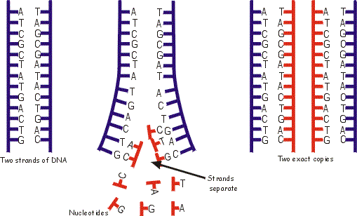

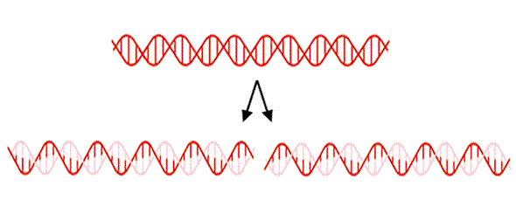
- Why is DNA replication referred to as semi conservative? ________________ ________________________________ _________________________________
_________________________________

- During DNA replication, which enzyme breaks apart the DNA double helix? __________________
- During DNA replication, which enzyme adds complimentary bases to the DNA template? _________________________
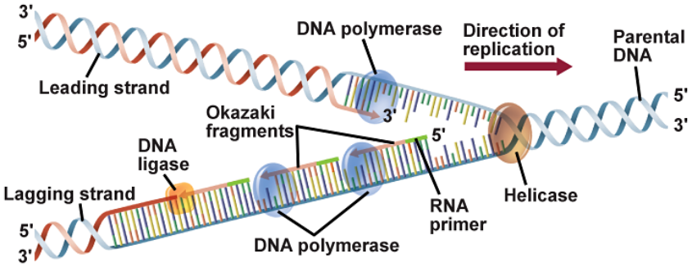
- The template strand of a piece of DNA being replicated reads: 5'ATAGGCCGT-3'. A partially synthesized Okazaki fragment is 5'CCTAT3'. What are the next four bases?

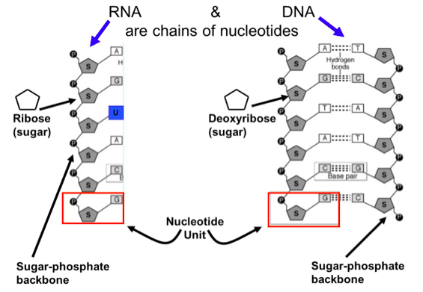
Section F: RNA vs. DNA
- What sugar is found in RNA? ___________________
- Which base is found in RNA, but not DNA? _________________
- What is the monomer of RNA? ___________________________
- How many strands make up an RNA molecule? ___________

- Compare DNA and RNA.
DNA | Both | RNA

Section G: Transcription
- What is transcription? ____________________________________________________________
- Where does transcription occur? ________________________
- Describe the function of RNA polymerase. ____________________________________________ ______________________________________________________________________________
- What are exons? ________________________________________________________________
- What are introns? _______________________________________________________________
- Write the complementary mRNA strands for the following DNA template strands:
  - TATGAT b. GGTCTA c. TCATCG
_______________ ________________ _______________
- In eukaryotic cells, RNA is edited before leaving the nucleus. During the editing process, __.
  - Introns and exons trade positions within the RNA strand
  - Introns and exons are removed from the RNA
  - Exons are removed from the RNA while introns remain
  - Introns are removed from the RNA while exons remain
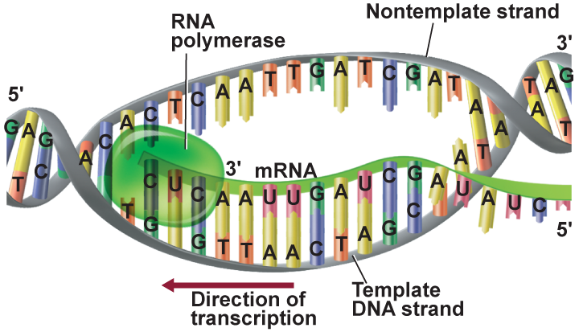
- What process is occurring in the diagram? ___________________

Section H: Translation
- What is translation? _____________________ ______________________________________ ______________________________________
- Where does translation occur? _______________________
- What are the 3 N-bases on mRNA called? ________________
- What are the 3 N-bases on tRNA called? _________________
- What is the name of the bond formed between amino acids? _________________________
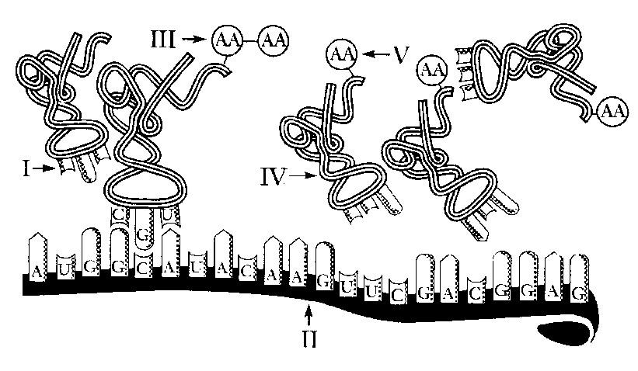
- Identify each labeled structure. Use this wordbank: amino acid, polypeptide chain, anticodon, tRNA, mRNA
I.____________________
II.____________________
III.____________________
IV.____________________
V.____________________

- What process is illustrated in the diagram? __________________
- True or False When an organism produces similar proteins, this indicates that organisms are more closely related.
- Determine the amino acid sequence for the following DNA strand? ATTCCTGAT _____________________________________________________________________________
- If the following tRNA anticodon is ACU, what would the original DNA triplet be? ____________
- Put the events of protein synthesis in order.
______ RNA moves from the nucleus to the cytoplasm.
______ DNA serves as a template for mRNA.
______ tRNA bonds to a specific codon.
______ Amino acids are bonded together.
______ mRNA attaches to a ribosome.

Section I: Protein Synthesis Practice
- Fill in the complimentary DNA strand using the base pair rule.
Challenge:
- How many codons are needed to make 6 amino acids? ___________

DNA
T
T
C
G
A
A
G
A
A
G
T
A

DNA

2. Use the complimentary strand of DNA to transcribe an mRNA strand.

mRNA

- Translate the mRNA to determine the amino acid chain.

Amino
Acid

tRNA

Section J: Protein Synthesis Webquest
On the ‘Websites-Genetics’ page, click on ‘Genetics Science Learning Center’…click on ‘molecules of inheritance’.
- What is the Central Dogma? _______________________________________________________
- Click on “TRANSCRIBE and TRANSLATE a gene”. Use the keyboard to type the bases that would form the mRNA. Now translate the mRNA by dragging the amino acid and tRNA. List the order of your amino acids. _______________________________________________________________ ____________________________________________________________________________
- Scroll down to the bottom of the page and read. What occurs during transcription? ____________ ___________________________________________________________________ What occurs during translation? ______________________________________________________________

Quizzes:
Don’t forget to use the mRNA CODON to find the amino acid!
http://edhsgreensea.net/Biology/taters/dna_structure_replication_mc.htm
http://www.sciencegeek.net/Biology/review/U5DNA.htm
http://edhsgreensea.net/Biology/taters/proteinsynthesis_mc..htm
http://www.sciencegeek.net/Biology/review/U5RNA.htm
http://www.sciencegeek.net/Biology/review/U5Protein.htm
http://www.sciencegeek.net/Biology/review/U5Review.htm

