Name _______________________________________ Period _____ Date _____________________

BUILDING AN ELECTROMAGNET LAB
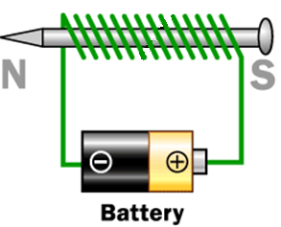
Goal: To build an electomagnet
Materials: A large iron nail (about 8cm) , about a meter of copper wire, power source, two wires and clips, 15-20 small paperclips, small piece of sand paper.
Procedure:
- Leave about finger length of wire loose at one end and wrap most of the rest of the wire around the nail. Try not to overlap the wires.
- Attach each side to a wire with a clip to both ends. Attach the wires to the power source (start at 2.2 Volts). See picture above. (Be careful: the wire could get very hot!)
- See how many paper clips you can pick up.
- You can change the settings on the power source and go up from 2.2V. Got to at least two more settings and see how many paper clips you can pick up.
Data
Voltage | # of paper clips | Voltage | # of paper clips | Voltage | # of paper clips
Questions:
- Does the number of times you wrap the wire around the nail affect the strength of the nail? How?

- Did raising the voltage change the number of paper clips you could pick up? Why?

- What are two ways that you can make you electromagnet stronger?

- What are some “everyday” uses for electromagnets? Give a least two.

Name _______________________________________ Period _____ Date _____________________

BUILDING AN ELECTRIC MOTOR

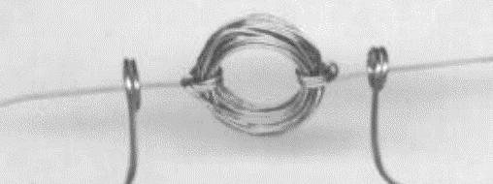
Goal: To build a working electric motor.

Materials: copper wire, C battery, two large paper clips, masking tape, small piece of sandpaper, magnet, power source, two wires with clips
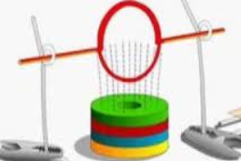
- Coil some wire around a “C” battery three times so that it looks like the photo to the right. Hint: It must be almost perfectly round or it will wobble.
- Bend 2 large paper clips to hold the motor as seen to the right. You can use tape to hold the paper clips to the table. Strip off any coating on the ends of the copper wire with sandpaper so that the motor makes good contact with the paper clips.
- Place a magnet below the motor. You need to stack some coins to hold the magnet in place.
- Attach a wire to each paper clip and then to the power source.
- Watch the motor spin!
Questions:
- What type of energy conversion is taking place in the electric motor?

Converts _____________________________ to _____________________________

- How is this different from a generator? Write at least two complete sentences.

- What is electromagnetic induction?

