Name ___________________________________ Period ______ Date _________________
ELECTRICITY AND MAGNETISM
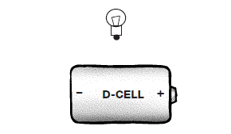
- Look at the set up to the right.
  - Draw wires to show how you would light the bulb.
  - Draw arrows to show which way the electricity is going through the circuit.

- You are making an electromagnet. You wrapped a long, insulated wire around an iron nail. What should you do next to complete the electromagnet?

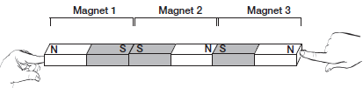
- Three bar magnets were held together as you see above. What did they look like when you released them? (Write the letter of the best answer in the box.)
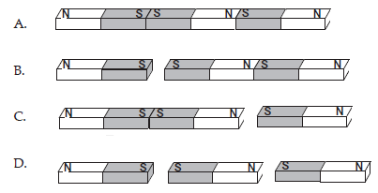
- Arthur was playing with magnets. He had one magnet on the table, and one in his hand. As he moved the magnet in his hand closer to the one on the table, the magnets suddenly snapped together. Explain to Arthur why the magnets snapped together.

- A student set up the circuit you see in the picture. There was a compass sitting on the table next to the circuit. When the student connected the plastic-coated copper wire to the battery, the compass needle moved. Why did the compass needle move? (Write the best answer in the box.)
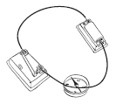
  - Electricity was flowing through the wire to the compass.
  - Magnetic force was flowing from the battery to the compass.
  - The energy flowing through the wire caused the compass to vibrate.
  - Magnetism was created when electricity flowed through the wire.
- Samuel Morse, the inventor of the telegraph, had a problem. His telegraph’s signal was too weak. He needed a stronger electromagnet. What is one way that he might have increased the strength of the electromagnet for his telegraph?

- Look at the schematic diagram.
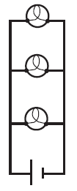
  - What will happen to the other two bulbs if the middle bulb burns out?

  - Why does that happen?

- Electricity can be changed into other forms of energy.
  - The bulb in a lamp changes electric energy into _______________________________
  - A motor changes electric energy into _____________________________________
  - A generator changes mechanical energy into _________________________________
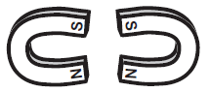
- A student placed two horseshoe magnets near each other on a table. What will happen when she lets go of the two magnets? (Write the letter of the best answer in the box.)
  - One side of the magnet will repel and the other side will attract.
  - The two magnets will repel and push apart.
  - The two magnets will attract and stick together.
  - The force will be cancelled between the magnets.

- Which picture has arrows that show how electricity flows through a bulb and battery circuit? (Write the letter of the best answer in the box.)
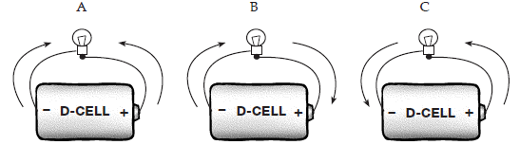
- When black sand and iron filings are mixed together, they look like a black powder. Which of the following would be the easiest way to separate the sand and the filings? (Write the best answer in the box.)
  - Use a magnifying glass. c. Use a magnet.
  - Add water to the mixture. d. Use a hot plate to heat the mixture.
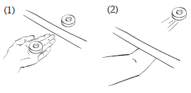
- Jorge discovered that he could move a magnet across the top of a wood table by moving another magnet under the table. Explain why Jorge is able to move the magnet on top of the table without touching it.

