Enzyme and Chemical Reactions Practice
1. Label the diagram with the following terms: products, enzyme, substrate, active site.
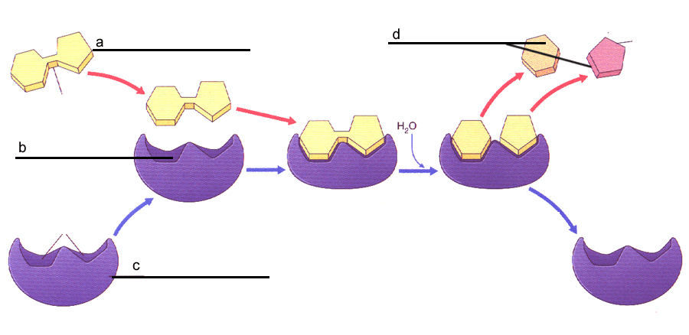

2. Answer true or false to the following statements:
a. _______ Enzymes interact with specific substrates.
b. _______ Enzymes change shape after a reaction occurs.
c. _______ Enzymes speed up reactions.
d. _______ One enzyme can be used for many different types of chemical reactions.
3. Amino acids are linked together to make proteins by removing a molecule of ______________ in a process called __________________________________.

4. Why are enzymes important to organisms?

5. Reactants in an enzyme catalyzed chemical reaction are also called ______________
A. polymers
B. products
C. substrates
D. organics

6. Macromolecule that can act as enzymes are __________________.
A. carbohydrates
B. lipids
C. Nucleic acids
D. proteins

7. Enzymes speed up chemical reactions by ___________________.
A. decreasing the activation energy
B. increasing the activation energy
C. making more hydrogen bonds
D. changing the pH of the solution

8. Proteins (like enzymes) unwind or _____________ when placed in extreme pH or temperature conditions.
A. desensitize
B. polymerize
C. depolarize
D. denature

9. Enzymes are _______________
A. used up during chemical reactions.
B. unchanged during chemical reactions and reusable.

10. Name two (2) environmental conditions that can cause proteins (enzymes) to change their shape.

11. DNA polymerase is a molecule found in all cells. Judging by its name, do you think it is an enzyme? (YES or NO) How can you tell (be specific)?
13. Which graph below shows an enzyme catalyzed reaction? _________
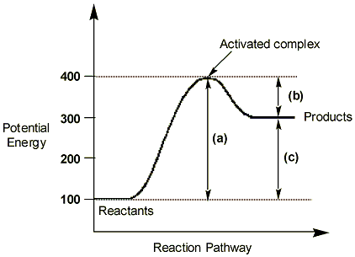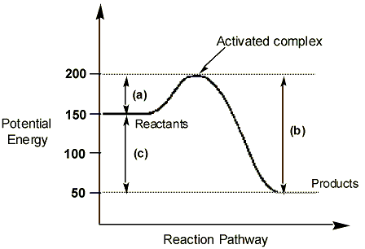
A B
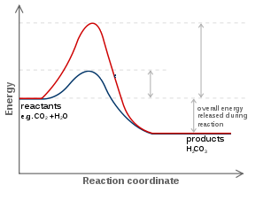
C

Enzyme and Chemical Reactions Practice
1. Label the diagram with the following terms: products, enzyme, substrate, active site.
a. substrate
b. active site
c. enzyme
d. products

2. Answer true or false to the following statements:
a. ___T____ Enzymes interact with specific substrates.
b. ___F____ Enzymes change shape after a reaction occurs.
c. ___T____ Enzymes speed up reactions.
d. ____F___ One enzyme can be used for many different types of chemical reactions.
3. Amino acids are linked together to make proteins by removing a molecule of __water____ in a process called __dehydration synthesis_.

4. Why are enzymes important to organisms?
They help break down food, transmit messages, speed up reactions in the body, make things the cells need, make reactions occur in a timely fashion.
5. Reactants in an enzyme catalyzed chemical reaction are also called ____C____________
A. polymers
B. products
C. substrates
D. organics

6. Macromolecule that can act as enzymes are ________D______________.
A. carbohydrates
B. lipids
C. Nucleic acids
D. proteins

7. Enzymes speed up chemical reactions by _________A___________.
A. decreasing the activation energy
B. increasing the activation energy
C. making more hydrogen bonds
D. changing the pH of the solution

8. Proteins (like enzymes) unwind or _______D_______ when placed in extreme pH or temperature conditions.
A. desensitize
B. polymerize
C. depolarize
D. denature

9. Enzymes are _______B________
A. used up during chemical reactions.
B. unchanged during chemical reactions and reusable.

10. Name two (2) environmental conditions that can cause proteins (enzymes) to change their shape.
change in pH or temperature
11. DNA polymerase is a molecule found in all cells. Judging by its name, do you think it is an enzyme? (YES or NO) How can you tell (be specific)?
yes, because it ends in -ase

12. Which graph below shows an exothermic reaction? ___B_______
13. Which graph below shows an endothermic reaction? ____A______
14. Which graph below shows an enzyme catalyzed reaction? ____C_____
A B
C

15. When reactants are produced at the same rate as products they are in ___equilibrium_______.
16. In reactants, bonds are [ formed / broken ] , whereas, in products, bonds are [ formed / broken ] . (Circle the correct answer for each set)
broken....formed

