Microevolution & Macroevolution Worksheet Name_______________________

Section A: The Making of the Fittest --- Evolving Bodies, Evolving Switches
http://www.hhmi.org/biointeractive/making-fittest-evolving-switches-evolving-bodies
- Identify if the following statements are true or false. Explain your answer.
  - “Having pelvic spines is always advantageous to a stickleback.” _______________________________ _____________________________________________________________________________________
  - “All mutations are bad.” ________________________________________________________________ _____________________________________________________________________________________
- What special features of the environment in Bear Paw Lake, Alaska, may have favored the survival and reproduction of stickleback fish with reduced pelvis? ________________________________________________ ____________________________________________________________________________________________
- In the film, Dr. Bell notes that in multiple freshwater populations and at multiple times in history, the frequency of stickleback fish with pelvic fins decreased and frequency of stickleback fish with reduced pelvises increased. This demonstrates that __.
  - only fish with smaller pelvises migrate to freshwater
  - similar environments select for similar genetic changes
  - the pelvis of the marine fish is destroyed by freshwater
- Circle whether each statement is true or false.
  - True or False Evolutionary change always takes millions of years.
  - True or False Dramatic changes in traits, such as the loss of limbs, can occur through mutations
affecting a single gene.
- During a high-flood season, a lake overflows its banks and some resident freshwater stickleback fish are carried out to the ocean. For each of the following statements, circle the outcome most likely to occur.
  - When they reach salt water, individual fish (will / will not) spontaneously generate pelvic spines during their lifetime.
  - More fish (with / without) pelvic spines will be eaten by large-mouthed predators.
  - Over many generations, the frequency of stickleback fish with pelvic spines will (increase / decrease) in populations that descended from the original one that spilled out from the lake.

Section B: Natural Selection and Adaptation
http://www.hhmi.org/biointeractive/making-fittest-natural-selection-and-adaptation
- Explain how the environment plays a role in changing the frequency of a mutant allele in a population.

- Near the end of the film, Dr. Sean B. Carroll states that “while mutation is random, natural selection is not.” In your own words, explain how this is possible.

- For rock pocket mice, which of the following contributes to selective pressure favoring dark-colored fur? Write “yes” or “no” next to each of the four possible responses. There may be more than one yes response.
Predators _____________ Genetic mutations _____________
Rock color _____________ Availability of food for the rock pocket mice _____________

Section C: Genetic Drift
- Polydactyly – extra fingers or toes – is one symptom of Ellis-van Creveld syndrome. The syndrome is commonly found among the Old Order Amish of Pennsylvania, a population that experiences the “founder effect”. This disease is more concentrated among the Amish because they marry within their own community, which prevents new genetic variation from entering the population. Children are more likely to inherit two copies of the recessive genes leading to the genetic disease. http://www.pbs.org/wgbh/evolution/library/06/3/l_063_03.html
  - Is this an example of genetic drift? Explain your answer. ______________________________________ _____________________________________________________________________________________
  - Would the frequency of the disease be different in a larger population? Explain your answer. _____________________________________________________________________________________ _____________________________________________________________________________________
- Below are examples of genetic drift. What similarities do you see in the examples? _______________________ _____________________________________________________________________________________________ _____________________________________________________________________________________________

- Many individuals are killed due to a disease that only attacks those with blue eyes, causing blue eyes to become rarer in the area.
- An airplane crash introduces the white heron, which loves spotted mackerel, into a population of spotted and unspotted mackerel. Over time, fewer mackerel are born with spots.
- A man steps on a group of beetles, randomly killing most of the green ones but leaving most of the brown ones alive, resulting in fewer green beetles being produced in the population.
- A wildflower population consisting of blue, purple, and pink flowers is subjected to a mudslide that kills most of the blue ones. As time progresses, blue flowers eventually die out, leaving only purple and pink wildflowers.

Section D: Patterns of Evolution
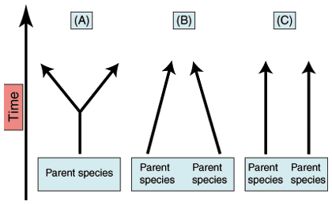
- Identify if the following organisms represent divergent evolution or convergent evolution.
  - butterflies and bats – different ancestry, similar structures (wings) ________________________
  - dolphins and porpoise – closely related, different traits (teeth shape) _________________________
  - snakes and lizards - ______________________
  - sharks and whales - ______________________
  - eels and earthworms - _______________________
  - zebra and horses - _______________________
  - letter ‘A’ in the diagram - _____________________
  - letter ‘B’ in the diagram - ______________________

- What evolutionary evidence supports divergent evolution? _________________________________________ ___________________________________________________________________________________________ ___________________________________________________________________________________________

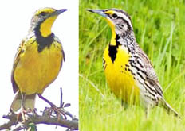
- A brown bird of some African prairies and grasslands, the African yellow-throated long-claw (Macronix croceus), a motacillid, has a yellow breast with a black chevron "V". This motacillid looks and acts so much like an American meadowlark (Sturnella magna), an icterid, that a competent bird watcher might mistake them for the same species, yet they belong to different avian families. Why would these organisms that are not related start to look similar? ____________________________________________________________ ____________________________________________________________ ____________________________________________________________
- The pattern of evolution that explains how birds have evolved so many different kinds of feet that are adapted to many different environments is _______________________________ evolution.
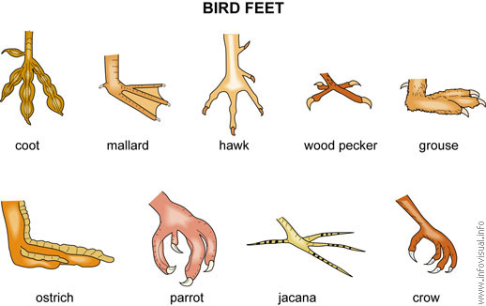

Section E: Coevolution of the toxic newt and the garter snake
- Explain how the relationship between the toxic newt and the garter snake is an example of coevolution. __________________________________________________________________________________________
__________________________________________________________________________________________

Section F: Macroevolution
Macroevolution is evolution over geologic time above the species level. One of the main topics in macroevolution is how new species arise; this process is known as speciation. How does speciation usually happen? First a species become isolated.
- Assume that some members of a species become geographically separated from the rest of the species. If they remain separated long enough, they may evolve genetic differences. If the differences prevent them from interbreeding with the original species. They have evolved into a new species. This speciation is caused by geographic isolation.
- Assume Hawthorn flies lay eggs in Hawthorn trees. The eggs hatch into larvae that feed on fruits. Apple trees were introduced to the U.S. and often grown near Hawthorn trees. Some Hawthorn flies started laying eggs in nearby apple trees. When the eggs hatched, the larvae fed on apples. Overtime, they become reproductively isolated because they breed at different times; the breeding season matches the season when the apple or hawthorn fruits mature. Because they rarely interbreed, the two populations of flies are evolving genetic differences and becoming different species. This speciation is caused by temporal isolation.
- The blue footed booby bird has an elaborate mating “dance” that males must do to woo the female. The female can either then accept or reject the advances of the male. Other species of birds do not have the same mating dance and will be fully ignored by the female meaning they have no chance at reproducing with the female blue footed booby. This speciation is caused by behavioral isolation.
- How is macroevolution different from microevolution? _____________________________________________ ____________________________________________________________________________________________ ____________________________________________________________________________________________
- What factors has to be present for speciation to occur? ______________________________________________ _____________________________________________________________________________________________
- You are provided with examples and explanations of three isolation mechanisms. Use this information to identify the type of isolation mechanism is illustrated in these examples.
  - In North America, five frog species of the genus Rana differ in the time of their peak breeding activity. What mechanism is illustrated? _______________________________
  - The lion and tiger habitat overlapped in India until 150 years ago, but the lion lived in open grassland and the tiger in forest. Consequently, the two species did not hybridize in nature. What mechanism is illustrated? ___________________________________
  - If a male firefly tries to impress a female and the female firefly does not recognize the patterns of light created by a male firefly. What type mechanism is illustrated? _______________________________

Section G: Gradualism or Punctuated Equilibrium?
Every now and then, paleontologists uncover what appears to be a complete series of fossils. They find batches of fossils which seem to represent a population of one species, living at one period of time, and showing a typical range of variation, but still clearly members of one species. As they search layers of sediment above and below, they find more fossil groups of what appear to be the same species.
As paleontologists study the entire series of fossils, they tend to find two kinds of patterns. Sometimes there appear to be slight shifts in the average features of the fossils over time, eventually becoming so different from the earliest form that they have to say a new species has formed. But with another series of fossils (may be a totally different kind of organism), they find very little difference for long periods of time, then, all of a sudden, they begin to find fossils similar to the earlier ones, but showing some striking differences, clearly a new species. Sometimes, in both cases, the original species continues to exist along with the new species, and sometimes the original species can no longer be found.
- Which rate would show transitional fossils showing slight variations in fossils? __________________________

Section H: Rates of Evolution
- Identify if the following demonstrates gradualism or punctuated equilibrium.
  - Evolution of humans ___________________________
  - Darwin believed that evolution happened slowly overly over a long period of time. _________________________
  - Bacteria becoming resistant _______________________________
  - Transitional fossils are present ___________________________
  - Pattern seen in horses in which long periods without change are interrupted by short periods of rapid change. ___________________________

Quizzes:
http://www.sciencegeek.net/Biology/review/U6Evolution.htm
http://www.sciencegeek.net/Biology/review/U6Populations.htm
http://www.sciencegeek.net/Biology/review/U6Review.htm

