Natural Selection & Evidence Worksheet Name______________________

Section A: Pre-Darwinian Theories
- Read the article and summarize the scientist’s contribution to the theory of evolution.
Linnaeus

Buffon

Erasmus Darwin
Lamarck

Cuvier

Lyell

Hutton

Section B: Charles Darwin
On the ‘Websites-Evolution’ page, click on ‘Darwin & Natural Selection’.
- What was Darwin’s position on the H.M.S. Beagle? ______________________________________________
- How did Lyell’s books influence Darwin? ______________________________________________________ _________________________________________________________________________________________
- How were the Galapagos Islands significant in Darwin’s evolutionary thought? ______________________ _________________________________________________________________________________________
- List some examples of some of the organisms that Darwin encountered on the Galapagos Islands. _________________________________________________________________________________________
- What is adaptive radiation? Use the finches to explain the concept._________________________________ _________________________________________________________________________________________ _________________________________________________________________________________________
- What is “descent with modification”? _________________________________________________________ _________________________________________________________________________________________
- Explain the process of natural selection. _______________________________________________________ _________________________________________________________________________________________ _________________________________________________________________________________________
- Explain why “survival of the fittest” doesn’t always mean the strongest. _________________________________________________________________________________________ _________________________________________________________________________________________
- How were Darwin’s thoughts different from Lamarck’s? __________________________________________ _________________________________________________________________________________________ _________________________________________________________________________________________
- What did the critics say about Darwin’s explanation? ____________________________________________ ________________________________________________________________________________________
- How did Malthus’ essays influence Darwin? ____________________________________________________ _________________________________________________________________________________________
- What does “fittest” mean from an evolutionary perspective? ______________________________________ _________________________________________________________________________________________ _________________________________________________________________________________________
- Why didn’t Darwin publish his findings soon after returning from his voyage? ________________________ _________________________________________________________________________________________
- Who was Alfred Wallace and what was his contribution to evolutionary thought? _____________________ _________________________________________________________________________________________ _________________________________________________________________________________________

Section C: Adaptation & Fitness
- Living things that are well adapted to their environment survive and reproduce. Those that are not well adapted don’t survive and reproduce. An adaptation is any characteristic that increases fitness, which is defined as the ability to survive and reproduce.
  - Based on the definition of fitness, use the chart to determine what characteristic of the mice is an adaptation that increased their fitness? _________________ __________________________________________________________________________________
  - Which mouse would biologists consider the fittest? _____________________

Color of Fur | Black | Tan | Tan and Black | Cream
Age of Death | 2 months | 8 months | 4 months | 2 months
# of offspring | 0 | 11 | 3 | 0
Running Speed | 8 m/min | 6 m/min | 7 m/min | 5 min/m

Name of Lions | George | Dwayne | Spot | Tyrone
Age of Death | 13 years | 16 years | 12 years | 10 years
# of offspring | 19 | 25 | 20 | 20
# cubs surviving to adulthood | 15 | 14 | 14 | 19
Adulthood | 10 feet | 8.5 feet | 9 feet | 9 feet
- A more complete definition of fitness is the ability to survive and produce offspring who can also survive and reproduce. Which lion would biologists consider the “fittest”? Explain why. _________________________________________________________________________________________________________________________________________________________________________________
Over many generations heritable adaptive characteristics become more common in a population. Evolution by natural selection takes place over many, many generations. The term evolution by natural selection refers to changes in the frequency of adaptive characteristics in the population.

Section D: “How does evolution really work?”
- What are the four causes of natural selection?
  - ___________________________________ c. ____________________________________
  - ___________________________________ d. ____________________________________
- Describe the process of natural selection and how it affects hummingbird populations. __________________________________________________________________________________________________________________________________________________________________________________

Section E: Variation and Selection in the Egyptian Origami Bird
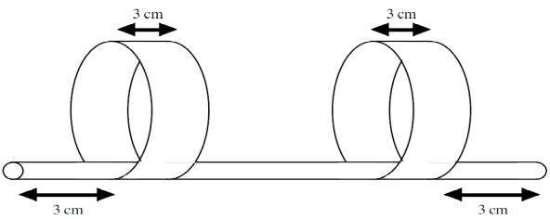
Adapted from: http://www.indiana.edu/~ensiweb/lessons/origam2.pdf
INTRODUCTION: The Egyptian Origami Bird (Avis papyrus) lives in arid regions of North Africa. Only those birds which can successfully fly the long distances between the sparsely spaced oases will be able to live long enough to breed successfully. You will breed several generations of Origami Birds and observe the effects on their evolutionary success.

PROCEDURE:
- All students will start with the same P generation dimensions. You will breed offspring to create your F1 generation. Flip a coin to determine if the mutation occurs on the front wing or the back wing. If heads, the mutation occurs on the front wing. If tails, the mutation occurs on the back wing.
- For each chick, throw your dice then record the results on the table. The dice throw determines how the mutation affects the wing. On the dice….
  - 1 = the wing moves 1 cm toward the end of the straw
  - 2 = the wing moves 1 cm away from the end of the straw
  - 3 = the circumference of the wing increases 2 cm
  - 4 = the circumference of the wing decreases 2 cm
  - 5 = the width of the wing increases 1 cm
  - 6 = the width of the wing decreases 1 cm
- Continue to create offspring for the F2, F3, and F4 generation by throwing the dice each time to determine the type of mutation. Record the results on the table.
- Once you know the genotype of your F4 generation, create a model of your bird after all the mutations. Cut two strips of paper according to the length and width in the F4 generation. Loop each strip of paper with a 1 cm overlap and tape according to the distance in the F4 from the edge of the straw. You will need to add 1 cm to account for the overlap.
- Now it’s time to see how your bird compares to the rest of the birds in the class. We will test to see which birds will be able to survive the long trek to the water source.
DISCUSSION:
- Did you notice common characteristics in birds that were able to fly the furthest?

- How did this experiment produce variation among the offspring? How did this experiment select offspring to breed the next generation?
.

- Predict the appearance of your F4 bird’s descendants if the selection conditions change the worst flying bird survives to produce the most offspring. .

Generation | Genotypes (Measurements)
P | Front wing - Distance from end -  3x20 cm 3 cm  Back wing - Distance from end –  3x20 cm 3 cm
F1 | Front wing - Distance from end -  Back wing - Distance from end –
F2 | Front wing - Distance from end -  Back wing - Distance from end –
F3 | Front wing - Distance from end -  Back wing - Distance from end –
F4 | Front wing - Distance from end -  Back wing - Distance from end –

Section F: Peppered Moth Simulation
On the ‘Website-Evolution’ page, click on “Peppered Moth Simulation”. …..read & go through the animation.
Charles Darwin accumulated a tremendous collection of facts to support the theory of evolution by natural selection. One of his difficulties in demonstrating the theory, however, was the lack of an example of evolution over a short period of time, which could be observed as it was taking place in nature. Although Darwin was unaware of it, remarkable examples of evolution, which might have helped to persuade people of his theory, were in the countryside of his native England.
- Scenario: The economic changes known as the industrial revolution began in the middle of the eighteenth century. Since then, tons of soot has been deposited on the country side around industrial areas. The soot discolored and generally darkened the surfaces of trees and rocks. In 1848, a dark-colored moth was first recorded. Today, in some areas, 90% or more of the-peppered moths are dark in color. More than 70 species of moth in England have undergone a change from light to dark.
- You will run simulations for 1 minute each, during this time you will play the part of the Bluejay that eats moths. After 1 minutes record the % of dark moths and light moths.
 | % Dark Moths | % Light Moths
Light Forest
Dark Forest
- Click on the last bubble that says “A bird’s Eye View…” when you mouse over it. Read the information and continue to click until you get to the simulation. Choose the Light Forest, and run the simulation. Choose the Dark Forest and run the simulation.

Questions:
- Explain how the color of moths increases or decreases their chances of survival depending on the environment.

- 500 light colored moths and 500 dark colored moths are released into a polluted forest. After 2 days the moths were recaptured, make a prediction about the number of each type of moth that would be captured.

Section G: Natural Selection
- There are two types of rabbits: those that strictly eat grass and those that strictly eat berries and flowers. A drought occurs one year and plants have difficulty producing extra flowers, berries, etc., but they are still green. The rabbits have had babies all year long, but many are eaten by foxes or hawks. Due to the drought, many have starved to death.
  - What rabbit will natural selection select against? ____________ For? ______________
  - Identify the 5 points of Darwin’s natural selection from the rabbit scenario.
- Populations have variations. ______________________________________________________
- Some variations are favorable. ____________________________________________________
- More offspring are produced than survive. ___________________________________________
- Those that survive have favorable traits. _____________________________________________
- A population will change over time. ________________________________________________
- Identify if the following is an adaptation or an acquired trait. Adaptation is an inherited trait. An acquired trait is a learned behavior to an environmental change.
  - Leopard seals have a lot of body fat so that they can withstand the cold water. ________________
  - Fiddler crabs can alter the shape or size of their claw by using it more. __________________
  - Camels have 3 eyelids to prevent sand from entering during a sand storm. ___________________
  - Chameleons change their skin color to hide in their surroundings. ____________________
  - A rat’s hair was burned off and is able to avoid predators because it has a different scent. ____________________
- Bob believes that giraffes have long necks because they have stretched their necks to try and reach food that is high in trees. Since the parent had stretched its neck, it passed the long neck on to its offspring. Who does Bob think like -- Lamarck or Darwin? _________________________

Section H: Pesticide Resistance
On the ‘Website-Evolution’ page, click on “Pesticide Resistance”. …..go through the animation.
 | S % (Susceptible – SS, SR) | R% (Resistant – RR)
Generation #1
After 1st spray of DDT- Survival Rate
Generation #2
After 2nd spray of DDT- Survival Rate
Generation #3

- What happened to the frequency of the resistant allele in the population?

- Could the entire population of insects become resistance to DDT in the future?

Section I: Evolution Game
On the ‘Website-Evolution’ page, click on “Evolution Game”. …..play the survival game.
- What is the key to survival? _________________________
- What were your life-preservers? ________________ How did this help the population? ____________ _________________________________________

Section J: Rise of the Superbugs
On Monday, Eva went to the ER following a fall from her bike. Fortunately, her only broken bone was a finger. But she suffered scrapes and cuts, including some deep cuts on her legs. After spending several hours in the ER having her wounds cleaned, stitched and bandaged, Eva returned home.
Tuesday morning, one of the deeper cuts on Eva’s leg was red and felt warm. She had a few pills of an antibiotic left over from her bout with strep throat that previous winter. Thinking it might help to prevent infection, she took them according to the prescription instructions.
Throughout Tuesday, the cut on Eva’s leg became increasingly red, swollen, and painful. Eva felt awful and returned to the hospital on Tuesday night. Her cut had become infected. The doctors cleaned and re-stitched her leg and prescribed a daily dose of Antibiotic A, a stronger version of the same antibiotic Eva had taken at home just that morning.
By Thursday, Eva’s infection had spread to the point where it was too painful to walk. In addition, Eva felt ill. She returned to the hospital and this time was admitted. The doctors immediately administered a different kind of antibiotic, Antibiotic C, directly into Eva’s bloodstream through an intravenous tube.
Friday, Eva felt better and her leg became less painful and swollen. But on Saturday, it was clear that Eva had taken a turn for the worse. The infection on her leg continued to spread and she had become feverish. The medical staff involved with Eva’s case held a meeting to plan the next steps in Eva’s treatment.

- What might explain why Eva’s infection is not responding to treatment by antibiotics?

- What would be the next step in Eva’s treatment?

Section K: What’s happening to the Spotted Salamanders?
Background: A fatal genetic disease has been observed in a population of Spotted salamanders commonly found throughout the state of Georgia. You are a wildlife biologist who has been charged with monitoring changes in the population. You have determined that the fatal disease is the result of a recessive trait and that the affected salamanders typically die in their second year of life. Male and female salamanders are equally likely to be affected by the disease. You have decided to use beads to simulate the salamanders’ gene pool. You are using red beads to represent normal alleles and white beads to represent the allele for the fatal gene. A container will hold the gene pool of the salamanders. This exercise simulates the change in allele frequencies under selection.

Procedure: The bag will contain the “gene pool” consisting of 50 red and 50 white beads. Without looking, withdraw 2 beads from the bag. Tally the beads’ colors (red-red, red-white, or white-white) in the table below, and return the two beads to the bag. Thoroughly mix the beads. Continue withdrawing beads two at a time, tallying their colors, and returning the beads to the container, until you have drawn 50 pairs of beads. Find the frequency of each color combination using the following formula:

Frequency of a color combination = number drawn of the combination / 50.

Generation 1 | Red-red | Red-white | White-white
Color combination Tally
Number of pairs with color combination
Frequency of color combination

Now you will simulate the removal of individuals with the fatal white/white gene pair from the population. Determine the total number of white beads you withdrew in white/white pairs. Remove this number of white beads from the gene pool (the bag) and replace them with red beads from the bag of extra red beads. For example, if you drew 13 white/white pairs, replace 26 white beads with 26 red beads. From the new “gene pool”, randomly draw another 50 pairs of beads, tally their color combinations (red-red, red-white, white-white) as before, and return them to the bag before you draw the next set.

Generation 2 | Red-red | Red-white | White-white
Color combination Tally
Number of pairs with color combination
Frequency of color combination

Questions:
- What affect would migration have on this population? Are there other conditions that could impact reproductive survival rates?

- How does this example provide evidence that evolution by natural selection is occurring?

- What type of selection is represented in this lab?

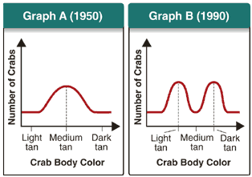
Section L: Outcomes of Selection
- Which of the following is most likely to have caused the change in the population shown in the graphs at the left?
  - a new predator prefers dark-tan crabs
  - a new predator prefers light-tan crabs
  - a new beach color makes medium-tan crabs the least visible
  - a new beach color makes medium-tan crabs the most visible

- Label the 3 graphs as: directional selection, stabilizing selection, disruptive selection
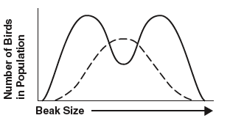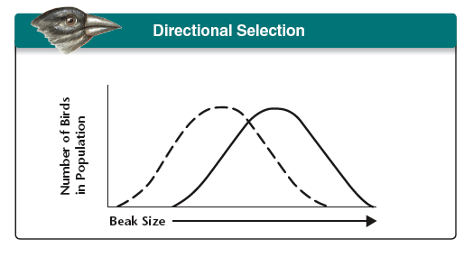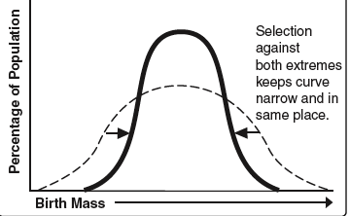

___________________ ____________________ __________________

- Identify the type of selection: directional selection, stabilizing selection, disruptive selection
  - ________________________ In which of these is the fitness of individuals at one end of the normal distribution curve higher than that of individuals in the middle or at the other end of the curve
  - ________________________ In which of these is the fitness of individuals in the middle higher than that of individuals at the extreme ends
  - ________________________ In which of these is the fitness of individuals at the extreme ends higher than that of individuals in the middle
  - ________________________ Human babies born smaller than average are likely to be less healthy and less likely to survive. Larger than average babies are likely to have difficulty being born. The fitness of these larger or smaller weight babies is lower than average-sized babies so human babies tend to born of average size.
  - ________________________ Birds with bigger, thicker beaks can feed more easily on larger, harder seeds. A food shortage causes the supply of small and medium seeds to run low, leaving only larger seeds. Birds with bigger beaks show greater fitness than birds with medium or small beaks. Over time more birds with bigger beaks survive and reproduce.
  - ________________________ The orange and black pattern of a Monarch butterfly serves as a warning to sharp-eyed birds that the Monarch is poisonous to eat and tastes bad. Individuals with the brightest color pattern were more likely to warn off birds and survive to reproduce than those with a dull or medium color pattern. Over time and many generations, the Monarch population became more brightly-colored.
  - ________________________ In birds, feather color among males is more likely to attract a mate, but also more likely to attract a predator. Over time and many generations, the highest frequency color is for males with medium colors, while males with very dull colors and males with very bright colors become increasingly rare.
  - _______________________ A population of birds lives in an area where plants with medium sized seeds are wiped out by a fungal infection. Birds with unusually large or small beaks would have higher fitness than those with medium sized beaks. Over time the population splits into two subgroups; one that eats small seeds and one that eats large seeds.

Section M: Dating the Fossil Record
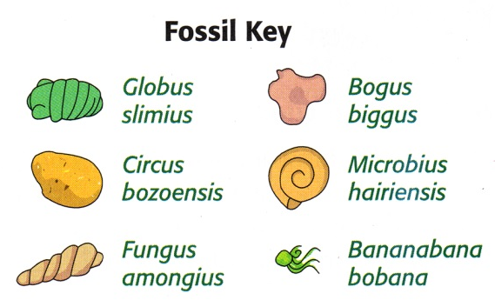
You have received nine rock samples from a paleontologist in California. Your job is to arrange the samples in order from oldest to youngest according to their fossil content and to determine their relative age using the process of relative dating. Results from absolute dating methods will not be available from a laboratory for several weeks, and the paleontologist needs the information immediately. You know from previous work that the rocks in sample 2 are the oldest.
In your teams, arrange the fossil cards from oldest to youngest. Begin with sample 2 because you know this sample is the oldest. You may need to try several different arrangements to get the cards in order. After an organism becomes extinct, it does not appear in younger rocks.
Record the samples in order from oldest to youngest in the first column. Indicate which fossils are found in the sample. You are planning on preparing a timeline for the paleontologist in California. But when the results, shown here, come in from the geology lab, you discover that the dates have been separated from the appropriate rock samples. Absolute dating is very expensive and you can’t have it done again. You have already determined the relative ages of the samples. All you have to do is arrange the dates from oldest to youngest. Add these dates to your table.
Fossil Ages: 28.5 mya, 30.2 mya, 18.3 mya, 17.6 mya, 26.3 mya, 14.2 mya, 23.1 mya, 15.5 mya, 19.5 mya

Order of Samples | Species found in sample | Age of sample (in millions of years)
2 | G. slimius | 30.2 mya

Section N: How old is the body?
The body of a man wearing the traditional clothes of the snow plains nomads was found at the bottom of one of the many peat bogs that remain from the last glacial retreat. He had a stone ax buried in the back of his skull. The ax was made in the ancient nomad style, stone chipped to a sharp edge and bound by leather strips to a forked branch. Because of the victim’s dress and the unusual murder weapon, the police are assuming this homicide involves a clan dispute among the wandering deep snow people who still maintain their ancient territorial ways.
Years since death | C¹⁴ atoms remaining per 100,000,000 C¹² atoms
0 | 10,000
5,700 | 5,000
11,400 | 2,500
17,100 | 1,250
22,800 | 625
28,500 | 312
34,200 | 156
39,900 | 78
45,600 | 39
The acid in the bog has ‘tanned’ the man’s body, preserving it well. Although the man’s skin is wrinkled and pulled tightly over his bones, his features are still distinguishable and his clothes and internal organs are still intact and available for police analysis. The withered condition of the body has convinced the police that the homicide happened at least 10 years ago. Forensic evidence shows the man was killed elsewhere, dragged to the bog and then thrown in, presumably to hide the crime.
Follow up comment: After months of investigation no new evidence or information was turned up. Eventually the police requested a Carbon-14 radio-active dating test done on the victim’s body and clothes. To their astonishment the test found that only 3,000 radioactive C¹⁴ atoms were present instead of the 10,000 atoms expected from a recently deceased person. This has greatly confused the police who had assumed that the murder was a recent event.

How long ago did the murder take place? ________________

Section O: Adaptive Radiation & Embryology
- Adaptive radiation is the relatively fast evolution of many species from a single common ancestor. Adaptive radiation generally occurs when an organism enters a new area and different traits affect its survival. An example of adaptive radiation is the development of mammals after the extinction of dinosaurs.
  - Watch video and summarize how the salamanders are undergoing adaptive radiation.
______________________________________________________________________________________________________________________________________________________________________________________________________________________________________________________
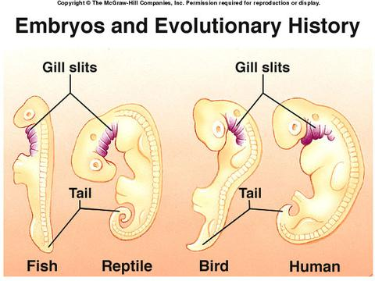
- All vertebrate embryos follow a common developmental path due to their common ancestry. All have a set of very similar genes (the homeobox genes) that define their basic body plan. As they grow, the differences that will distinguish the embryos as adults become more and more apparent. Why is embryology a good indicator of evolution?
  - All embryos use the same genes at the exact same instant during development.
  - The embryos of various groups of vertebrates all share the same features of early development, suggesting an evolutionary relationship.
  - Embryological development occurs at the same pace in all organisms.
  - The fact that any organisms undergo embryological development at all suggests evolution.

Section P: Genetic Evidence – Building a Cladogram
Cytochrome-C is an enzyme found in almost all living things. It is involved in the conversion of food to useable energy during cellular respiration. The protein chain that makes up the enzyme is 60 amino acids long. Even though all organisms have this enzyme, there is a slight variation in the exact amino acid sequence between organisms. Your job today is to determine the number of differences in each amino acid chain compared to a human.

Organism | Amino Acid Sequence in Cytochrome-C (Letters stand for the amino acids) | Differences
Human | GDVEKGKKIFIMKCSQCHTVEKGGKHKTGPNLHGLFGRKTGQAPGYSYTAANKNKGIIWG
Chicken | GDVEKGKKIFVQKCAQCHTVEKGGKHKTGPNLHGLFGRKTGQAPGFTYTDANKNKGITWK
Chimpanzee | GDVEKGKKIFIMKCSQCHTVEKGGKHKTGPNLHGLFGRKTGQAPGYSYTANNKNKGIIWG
Donkey | GDIEKGKKIFVQKCSQCHTVEKGGKHKTGPNLHGLFGRKTGQAEGFSYTDANKNKGITWG
Horse | GDIEKGKKIFVQKCSQCHTVEKGGKHKTGPNLHGLFGRKTGQAEGFSYTDANKNKGITWG
Lemur | GDVEKGKKIFTMKCSQCHTVEKGGKHKTGPNLHGLFGRKTGQAVGYSYTAANKNKGITWG
Monkey | GDVEKGKKIFIMKCSQCHTVEKGGKHKTGPNLHGLFGRKTGQAPGYSYTAANKNKGTWG
Turkey | GDVEKGKKIFVQKCAQCHTVEKGGKHKTGPNLHGLFGRKTGQAPGRTYTDNKNKGITWK

Draw your cladogram here.

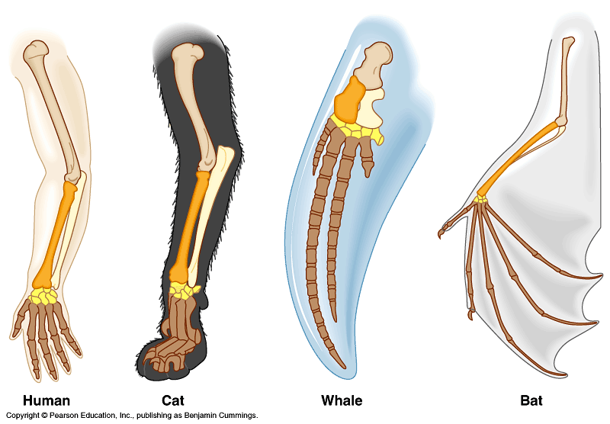
Section Q: Comparative Morphology
- What are homologous structures?

- What do these homologous structures indicate about the organisms?

- What are analogous structures?

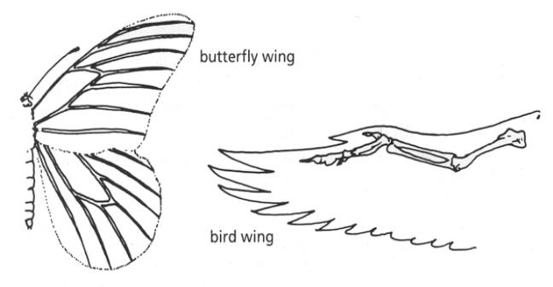

- What would cause organisms to develop analogous structures?

- Do birds and insects share any structural similarities that would suggest they are closely related taxonomically? Explain.

- What are vestigial structures?

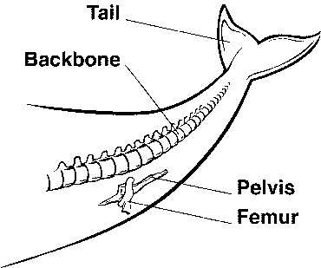
- List some examples of vestigial organs.

- How do scientists explain the vestigial structures in a whale shown in the figure?

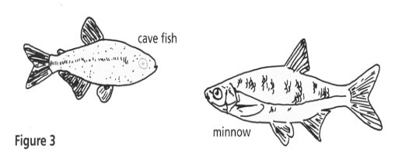
- Gradual changes have occurred throughout time that have in some cases reduced or removed functions of some body structures and organs. The cavefish and the minnow are related, but the cavefish is blind. Explain why eyesight is NOT an important adaptation to life in a cave.

Section R: Concept Check
- Diagram A represents undisturbed rock strata in a given region. A representative fossil of an organism is illustrated in each layer. Which statement best describes a relationship between these representative organisms?
A
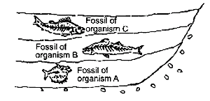
  - Organism A was probably more structurally advanced than organism B and organism C
  - Organism C probably gave rise to organism A and organism B.
  - All the organisms evolved at the same time.
  - Organism A was probably more primitive than organism B & C.
- Four of the five answers listed below are sources of variation in a population. Select the exception.
  - mutation c. crossing over e. independent assortment
  - sexual reproduction d. asexual reproduction
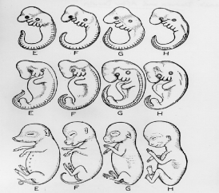
- Diagram B represents stages in the embryonic development of four organisms. The similarities in embryonic development shown in the diagram suggest that these organisms
B
  - are all members of the same species
  - all undergo external development
  - may have evolved from a common ancestor
  - have adaptations for the same environment as adults
- Which one of the following sets of structures includes only analogous structures?
  - Wings of a butterfly and a bat c. Hind legs of horses and a zebra
  - Hands of a monkey and a human d. Fin of a salmon and a catfish
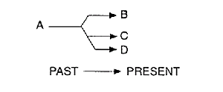
- In the diagram to the right B, C, and D represent organisms that exist in the present time and show a striking similarity to each other in their bone structure. In the diagram, letter A most likely represents
  - homologous structures c. an acquired characteristic
  - a common ancestor d. geographic distribution
- Adaptive radiation __.
  - is another term for natural background radiation that causes adaptive changes
  - is the evolution of the biggest and fiercest animals
  - is the formation of new adaptive structures or colors within a species
  - is the evolution of many species that occupy various niches, from a single ancestral form
- Fossils would most likely be found in __.
  - amber that is over 8 billion years old c. icebergs that are 500 billion years old
  - sedimentary rock that are 500 million years old d. volcanic rock that are 50 million years old
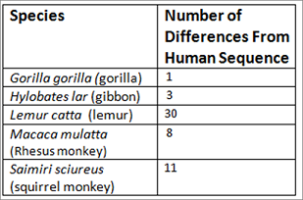
- The amino acids for beta hemoglobin found in five species were compared to the amino acids found in human (Homo sapiens) beta hemoglobin. The number of sequence differences was recorded. Based on the molecular data, which species is most closely related to humans?

- Which of the following are homologous structures?
  - the fin of a dolphin and the fin of a shark c. the wing of a bat and the wing of a bird
  - the beak of a bird and the beak of a turtle d. the leg of a horse and the leg of a dog

Quizzes:
http://www.sciencegeek.net/Biology/review/U6Evolution.htm
http://www.sciencegeek.net/Biology/review/U6Populations.htm
http://www.sciencegeek.net/Biology/review/U6Review.htm

