Genetics Worksheet Name___________________

Section A: Vocabulary
- Identify if the alleles are homozygous (Ho) or heterozygous (He).
  - DD ______ c. Yy ______ e. Ee ______
  - Tt ______ d. hh ______ f. KK ______
- For each genotype below, determine the phenotype.
  - White fur is recessive to black fur.
BB _____________ b. Bb _____________ c. bb _____________
  - Purple flowers are dominant to white flowers.
PP _____________ b. Pp _____________ c. pp _____________
- For each phenotype, identify the genotype.
  - Brown eyes are dominant to blue eyes. What are the possible alleles if you have brown eyes? ____________ What are the possible alleles if you have blue eyes? ____________
  - Curly hair is dominant to straight hair. What are the possible alleles if you have curly hair? ____________ What are the possible alleles if you have straight hair? ___________
- Fill in the chart with the missing information.
A = apple shaped head R = right handed
a = dome shaped head r = left handed
Genotype | Phenotype | Homozygous | Heterozygous
AA
 | Apple shaped head |  | 
 | Dome shaped head
Rr
rr

- Fill in the missing vocab based on the definition below.
  - ____________________ allele from that is only seen when it is homozygous
  - ____________________ alternative versions of genes
  - ____________________ these alleles are the same
  - ____________________ these alleles are different
  - ____________________ another name for homozygous
  - ____________________ the physical appearance of a trait
  - ____________________ an organisms alleles

Section B: Monohybrid Crosses
- Round seeds (R) are dominant to wrinkled (r) seeds. Cross a homozygous dominant seed with a heterozygote.
Parents = _____ x ______

Genotype: ____ % RR ____ % Rr ____ % rr

Phenotype: ____ % round ____% wrinkled

- In horses, straight manes are dominant to curly manes. A curly manned horse is mated to a hybrid horse. What would you expect their offspring to look like?
Parents = _____ x ______

Genotype: ____ % MM ____ % Mm ____ % mm

Phenotype: ____ % straight ____% curly

- A black coat is dominant over brown coats in guinea pigs. Cross two heterozygous guinea pigs to see the possibilities of their offspring.
Parents = _____ x ______

Genotype: ____ % BB ____ % Bb ____ % bb

Phenotype: ____ % black ____% brown

Oompa Lommpa Crosses -
- Oompa Loompas generally have gray faces (G) which is dominant. The recessive allele results in an orange face (g). Two heterozygous Oompa’s mate and have babies. What are the possible outcomes?
Parents = _____ x ______

Genotype: _________________________________

Phenotype: ________________________________

- Odie Oompa has a gray face, in fact everyone in Odie’s family has a gray face. The family likes to brag that they are ‘pure’ line. Much to the family’s horror, he married Ondi Oompa who has an orange face. What are the possible outcomes of their children?
Parents = _____ x ______

Genotype: _________________________________

Phenotype: ________________________________

- A gray faced OOmpa (homozygous) is married to an orange faced Oompa. They have 8 children. How many of the children have gray faces? ______ How many have orange faces? ______

- Otis Oompa has an orange face and is married to Ona Oompa who has a gray face. They have 60 Oompa children, 30 of their children have orange faces. What is Ona and Otis genotype? ___________________

Let’s try something a little harder.
- In Squid people, the allele for light blue skin (B) is dominant over the green (b) allele. Everyone in Squidward’s family has light blue skin. His family brags they are ‘purebred’ line. He recently married a nice girl with light green skin, which is recessive. What are the possible offspring outcomes? Would the children still be considered ‘purebred’? Why or why not?

- In goats, a recessive gene causes the goats to ‘faint’ when they are startled. A farmer breeds two goats (that have never fainted) and their first offspring faints two days after its birth. What must the parent’s genotypes have been? _____ x ______

- Two short-haired guinea pigs are mated several times. Out of 100 offspring, 25 of them have long hair. What are the probably genotypes of the parents? ______ x ______

- A tall plant of unknown genotype is test-crossed. Of the offspring, 869 are dwarf and 912 are tall. What is the genotype of the unknown parent? ______

- In humans, tongue rolling is a dominant trait. Those with the recessive condition cannot roll their tongues. Bob can roll his tongue, but his mother could not. He is married to Sally, who cannot roll her tongue. What is the probability that their first born child will not be able to roll his tongue? __________

- If both parents are heterozygous for both traits, what are the expected phenotypes of their offspring and in what proportion?

- If out of 100 offspring, 52 have red eyes and 48 have brown eyes. What are the probably genotype and phenotype of the parents?

- A round (R) seed plant is dominant to a wrinkled (r) seed plant. What parental genotypes will produce offspring that are 50% homozygous dominant and 50% heterozygous?

- On the “Websites-Genetics” page, click on the links and practice monohybrid crosses ----‘Punnett square animation’, ‘Practice crosses’, ‘Practice problems’.

Section C: Dihybrid Crosses
- In guinea pigs, short hair is dominant to long hair and black eyes are dominant to red eyes. A male guinea pig that is homozygous dominant for both traits is crossed with a female who has long hair and red eyes. Complete a punnett square and determine the genotypic and phenotypic ratios.

Parents: ______ x _______

Possible gametes: _____ _____ _____ _____ x _____ _____ _____ _____

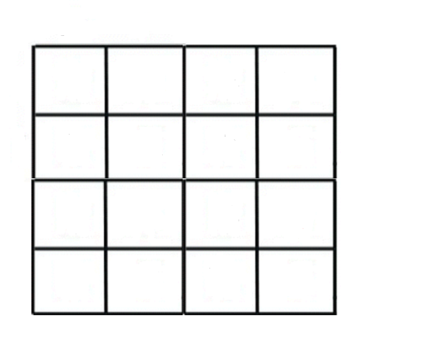

Genotypes:

Phenotypes:

You will need a separate sheet of paper for these problems.
- In fruit flies, the allele for normal size wings (H) is dominant over the allele for vestigial wings (h). The allele for normal size eyes (E) is dominant over the allele for small eyes (e). The genes for wing size and eye size are on different chromosomes. Predict the results of a cross between a heterozygous individual for both traits and an individual who is homozygous recessive for both traits. Complete a punnett square and determine the genotypic and phenotypic ratios.

- In racing horses, black hair (B) is dominant to chestnut hair (b) and a trotting gait (G) is dominant to a pacing gait (g). Cross two horses that are heterozygous for both traits. Complete a punnett square and determine the genotypic and phenotypic ratios.

- Starting with a P generation with the following genotypes (AABB x aabb). Based on classical Mendelian inheritance, what is the expected phenotypic ration observed among the F2 generation?
  - 9:3:3:1 b.1:2:1 c. 3:1 d. 1:1 e. 1:1:1:1

- If AaBb is crossed with aabb, what proportion of the offspring would be expected to be aabb?
  - 9/16 b. 2/16 c. 4/16 d. 1/16

- If the offspring of a cross show a 9:3:3:1 ration, the parents of the cross have the genotypes __.
  - AaBb x AaBb b. AaBb x aaBB c. aaBb x aabb d. aaBb x Aabb

Section D: Beyond Mendel – Patterns of Inheritance
Codominance –
- Crow’s (the black bird) feet can have orange markings or have brown markings. When a crow with orange (O) markings is mated with a crow with brown (B) markings, the resulting phenotype is both orange and brown spots on the feet. Cross an orange footed crow with a crow that has orange and brown spots on its feet. What are the genotypic and phenotypic ratios of the offspring?

- Why is the crow’s markings considered codominant inheritance?

- You are exploring the jungle and find a new species of plant. Some of the flowers are red and some are yellow. If the inheritance pattern is codominant, what would you expect the heterozygous phenotype to be?

Incomplete Dominance –
- Rats can have a variety of fur color. When a black (B) furred rat is crossed with a white (W) furred rat, the resulting phenotype is gray fur. Cross a gray furred rat with a black furred rat. What are the phenotypic ratios of the offspring?

- Why are the rat’s fur color considered incomplete dominance?

- If the red and yellow alleles in the mystery jungle plant above showed incomplete dominance, what would you expect the heterozygous phenotype to be?

Sex-Linked –
- In fruit flies, eye color is sex-linked. Red is dominant to white. Cross a white eyed female X ^{r} X ^{r} with a red-eyed male X ^{R} Y. What are the genotypes and phenotypes of the offspring?

- In humans, hemophilia is a recessive sex linked trait. Females can be normal, carriers, or have the disease. Males will either have the disease or not (but they won’t ever be carriers) Show the cross of a man who has hemophilia with a woman who is a carrier. What is the probability that their children will have the disease?
X^{H} X^{H}= female, normal
X^{H} X^{h}= female, carrier
X^{h}X^{h}= female, hemophilia
X^{H}Y= male, normal
X^{h}Y= male, hemophilia

- A woman who is a carrier marries a normal man. If they have a daughter, what are the possible phenotypes? If they have a son, what are the possible phenotypes?

- Coat color in cats is a codominant trait and is also located on the X chromosome. Cats can be black, yellow or calico. A calico cat has black and yellow splotches.
  - When a female calico cat is mated with a male black cat, what are the phenotypes of the offspring?

  - Where any of the offspring calico? ________ If so, what gender was it? ____________

- A girl inherited colorblindness, which is a sex-linked recessive trait. It is probable, therefore, that __.
  - Both parents had one colorblindness gene.
  - Only one parent had the colorblindness gene.
  - The gene in the mother guaranteed the girl having the disease.
  - The father did not have the recessive gene.

- A colorblind man marries a woman who is neither colorblind nor a carrier of the trait. Which statement best describes their probable offspring?
  - All the boys will be colorblind. c. All the girls will be carriers but not have the disease.
  - All the girls will be colorblind. d. Half the boys will carry the gene for colorblindness.

Multiple Alleles –
- In the ABO blood type system, the A and B are codominant and the o allele is recessive. A man with type AB blood marries a woman with type AB blood. If they have children, what are the possible phenotypes?
_______ A blood _______ B blood _______ AB blood _______ o blood

- A man with type AB blood is married to a woman with type o blood. They have two natural children and one adopted child. Jane has type A blood, Bobby has type B blood and Grace has type o blood. Which child was adopted? ____________

- A nurse at a hospital removed the wrist tags of three babies in the maternity ward. She needs to figure out which baby belongs to which parents, so she checks their blood types. Using the chart below, match the baby to its correct parents. Show the crosses to prove your choices.
Parents | Blood Types |  | Baby | Blood type
Mr. Frisbee | A
Mrs. Frisbee | B |  | Dominic | O
Mr. Zimmerman | O |  | Kristen | AB
Mrs. Zimmerman | O |  | Tommy | B
Mr. Law | AB
Mrs. Law | O

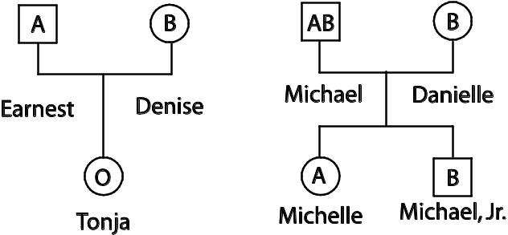
- Where the babies switched? Determine if Earnest and Denise’s baby girl was switched with Michael and Danielle’s baby girl. They following family tree shows the blood types for both families. Was a switch made at the hospital? ______

  - Is it possible for Michael and Danielle to have a child with type o? Explain.

- JERRY SPRINGER GENETICS: Wanda tells Jerry Springer that she thinks either Ralph or Fred could be the father of her baby. Wanda’s genotype is Ao. Wanda’s baby has type o blood. Ralph’s genotype is AB. Fred’s genotype is Bo. Who is the father? __________________ Make two crosses to show who could be the father of Wanda’s baby.

Ralph X Wanda Fred X Wanda
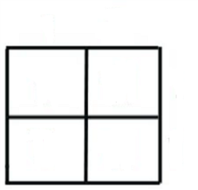
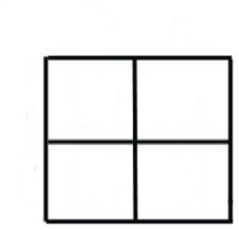

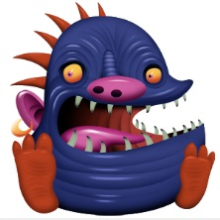
Polygenic Inheritance –
- In Snarlymonsters, the number of teeth is polygenic. The recessive condition (aabbcc) results in a toothless Snarlymonster, and the dominant condition (AABBCC) results in a Snarlymonster with 6 teeth. There are 5 other possible variations. How many teeth would a Snarlymonster with AaBbCc have?

Lethal Genes –
- In mice, the spinning behavior is caused by a dominant gene that affects the mouse's equilibrium. This gene is lethal if two alleles are present. Two "spinning mice" are mated together. Show the cross. What are the phenotypes of the offspring and in what proportion?

- On the “Websites-Genetics” page, click on the links and practice other patterns of inheritance crosses -- ‘Practice crosses’, ‘Practice problems’.

Section E: Pedigrees
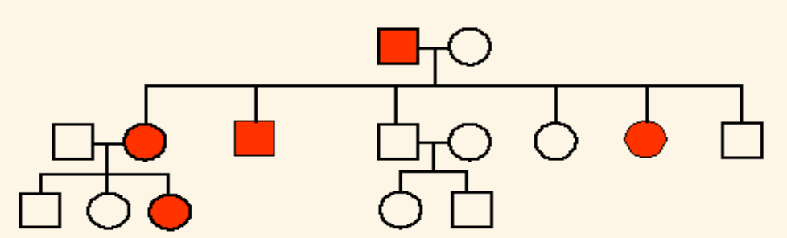
I
1 2
= Huntington’s
Disease

II 1 2 3 4 5 6 7 8

III
1 2 3 4 5

- There are no carriers for Huntington’s Disease- you either have it or you don’t. With this in mind, is Huntington’s disease caused by a dominant or recessive trait? ___________________
- How many girls did II-1 and II-2 have? ___________ How many have the disease? ____________
- If individual III-1 marries someone heterozygous for Huntington’s, then what’s the chance of having a child with Huntingtons?

- The pedigree to the right shows the passing on of colorblindness. What sex can ONLY be carriers of colorblindness? __________________________
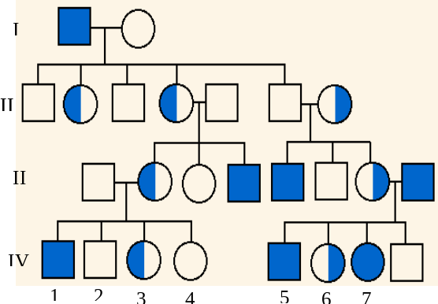
- With this in mind, what kind of trait is colorblindness? _____________________
- Is this trait recessive or dominant? ________________ How did you know? ____________________________ ____________________________________________
III.
- Why do all the daughters in generation II carry the colorblind gene? ______________________________ ____________________________________________
- If individual IV-1 marries a carrier for colorblindness, then what’s the chance they will have a daughter who is colorblind?

Interactive Pedigree: http://highered.mcgrawhill.com/sites/0072485949/student_view0/chapter3/interactive_activity.html

Quizzes:
http://www.sciencegeek.net/Biology/review/U4Genetics1.htm
http://www.sciencegeek.net/Biology/review/U4Genetics2.htm
http://www.sciencegeek.net/Biology/review/U4Review.htm

