Magnetic Fields Lab

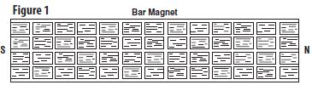
Introduction: A magnetic material is made of small regions called magnetic domains. These magnetic domains can be pictured as small bar magnets. When the domains are aligned, as shown in Figure 1, the magnetic fields of the domain add together. This causes the material to be surrounded by a magnetic field. The magnetic field surrounding a magnet exerts a magnetic force on other magnets and magnetic materials. The direction of the magnetic field around a magnet can be represented by magnetic field lines. Magnetic field lines always begin on the north pole of a magnet and end on the south pole. Magnetic field lines are closer together where the magnetic field is stronger, and farther apart where the field is weaker.

Questions:
- Where is the magnetic field the strongest? _______________________________________________
- Where do magnetic field lines start and stop? _____________________________________________
Objectives
- You will observe the effect of a magnetic field around a magnet.
- You will represent the shape of magnetic field lines by drawing an example.
- You will compare and contrast the magnetic field lines around a bar magnet and a horseshoe magnet.
- You will observe the interaction of two magnetic fields.
Materials
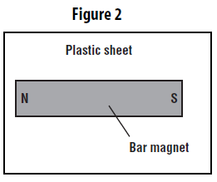
plastic sheet with iron filings, 2 bar magnets, small horseshoe magnet, white sheet of paper
Procedure
Part A—Magnetic Field of a Magnet
- Lay one bar magnet on the white sheet of paper on a flat surface parallel to the edge of the table. Place the plastic sheet over the magnet so that the magnet is centered as shown in Figure 2.
- Sketch the magnetic field lines around the bar magnet in Figure 3.
- Repeat steps 1 and 2 with the horseshoe magnet. Use Figure 4 below to sketch the magnetic field lines around the horseshoe magnet.
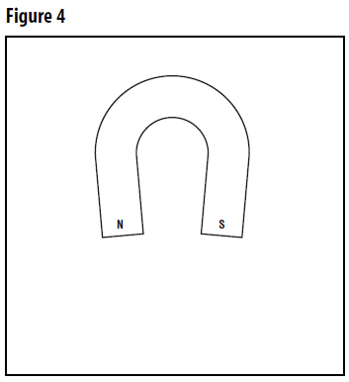
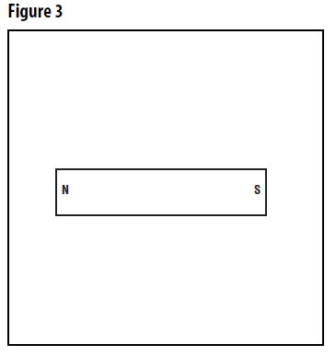

Part B—Interaction of Magnetic Fields
- Lay two bar magnets end to end on a flat surface as shown in Figure 5 below. Place the sheet of plastic over the magnets so that the magnets are centered as shown in Figure 5.
- Sketch the magnetic field lines around the two bar magnets in Figure 5.
- Repeat steps 1 and 2 for each position of the magnets shown in Figure 6 through Figure 8 seen below.
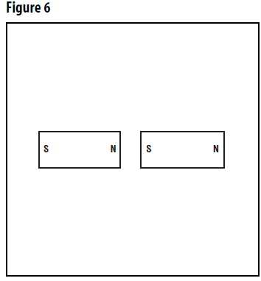
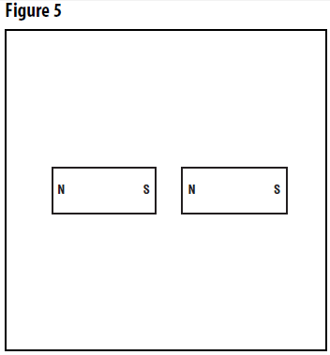
Questions:
- Where are the field lines the closest together? (at the poles or in the middle …where?)

- What does it mean when the field lines are close together?

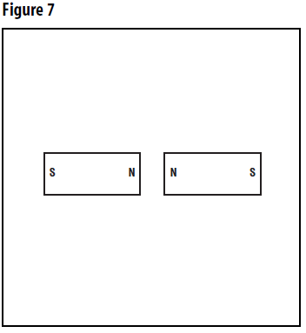
- Do the Crossword below.
