MUTATIONS
- What are mutations?

- Write the name of the chromosomal mutation underneath each chromosome in the left column.
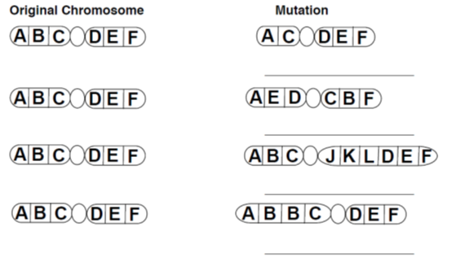
- Using the information above, indicate the mutation in the left column based on the description in the right column.
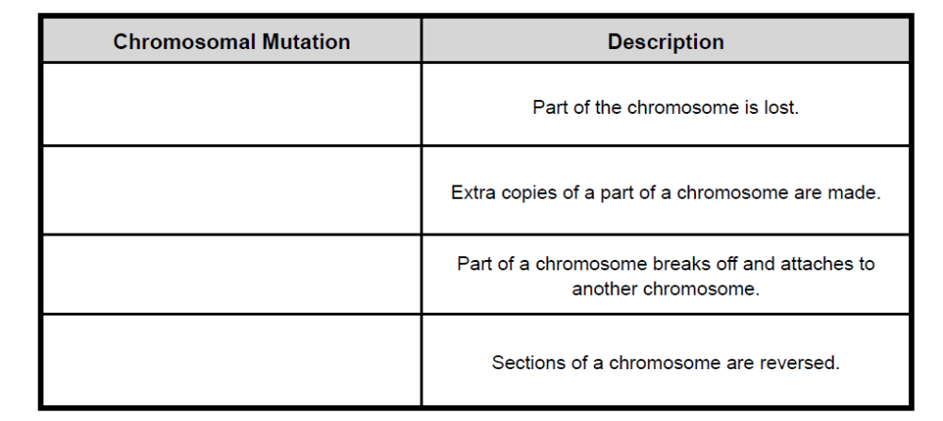
- Which types of chromosomal mutations can add genes to a chromosome?

- Which type of chromosomal mutation can take away genes from a chromosome?

- Which type of chromosomal mutation changes the order of the genes, but not the number of genes in a chromosome?

- What is polyploidy?

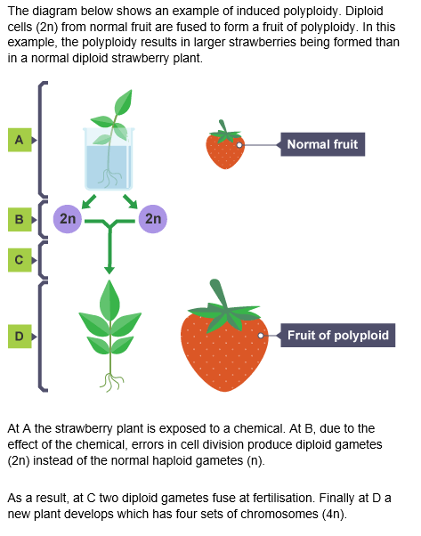
From: http://www.bbc.co.uk/education/guides/zc499j6/revision/4

