CHEMICAL BONDING

When atoms interact to form a ______________________, only the outer energy level electrons, the ___________________________, interact. ____________________________________ are used to keep track of the valence electrons.
A Chemical Bond is the ___________ that holds atoms together in a ____________________. It is formed in definite ways according to certain _______________.
PRACTICE: Draw the Electron Dot Diagrams for the following elements:

K Se Be Ga Ge P Ar

CHEMICAL STABILITY
It is the goal of every atom to have a ______________________________ energy level. Remember that full is ____________ electrons ____________ except for hydrogen and helium, which have __________. The atom gets a full energy level by _________________ or ____________________ electrons to form an octet. This is the most __________________ formation. The _____________________ of valence electrons determines whether an atom will ___________ with another element in a chemical reaction.
Noble gases are _________________________________. Their outer energy levels are __________. Every element wants the ___________ number of valence electrons as a noble gas and will _________ electrons or ____________ electrons to get it.

IONS: Ions are _____________________ particles that have more or fewer electrons than protons. _______________: positive ion (lost electrons); _______________: negative ion (gained electrons)

OXIDATION NUMBER: ___________________________________ number that indicates how many electrons an atom has gained, lost, or shared to become ____________. Is written as a ______________________ with a positive or negative sign.

Na⁺¹ means that sodium has p⁺ = ______ and nº = 12 but e⁻ = ______. It is a ________ charge because there is __________________ proton than there are electrons. Cl⁻¹ means that chlorine has p⁺ = ______ and nº = 18 but e⁻ = ______. It is a ________ charge because there is __________________ electron than there are protons. For sodium to be “happy”/stable, it wants to __________ an electron. In order for chlorine to be “happy”/stable, it wants to ____________ an electron.
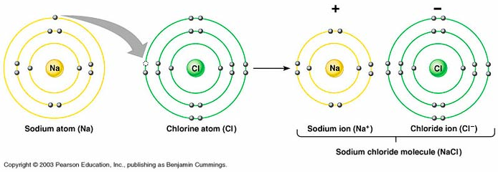

Look at the electron dot diagrams you did. Predict the ion formed for each below:
K ___ Se___ Be___ Ga___ Ge___ P___ Ar___

Write the correct ion for each below:
K ___ Se___ Be___ Ga___ Ge___ P___ Ar___

Write the number of valence electrons in each of the groups listed. Then write the ion formed.
Group 1 ve: _____ ion: _____ Group 15 ve: _____ ion: _____
Group 2 ve: _____ ion: _____ Group 16 ve: _____ ion: _____
Group 13 ve: _____ ion: _____ Group 17 ve: _____ ion: _____

Group 14 ve: _____ ion: _____ Group 18 ve: _____ ion: _____

IONIC BONDING

- involves a ____________________ of electrons from one atom to another
- is held together by _______________/electrostatic force (+/-)
- happens between ______________ ions and ______________ ions
- When the cation and the anion come together, there is _____________________________ .
- The basic rule is that opposites _______________. A _________________________ between oppositely charged ions (formed by the transfer of electrons) hold the ions together in an ionic bond.

CHARACTERISTICS
- ________ melting and boiling points
- tend to be ________________ in water.
- Solids are _______________ conductors of heat and electricity.
- When ____________________ in a liquid or melted, they become _______________ conductors of heat and electricity.
- Forms between elements on __________________ sides of the periodic table.

METALLIC BONDING

Metallic solids have only ____________________ in them.

Metals give up ____________________ easily.

A metallic bond is where the electrons in the outermost energy level overlap and form a ______________________________________________ (a sea of electrons).

The many electrons easily dislodged from a large group of metal ions _______________ ___________________ through the assembly of metal ions.

These electrons are called _________________________________.

This _____________ of electrons holds the positively charged metal ions together.

________________________ metals are the hardest and strongest metals because they have more electrons in this sea.
- It is the mobility of the electrons in metals that makes metals both _____________________ and ________________________. This also accounts for the metal’s high ________________ and ____________________________conductivities.

CHARACTERISTICS
- ___________________________ – the metal ions slide past each other, yet hold together.
- ___________________________ – free flowing electrons conduct heat and electricity well.
- _________________________________ – it takes a lot of energy to overcome this bond.

ALLOYS - solid solutions of metals; two metals _____________________ to each other.
- _____________________________ alloys – alloys where atoms of the original metal are ___________________ by metal atoms of a similar size. Examples: Sterling silver (silver/copper) and 10-karat gold (gold/copper or silver)
- _____________________________ alloys – small holes in the metal crystal are ________________________ atoms of a smaller size. Example: carbon steel (iron/carbon)

COVALENT BONDING

Atoms with ______________ electron affinities tend to ____________ electrons. There are not enough electrons for each individual atom to have a _________________. Neither atom wants to lose electrons; both want to _________ them. Usually forms between ____________________.
The positively charged nucleus of both atoms _________________ the negative electrons to be shared. Covalent bonds form a unit called a ____________________. A molecule is the ____________________ particle of a covalent bond that has all the _______________________ of that substance.

EXAMPLE: H₂ H : H H – H They share electrons and have a full outer energy level.

CHARACTERISTICS
- _________ melting points compared to ionic
- many exist as __________ or _________________ easily at room temperature
- relatively ________, _________________
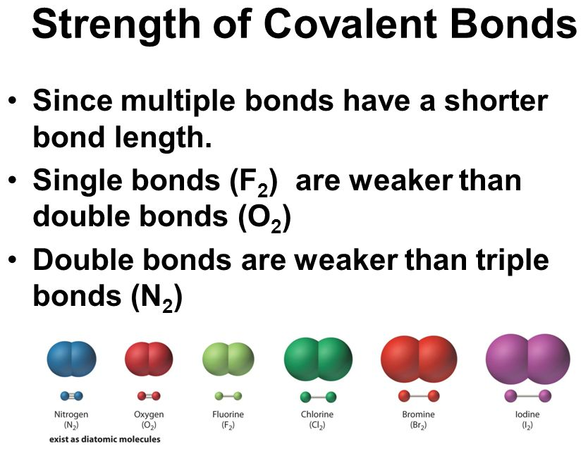
- _____________ conductors of electricity

TYPES OF COVALENT BONDS

_______________ - When a single pair of electrons is shared.

_______________ - When more than one pair of electrons are shared.

SHARING ELECTRONS – UNEQUALLY AND EQUALLY
Electrons are not always shared ___________________ between atoms in a covalent bond. The _________________ of the attraction of each atom is related to:
- _____________ of the atom
- _____________ of the nucleus
- _____________ number of electrons the atom contains.
An example of ________________ sharing is HCl. Chlorine has a ___________________ attraction for electrons than hydrogen does. As a result, the electrons will spend ___________ time surrounding the chlorine nucleus than they do the hydrogen nucleus. The chlorine atom is partially _______________ and the hydrogen atom is partially _________________. This is called a _____________ molecule – a molecule with a slightly positive end and a slightly negative end resulting in the electrons being _______________________________. Molecules where the electrons are shared ___________________ and do _______ have oppositely charged ends, like __________________________, are nonpolar molecules.
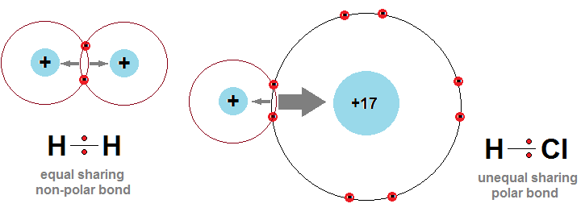

NOMENCLATURE – Naming Compounds and Writing Formulas

Three Goals:
- _________________ information given by a chemical formula
- Write _________________ for various compounds
- _______________ compounds given a formula

A chemical formula tells:
- what _____________ of atoms are present.
- the _______________ of each type of atom present.
- _______________ of one atom to another.

FIRST, you must determine which category it fits into: IONIC or MOLECULAR

IONIC NOMENCLATURE

- contains ______________ (+) and _______________ (-).
- includes _____________ and _____________________.
- _________________ ALWAYS go first in name and formula.
PRACTICE: Which symbol goes first in an ionic formula? Circle the correct one.

a. S and Cu c. N and Fe e. Ca and Cl

b. P and Bi d. C and Mg f. Al and Br

NAMING IONIC COMPOUNDS
- Write the name of the ______________ (metal) first.
- Write the name of the ______________ and change the ending to ____________.

PRACTICE

A. CaF₂
B. CaCl₂
C. MgBr₂
D. BeO
E. BeS
F. B₂S₃
G. NaF
H. K₂O

POLYATOMIC IONS
- An ion made up of ___________________ one atom: NO₃⁻¹, SO₄⁻², C₂H₃O₂⁻¹;
- The charges given to polyatomic ions apply to the ____________________ of atoms in the ion.
- _________________ change the subscripts of a polyatomic ion.
- If more than one ion is needed in the formula, a _____________________ is placed around the ion and the subscript is written _______________; Example: Al(OH)₃
- Polyatomic Ions you might run into:

Acetate, C₂H₃O₂⁻¹
Ammonium, NH₄⁺¹
Bicarbonate, HCO₃⁻¹
Carbonate, CO₃⁻²
Hydroxide, OH⁻¹
Nitrate, NO₃⁻¹
Phosphate, PO₄⁻³
Sulfate, SO₄⁻²

PRACTICE – Writing names
1. Ca(OH)₂
2. Na₂SO₄
3. KC₂H₃O₂
4. NH₄NO₃
5. Mg(HCO₃)₂
6. Al₂(CO₃)₃
- Al(NO₃)₃
- AlPO₄

WRITING SIMPLE IONIC FORMULAS
- Write the charge for the element ___________ the name. You determine the ______________ by looking at your periodic table or the list of ions in your notes.
- Write the ______________ for the cation, followed by the symbol for the anion.
_____________________ Ions
- An ion with only __________ atom: Mg⁺², Na⁺¹, O⁻².
- Most of the charges can be determined by the atom’s ______________ on the periodic table.
- ___________________ the numbers only (not the signs), writing the oxidation number as a _________________ for the other. Do not write the number ________. __________________ the charges by placing the subscripts. Net charges must be __________.
- Make sure the formula is in its __________________ form. Mg₂O₂ is reduced to MgO, but MgCl₂ _______________ be reduced.
- Check your work by calculating the _________ positive and negative charges and confirming that the total _____________ on the compound is ____________. MgO - Mg: +2 x 1 and O: -2 x 1 = +2 and -2 which is zero.

PRACTICE

- lithium fluoride
- lithium chloride
- barium bromide
- barium oxide
- aluminum iodide
- aluminum nitride

MULTIPLE OXIDATION NUMBERS
Some cations (positive ions) can have ________________________ charge. Most are _____________ elements. Lead and tin are ____________________. It is important to distinguish which ________ is in the compound.

Cu⁺¹ copper (I)
Cu⁺² copper (II)
Fe⁺² iron(II)
Fe⁺³ iron(III)
Sn⁺² tin(II)
Sn⁺⁴ tin (IV)
Pb⁺² lead(II)
Pb⁺⁴ lead (IV)

WRITING THE FORMULAS FOR THESE TYPES
- Write the name of the cation (metal)
- Write the name of the anion ending in “ide”.
- Just remember that the charge for the cation is in the ______________.
Examples: copper (II) sulfate, ____________ iron (II) oxide, ____________

PRACTICE

- Copper(I) fluoride

- Copper(II) oxide
- Chromium(III) bromide
- Manganese(II) iodide
- Lead(II) chloride
- Cobalt(III) sulfide

NAMING MORE COMPLEX IONIC COMPOUNDS
- Write the name of the _____________ (metal), then the name of the ______________.
- If the cation (metal) has ___________________________ charge, designate the correct charge with the ________________________ using the ________________ as a guide to determine the charge.
Example: Fe(OH)₂ _____________________ Fe(OH)₃________________________

PRACTICE – Writing names

- FeO
- Fe₂O₃
- CuCl₂
- CuCl
- PbF₄
- SnCl₂

PRACTICE – Writing formulas

- Potassium hydrogen carbonate

- Iron(II) hydroxide
- Iron(III) nitrate
- Beryllium carbonate
- Sodium acetate
- Potassium sulfate

MOLECULAR COMPOUNDS
(another word for covalent molecules)

- usually _______________; called a ___________________
- usually contains two ____________________; solid, liquid or gas
- sometimes contains a ________________ and a nonmetal

NAMING MOLECULAR COMPOUNDS
- Use _________________ to identify the number of atoms present.
- If only one of the first nonmetal atom, then _____________ prefix is used.
- Last element ends in __________.

PREFIXES
- - ________ 4 - ________ 7 - ________ 10 - ________
- - ________ 5 - ________ 8 - ________
- - ________ 6 - ________ 9 - ________

Examples:
CO₂ PCl₃
N₂O P₂O₃

PRACTICE:

- NCl₃

- CS₂

- Si₂Br₆
- S₄N₄

- SF₆

- N₂O₅

WRITING MOLECULAR COMPOUNDS
- Write the symbol of the _____________ element adding a _____________________ of the number of atoms present. If only one of the first atom (nonmetal), then ________ number is used.
- Write the symbol of the ______________ element adding a _____________________ of the number of atoms present.

PRACTICE

- boron trifluoride
- silicon tetrachloride
- iodine heptafluoride
- tetraphosphorus decoxide
- chlorine trifluoride
- sulfur dichloride

HYDRATES

- A _____________________ compound in which its __________ are attached to one or more ____________________ molecules.
- Hydrates are _______________ with water molecules _________________ in them.
- The “•” means that waters are _______________________.

- Written as:
(the number of waters)
XY • XH₂O
(ionic formula)
CuSO₄ • 5H₂O
copper (II) sulfate pentahydrate

Use the same prefixes as with covalent compounds:

mono – 1 tetra - 4 hepta -7 deca - 10
di - 2 penta – 5 octa - 8
tri - 3 hexa – 6 nona -9

Practice (Name the following):
Na₂PO₄ • 2H₂O

SrCl₂ • 6H₂O

Ba(OH)₂ • 8H₂O

