Photosynthesis Worksheet Name___________________

Section A: Adenosine Triphosphate
Adenosine triphosphate (ATP) is the energy molecule used by all cells to do work. It is a nucleotide consisting of adenine, ribose and 3 phosphate groups. ATP is able to store and transport chemical energy within cells. The LAST TWO phosphate groups (PO4) are joined by HIGH-ENERGY bonds. When these bonds are broken, energy is released for cells to use and ADP forms. Enzymes help to break and reform these high-energy bonds.

- What does ATP stand for? _______________________________
- What is the function of ATP? _________________________________________________________
- What three things make up an ATP molecule? ____________________________________
- How many high-energy bonds does ATP contain?__________________
- Where are these high-energy bonds found in ATP? _______________________________________
- What helps weaken these high-energy bonds so energy can be released and then later help reform them? ______________________
ATP molecule
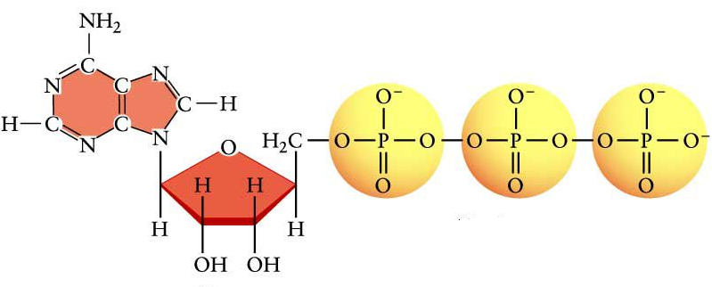
- When ATP loses a phosphate group ______________ is released for cells and a molecule of _________ forms.
- Label the ribose, N-base and the phosphates in the diagram.

Section B: Phosphorylation
http://www.youtube.com/watch?v=bbtqF9q_pFw
- Watch the video clip and explain how the cycle between ATP and ADP. ______________________ ________________________________________________________________________________ ________________________________________________________________________________
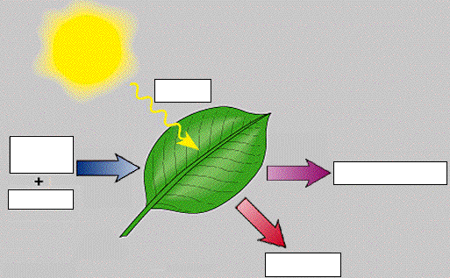
Section C: Intro to Photosynthesis
On the “Website-Cells” page…click on “Intro to Photosynthesis”. Go through all concepts and answer the questions below.
- What is photosynthesis? _____________________________ _____________________________ _____________________________
- Fill in the diagram.
- Which part of the spectrum drives photosynthesis? _______________ _____________________________
- Which color of light is most effective for photosynthesis? _______________________
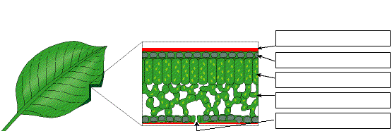
- Label the leaf structure diagram.
  - How does CO₂ get into and the O₂ get out of the leaf? __________
  - Which structure is a waxy layer that prevents the loss of water? ___________

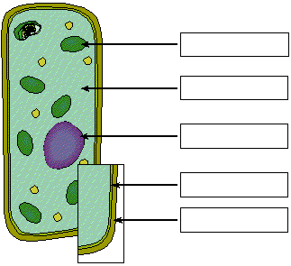
- Label the plant cell. What organelle would you expect to find in great abundance in a leaf cell (Mesophyll)? _________________
- Label the chloroplast.
  - What are the membrane disc-sacs called? _________________________________
  - What is the fluid called? _________________
  - A stack of thylakoid is called a _______________.

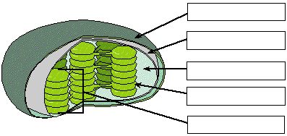

- Where is chlorophyll located within the chloroplast? ____________________
- Within the chloroplast, where does the light-dependent reaction take place? ___________________
- What occurs in the light-dependent reaction? ____________________________________________ ________________________________________________________________________________
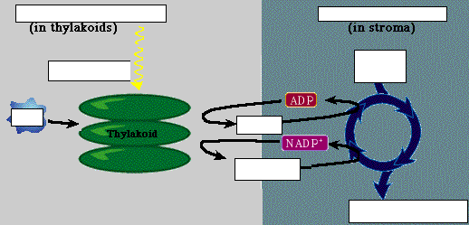
- Within the chloroplast, where does the Calvin Cycle (light-independent reaction) take place? __________________
- What occurs in the Calvin Cycle (light-independent reaction)? __________________________ __________________________ __________________________ __________________________
- Fill in the diagram.

Section D: Separation of Plant Pigments Using Chromatography
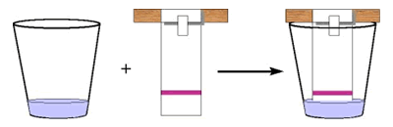
Paper chromatography is a useful technique in the separation and identification of different plant pigments. The solvent, isopropanol, is absorbed by the paper and moves up by capillary action. As the solvent crosses the area containing plant pigment extract, the pigments dissolve in and move with the solvent. Paper Chromatography is useful for identifying unknown compounds – often used in CSI to match ink, lipstick or colored fibers.
Procedure:
- Cut a strip of coffee filter. Place a spinach leaf about half an inch from the bottom and roll a penny over it so that you get green pigment on the filter. Repeat until the line is fairly dark.
- Put about a ½ inch of isopropanol in a cup.
- Set the cup aside. The isopropanol will move up the filter paper slowly and separate the pigments.

- What pigments did you extract? ______________________________________________
Section E: Leaf Stomata
- Get a leaf. Use the clear nail polish and paint a small section on the underside of the leaf. Allow the nail polish to dry completely.
- Tape a piece of clear tape to the dried, painted area on the leaf. Gently pull the tape up and place on a slide.
- Scan the slide to see the leaf impression. Locate the stomata. Each stoma is bordered by guard cells that open and close the stomata. When water concentration is high, the guard cells bulge and cause the stomata to open. When the water concentration is low, the stoma will close.
- Sketch and label….the stoma, guard cells, epidermal cells

Section F: Concept Check
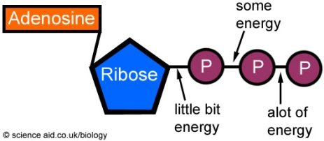
- What provides the energy used by all life on Earth? ____________
- In a molecule of ATP, where are the bonds broken to release energy? __________________________________________
- What is the formula for photosynthesis? __________________________________________________
- Define photosynthesis. _________________________________ _____________________________________________________
- What pigment absorbs light in a chloroplast? _______________________________
- What organelle is the site of photosynthesis? _______________________
- Where is chlorophyll located within a chloroplast? __________________
- Label the thylakoid membranes and the stroma in the chloroplast.
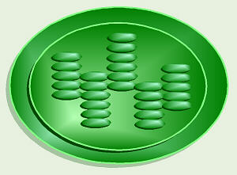
CHLOROPLAST
- What are the reactants of photosynthesis? _______________________________________________
- What are the products of photosynthesis? _______________________________________________
- What are the molecules that absorb light? __________________
- What is the function of accessory pigments such as carotenoids? ____________________________________________________
- What organisms do photosynthesis? ______________________
- Bacteria do not have chloroplast, yet some can still do photosynthesis. How is this possible? ______________________ _____________________________________________________
- In the diagram, what gas is being released by the plant? _________________
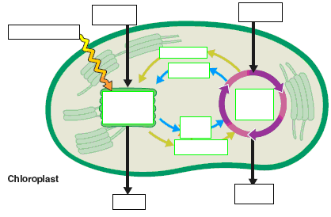
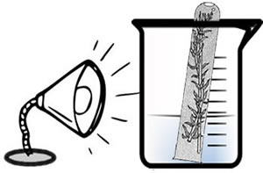

- Fill in the reactants and products of photosynthesis.

Section G: Light-Dependent & Light-Independent Reactions
- What is the energy source for the light-dependent reaction? ____________________________
- What happens in the light-dependent reaction? _________________________________________ _______________________________________________________________________________
- What is the location of the light-dependent reaction?___________________________
- Where does the O₂ released in the light-dependent reaction come from? ______________________
- What are the products of the light dependent reaction?_____________________________________
- What is photolysis? ___________________________________________________________
- What is the energy source for the light-independent reaction? _______________________________
- What are the reactants of the light independent reaction?__________________________________
- What is the location of the light-independent reaction?____________________________
- Arrange the pathway electrons take in photosynthesis. (1 is the start & 3 is the end)
____ photosystem I ____calvin cycle ____photosystem II
- How is the light independent reaction different from the light dependent reactions? ________________________________________________________________________________

Matching - Identify which reactions these events occur in. PSII, PSI or Calvin Cycle
- ____________NADPH is made
- ____________ATP is made
- ____________photolysis occurs
- ____________oxygen is released
- ____________glucose is made
- ____________carbon fixation occurs
- ____________NADPH and ATP are the energy source

Section H: Photosynthesis Animation
On the “Websites-Cells” page…..click on “Photosynthesis Animation”. Watch the animation and do the two exercises. This is a great review.

More Animations:
http://www.sumanasinc.com/webcontent/animations/content/harvestinglight.html
http://www.science.smith.edu/departments/Biology/Bio231/calvin.htm
http://sites.sinauer.com/cooper5e/animation0305.html
http://www.wiley.com/college/boyer/0470003790/animations/photosynthesis/photosynthesis.htm

Quizzes:
http://www.neok12.com/Photosynthesis.htm
http://www.sciencegeek.net/Biology/review/U2Photosynthesis.htm
http://edhsgreensea.net/Biology/taters/photosynthesis_mc.htm

Section I: Waterweed Simulation
On the “Websites-Cells” page….click on “Waterweed Simulation”. You will be looking at the production of O₂ as a plant photosynthesizes. O₂ is measured in the number of bubbles produced by the plant.

- Effect of Light Color on Photosynthesis – Set the simulator to 6.0 light level & 6.0 CO₂ level. Based on the data, what color of light results in the fastest rate of photosynthesis? __________________
- Effect of Light Level on Photosynthesis - Set the simulator to colorless light and 6.0 CO₂ level. Based on the data, what light level results in the fastest rate of photosynthesis? ____________________
- Effect of CO2 Level on Photosynthesis – Set the simulator to colorless light and 6.0 light level. Based on the data, what CO2 level results in the fastest rate of photosynthesis? ___________________
- Explain the purpose of this simulation. _________________________________________________ ________________________________________________________________________________

