Name _______________________________________ Period _____ Date ____________________
TEST #5 - CHEMICAL BONDING
TEST REVIEW
Objectives:
- State the main reason why chemical bonding occurs.
- Describe chemical stability.
- Describe ionic bonds and what happens to the electrons.
- Describe metallic bonds and what happens to the electrons.
- Describe covalent bonds and what happens to the electrons.
- Compare and contrast ionic and covalent bonds.
- Distinguish between a nonpolar molecule and a polar molecule.
- Know the vocabulary words.

Review:
- What is chemical stability and what does it have to do with chemical bonding?

- Fill in the table below:
Bond Type | IONIC | METALLIC | COVALENT
Generally formed between what types of elements?
Share or Transfer Electrons?
Conduct Electricity?
High or Low Melting Point?
Compound’s Phase of Matter (generally)?

- Complete the Venn diagram below concerning ionic and covalent bonding. List at least two items in each box.
JUST IONIC BONDING | BOTH IONIC AND COVALENT BONDING | JUST COVALENT BONDING

- Describe a polar and nonpolar molecule in terms of the electrons and charge difference.

- Identify the type of bond happening between the two elements at ionic, covalent, or metallic.

- _______________________ B. ______________________ C. ________________________
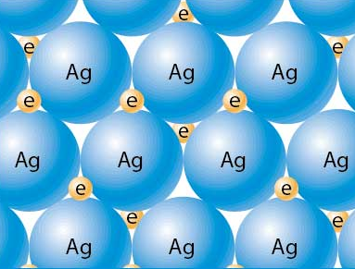
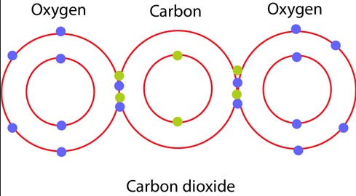
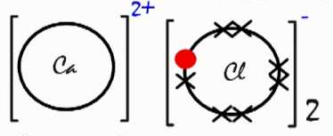

- Fill in the following sentences with the correct terms. The terms are in the box below.
The smallest unit of a compound is a ________________________________. In a water molecule, oxygen and hydrogen atoms _________________________ electrons. This type of bond is called a(n) _______________________________ bond. Molecules of elements that exist as two atoms of the same element joined by this type of bond are called _______________________ molecules. A covalently bonded compound has a _________ melting point and is a _______________ conductor of electricity.
Anion
Cation
Covalent
Diatomic
Good
Good
High
High
Ionic
Low
Metallic
Molecule
Negative
Poor
Poor
Positive
Sea of electrons
Share
Shared
Transferred

When sodium reacts with chlorine, an electron is _________________________________. This type of bond is called a(n) ________________________ bond. During the reaction between sodium and chlorine, the sodium atom becomes a __________________ ion and the chlorine atom becomes a _____________________________ ion. A positive ion is called a(n) ________________________ and a negative ion is called a(n) _________________________. An ionically bonded compound has a ________________ melting point and is a ______________ conductor of electricity when dissolved in water but a __________________conductor as a solid.
When silver is bonded to silver, the valence electrons are _________________________ and this is called a(n) ______________________ bond. The electrons are part of a _______________________________________ that move electrons between all the metal ions. A metallically bonded compound has a _____________ melting point and is a ____________ conductor of electricity as a solid and a liquid.

