Name ________________________________ Period _____ Date ______________________

REVIEW FOR TEST #9 - SOLUTIONS

OBJECTIVES
- Differentiate between colloids, solutions, and suspensions
- Define solvent and solute and be able to identify them in a solution.
- Describe the process of dissolving, dissociation, and ionization.
- Describe the conductivity of solutions in terms of ions, ionization, electrolyte, and nonelectrolyte.
- Be sure to study polarity of compounds to be able to predict solubility.
- Be able to distinguish between a concentrated solution and a dilute solution.
- Be able to calculate percentage by volume.
- Differentiate between saturated, unsaturated, and supersaturated.
- State and discuss the factors affecting the rate of solubility.
- State and discuss the factors that affect solubility.
- Be able to read a solubility curve graph.
- Know the chapter vocabulary words.

REVIEW QUESTIONS
Write T for true or F for false. If the statement is false, replace the underlined word or phrase with one that will make the statement true, and write your correction on the blank provided.

________________________ 1. Most solutions consist of a gas dissolved in a liquid.

________________________ 2. Water is the most common solvent.

________________________ 3. The solubility of a substance can be changed by altering the temperature.
________________________ 4. In terms of physical states of matter, there are three possible combination of solvent-solute pairs.
________________________ 5. Dissolving does not occur in the case of a polar solvent and a nonpolar solute.
________________________ 6. Solid solutions composed of metals are usually called alloys.

________________________ 7. When particles of a mixture are evenly distributed throughout, the mixture is heterogeneous.
________________________ 8. In a solution of sugar and water, water is the solvent.

________________________ 9. In a solution of sugar and water, sugar is the solvent.

________________________ 10. You can increase the solubility of a gas by increasing the temperature.
________________________ 11. Grinding a solute into smaller particles increases its surface area.

Fill in the missing parts of the table below.
 | SOLUTIONS | COLLOIDS | SUSPENSIONS
Particle Size | 12. |  | >1000 nm
Effect of Gravity | 13. | stable,  will not settle out
Effect of Light | no effect, light passes through | 14.
Filtration | 15. |  | particles can be filtered out

16. Describe the Tyndall Effect.

Classify each of the following mixtures as homogeneous or heterogeneous:

______________________ 17. lemonade with pulp
______________________ 18. coffee with cream and sugar
______________________ 19. Vinegar
______________________ 20. dessert gelatin with pears in it
21. Compare suspensions, colloids, and solutions in terms of particle size and methods to separate each type of mixture.

- Use the terms: Solutes, Polar solvents, water, oil, and nonpolar to complete
can be either
can be either
Contain
Contain
Solutions

Solvents
Polar

Polar
Nonpolar

Nonpolar solvents

such as

such as
dissolved in
dissolved in

- Explain the phrase "like dissolves like" and give an example.

- Explain the dissolving process when a polar solute dissolves in a polar solvent.

- What type of molecule will dissolve in a nonpolar solvent? ___________________
- Explain the dissolving process when a nonpolar solute dissolves in a polar solvent.

- Solution A has 25g of Kool-Aid® dissolved in water and Solution B has 75g dissolved in the same amount of water. Indicate which one is concentrated and which one is dilute and how you know.

- You are making a water solution with 10mL of the black cherry Mio® and 190mL of water. What is the concentration in percentage by volume of the solution you made? Show your work.

- Fill in the blanks below using the words in the Word Bank to the right. Some words can be used more than once.
Word Bank
Covalent
Dissociation
Dissolves
Electricity
Electrolytes
Ionic
Ions
Nonelectrolyte
Polar
If you have a solution that conducts _____________________, it contains ____________________. The electrolytes are __________, which are charged particles. The charged particles come from ____________ compounds that go through _____________________ when they are dissolved in water. Ionic compounds dissolve in water because they are _____________ compounds. Water is also a ______________ compound. So “like ________________ like”. If a _____________________ compound is dissolved in water, it will not break into ___________, will not conduct ___________________, and will be considered a ________________________.

- Describe three ways to speed up the dissolving of sugar in your tea or coffee.

- If you increase the temperature of your Coca Cola®, one part (sugar) will dissolve better while another part (carbon dioxide gas) will dissolve worse. Explain how you know this.

- What is solubility?

- In general, how does temperature affect solubility?

- Using a solution of sugar and water, explain what a saturated solution, unsaturated solution, and a supersaturated solution is.

Use the solubility graph to the right to answer the remaining questions.
- Which compound is least soluble at 10ºC?
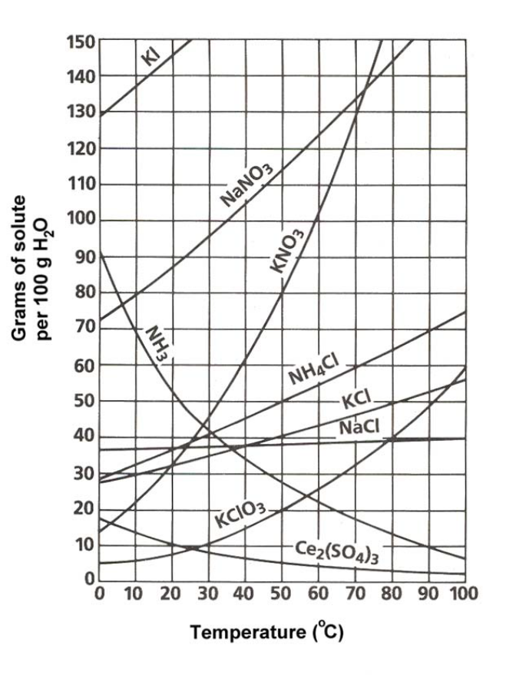

- How many grams of KCl can be dissolved in 100 g of water at 80ºC?

- How many grams of NaCl can be dissolved in 100 g of water at 90ºC?

- At 40ºC, how much KNO₃ can be dissolved in 100 g of water?

- Which compound shows the least amount of change in solubility from 0ºC to 100ºC?

- At 30ºC, 90 g of NaNO₃ is dissolved in 100 g of water. Is the solution saturated, supersaturated, or unsaturated?

- At 60ºC, 72 g of NH₄Cl is dissolved in 100 g of water. Is the solution saturated, supersaturated, or unsaturated?

- Which compounds shows a decrease in solubility from 0ºC to 100ºC?

- Which compound is most soluble at 10ºC?

- Which compound (besides Ce₂(SO₄)₃) is least soluble at 50ºC?

- If 120 g of KCl is placed in 100 g of water at 80ºC, how much will dissolve? How much will remain undissolved?

