Name___________________________________ Period ______ Date ___________________

THERMAL ENERGY REVIEW

Objectives
- Explain the difference between heat and temperature.
- Know the units for temperature and what is used to measure it.
- Know the units for heat/thermal energy and what is used to measure it.
- Define thermal energy.
- Know how thermal energy and temperature are related.
- Know the direction that heat flows.
- Compare and contrast thermal energy transfer by conduction, convection, and radiation.
- Compare and contrast insulators and conductors.
- Explain how insulation affects the transfer of energy.
- Explain the meaning of specific heat.
- Be able to calculate changes in thermal energy.

Review Practice
Answer the following.
  - When a substance is heated, do the molecules move faster or slower?___________________
  - As molecules move faster, does the temperature move up or down? ___________________
  - What is the unit for heat? __________________________
  - What is the metric unit for temperature? ___________________________
  - If you have a large block and a small block, which has more thermal energy? Explain why.

  - Which type(s) of heat transfer do NOT require matter? _____________________________
  - Which type(s) of heat transfer DO require matter? _________________________________
  - Explain HOW heat conduction works if you pour a hot cup of hot chocolate into a cold cup. What happens to the cup and HOW does it happen?

  - List a good conductor of heat. __________________________________
  - List a poor conductor of heat ____________________________________
  - Give an example of heat transfer by radiation. ____________________________________
  - Give an example of heat transfer by convection. ___________________________________
  - Give an example of heat transfer by conduction. ___________________________________
Choose the best answer and place it in the blank to the left.

_____ 14. When an object is cooled, its particles
- Lose kinetic energy
- Speed up
- Gain kinetic energy
- Lose electrons
_____ 15. Kinetic energy is the same as
- Chemical energy
- Motion energy
- Potential energy
- Electrical energy
_____ 16. Temperature is a measure of
- Average kinetic energy
- Heat
- Total calories
- Average potential energy
_____ 17. The amount of heat needed to raise the temperature of one gram of a substance on degree Celsius is called
- Kinetic energy
- Random motion
- Specific heat
- Temperature
_____ 18. The substance that takes more heat to raise its temperature than almost any substance is
- Lead
- Water
- Gas
- Carbon
______ 19. When most objects are heated, they
- Expand
- Shrink
- Solidify
- Gain molecules
_____ 20. The transfer of thermal energy by collisions between touching particles is called
- Radiation
- Conduction
- Convection
- Evaporation
_____ 21. If the temperature is low, what does that mean for kinetic energy?
- Low kinetic energy
- High kinetic energy
- No effect on kinetic energy
- All of the above
_____ 22. When one end of an iron poker is put into the edge of a fire the other end of the poker gets hot due to what form of heat transfer?
- convection
- magnetism
- radiation
- conduction

Fill in the blanks with words from the box.
conduction | convection |  | dense | Earth
energy | kinetic |  | liquids | radiation
rise | temperature |  | thermometer | vibrating
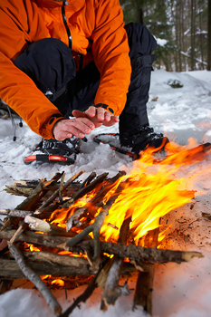  Keeping warm by the fire. |  | Heat is a form of _________________ that moves from hot things to cold things. In other words, heat is energy that flows from objects with a high _________________ to objects with a low temperature. Temperature is the average _________________ energy of the particles in an object and is measured using a _________________.  Heat can move from object to object in three ways. One way that heat flows is called _________________, which occurs when two objects are touching. In conduction, the particles in the high temperature object are _________________ quickly compared to the low temperature object. When the particles in the high temperature object bump into the particles in the low temperature object, the low temperature object’s particles begin to vibrate more quickly.
Another form of heat transfer is _________________, which occurs in _________________ and gases. In convection, the part of the liquid or gas with high temperature is less_________________ than the part with low temperature so the high temperature parts _________________ and the low temperature parts sink.
In both conduction and convection, heat is transferred through a material. However, heat energy can also travel through empty space in a third way called _________________, which is how heat travels from the sun to the _________________.

Identify the method of heat transfer that takes place in each illustration.
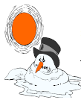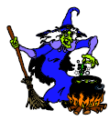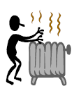
23. Snowman melting 24. Newt boiling in a 25. Warming hands
in the sun hot caldron over a radiator

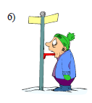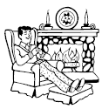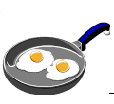
26. Tongue frozen to a 27. Warmth from the fireplace 28. Frying cooking in a
cold metal pole. circulating throughout the hot fry pan.
house.

Calculate the following showing what you know, where you are going, the formula, plug in the numbers with units and calculate the correct answer with units.

Q = mΔTC_{p}

27. How much energy is needed to raise the temperature of 10.0g of aluminum from 22°C to 55°C if the specific heat of aluminum is 0.90J/g°C?

28. How much heat is needed to raise the temperature of a piece of granite with a mass of 55g from 20°C to 37°C if the specific heat of granite is 0.79 J/g°C?

29. THIS IS TRICKY – You can do it! A 16g piece of iron absorbs 1090J of heat energy and its temperature changes from 25°C to 175°C. Calculate the specific heat of iron

