Name _____________________________________ Period _____ Date _________________
WAVES
TEST REVIEW

Objectives
- Know the 15 vocabulary words.
- Recognize that waves carry energy but not matter.
- Define mechanical waves.
- Define and recognize transverse and compressional (longitudinal) waves.
- Compare and contrast transverse and compressional (longitudinal) waves.
- Know the parts of a transverse and a compressional (longitudinal) wave.
- Define wavelength and frequency and know the units for each.
- Describe the relationship between wavelength and frequency.
- Explain how a wave’s amplitude is related to the wave’s energy.
- Calculate a wave’s speed, frequency, and/or wavelength
- Identify the Law of Reflection and know the parts of the diagram explaining it.
- Recognize what makes waves bend.
- Define refraction and diffraction and be able to give examples.
- Explain how waves combine, be able to give examples, and draw the waves before and after.

Review Questions
_____ 1. An example of a wave that can be transmitted through a vacuum is
- Light c. both light and sound
- Sound d. neither light nor sound
_____ 2. A wave in which particles of the medium move at right angles to the direction of the wave is called a
- Standing wave c. reflected wave
- Longitudinal wave d. transverse wave
_____ 3. The number of complete wave cycles per unit time is called
- Frequency c. amplitude
- Wavelength d. speed
_____ 4. Frequency times wavelength always equals
- 1 c. amplitude
- 1/speed d. speed
_____ 5. The apparent breaking in two of a pencil that is placed diagonally partway into water is caused by
- Reflection c. interference
- Refraction d. diffraction
_____ 6. You can hear a sound that is produced out of sight around a corner of a building because
- Reflection c. interference
- Refraction d. diffraction
_____ 7. The maximum displacement of molecules in a medium from their rest position is called
- Frequency c. rarefaction
- Incidence d. amplitude
_____ 8. In the lab, you could not see the penny until after you added the water. What properties of waves was this due to?
- Reflection c. interference
- Refraction d. diffraction
_____ 9. What is the name of the incoming wave before it is reflected back on a flat surface?
- Reflected wave c. incident wave
- Outgoing ray d. standing wave
_____ 10. The type of waves that always require matter in order for the wave energy to travel are called
- Standing wave c. reflected wave
- Longitudinal wave d. transverse wave
_____ 11. The high point of a transverse wave is called a
- Rarefaction c. crest
- Compression d. trough
_____ 12. The less dense region of a compressional wave is called
- Rarefaction c. crest
- Compression d. trough
_____ 13. The matter waves travel through is called a
- Medium c. mechanical wave
- Standing wave d. node
_____ 14. A collision between which of the following does not result in constructive interference?
- Two rarefactions c. two compressions
- A crest and a wave peak d. a crest and a trough

Complete the concept map using the terms below.

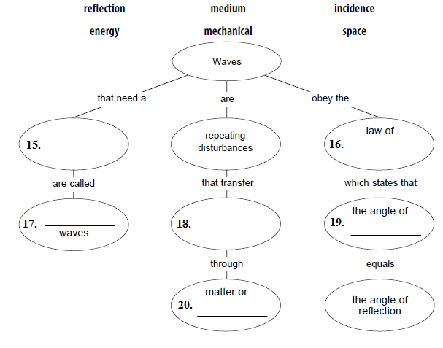

The illustration below represents the law of reflection. Copy the letters from the illustration next to the term they stand for.
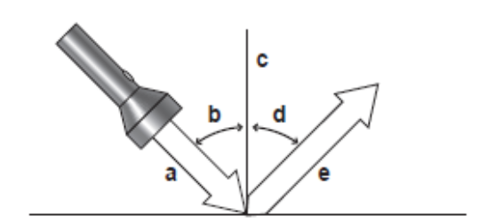
_____ 21. Normal
_____ 22. Angle of reflection
_____ 23. Reflected beam
_____ 24. Incident beam
_____ 25. Angle of incidence
26. Study each part in the diagram to the right and then identify each part by filling in the blanks below.
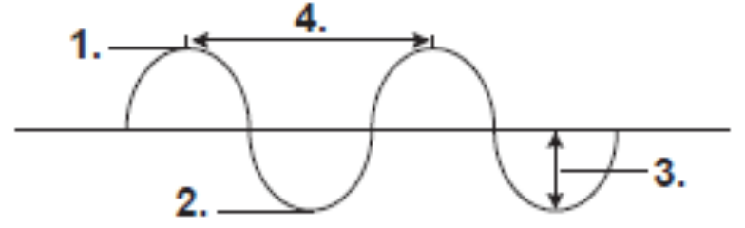

- __________________________
- __________________________
- __________________________
- __________________________
Type of wave: ____________________
27. Study each part in the diagram to the right and then identify each part by filling in the blanks below.
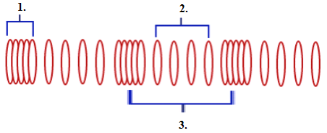

1. ________________________________
2. ________________________________
3. ________________________________
Type of Wave ____________________________

28. Calculate the following writing what you know, the formula, plugging in the numbers with units and writing the correct answer with units.
a. What is the speed of a wave with a frequency of 760Hz and a wavelength of 0.45m?

b. A wave with a wavelength of 15m travels 330m/s. Calculate its frequency.

29. What is the relationship between wavelength and frequency? Write a complete sentence!

30. Sketch a diagram showing what happens when a wave that is traveling through air enters water and slows down. Label the normal, the angle of incidence, the angle of refraction, the incident ray and the refracted ray.

31. In the drawing to the right, draw the wave in B that is a result of the interference between the two waves in A. List the type of interference in the blank below.
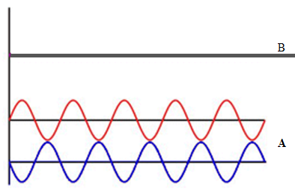

_________________________________

32. Match the wave characteristic definition and unit to the wave characteristic in the middle using the letters provided.

- hertz, Hz _____ Amplitude _____ Q. measures how many wavelengths pass a fixed point each second
- meters, m _____ Wavelength _____ R. distance between on point on a wave and the nearest point just like it on the following wave
- meters, m _____ Frequency _____ S. a measure of the energy carried by a wave.

33. A water strider is sitting on top of the water. Answer the following questions:



- In “A”, the wave is approaching from the right. What is taveling along the wave?

- Does the water strider get carried by the wave?

