Name _____________________________________ Period _____ Date ________________

Sneaky Static

Materials: Scotch tape, pen/pencil

Procedure:
- Pull four segments of scotch tape of 5 cm each. Stick them on the edge of a table. As shown in Figure 1. Fold back 1cm on each segment to make a handle. Label them A, B, C, and D with your pen/pencil.
- Stick the sticky side of A against the unsticky side of B together. Then pull them apart. When you move them close to each other again, what do you observe about the force between them?
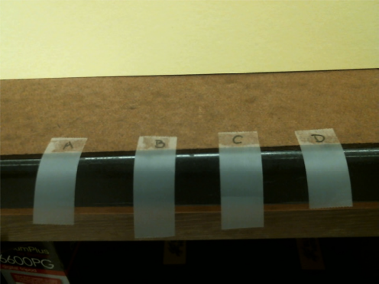
Figure 1

- Stick A and B on the edge of the table, using 1cm of the remaining sticky part near the handle. About 2 cm of each segment should suspend over the edge of the table and remain untouched.
- Repeat steps 2 and 3 with C and D. What do you observe about the force between them?

- Now pull A and C off the table. Move them close to each other. What do you observe about the force between them?

- Put C back down and pick up D. Move A and D close to each other. What do you observe about the force between them?

- Put A back down and pick up B. Before you move B and D close to each other, what is your prediction about the force between them? What is the actual result?
Prediction: Actual result:

- Static electricity can be sneaky in everyday life. List three household phenomena that involve static electricity.

