Name _____________________________________ Period _____ Date _________________

SOLUBILITY CURVES AND SOLUTIONS

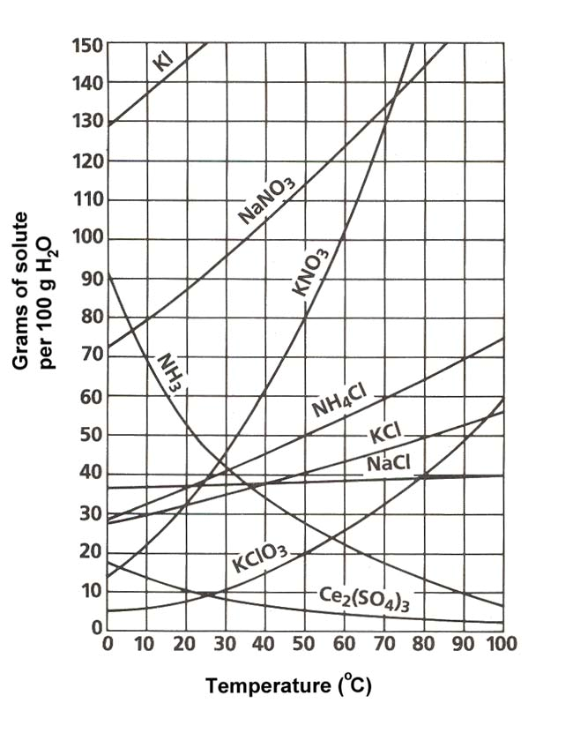
- Define solubility:

Use the solubility curve to the right to answer questions #2 - #15. Be sure to note the units on the axes of the graph.
- In general, how does temperature affect solubility?

- Which compound is least soluble at 10°C?

- How many grams of KCl can be dissolved in 100g of water at 80°C?

- How many grams of NaCl can be dissolved in 100g of water at 90°C?

- At 40°C, how much KNO₃ can be dissolved in 100g of water?

- Which compound shows the least amount of change in solubility from 0°C-100°C?

- At 30°C, 90g of NaNO₃ is dissolved in 100g of water. Is this solution saturated or unsaturated?

- At 60 C, 72 g of NH₄Cl are dissolved in 100g of water. This solution is considered to be:
- saturated b. unsaturated c. supersaturated

- Which compounds show a decrease in solubility from 0°C-100°C?
- KClO₃ c. NaNO₃ e. . Both B and D
- Ce₂(SO₄)₃ d. NH₃

- Which compound is the most soluble at 10°C?
a. Ce₂(SO₄)₃ c. KCl e. NH₃
b. NaCl d. KClO₃

- What is the difference between a solute and solvent?

- Classify each of the following as a heterogeneous mixture or a homogeneous mixture.
- restaurant Caesar salad

- tap water

- muddy water

- What are the 3 different types of mixtures? Define each one.

- How is a solution different from the other two types of mixtures?

- What is considered to be the “universal solvent?

- Not all solutions are solids dissolved in liquids. Provide 2 examples of other types of solutions.

- List the 3 factors that affect the rate of dissolving

