Name ___________________________________ Period _____ Date ___________________

SWITCHED AT BIRTH!
DNA FINGERPRINTING

Although a rare occurrence, cases of babies switched at birth in a hospital have made the news in the past. Since an individual’s DNA sequence is unique, with the exception of identical twins, DNA fingerprinting is a reliable method used to determine parents of a given baby. DNA fingerprints can be derived from restriction fragment-length polymorphism analysis or using polymerase chain reaction with variable number tandem repeats. IN this activity, you will analyze the results of a DNA fingerprint conducted on three babies and three sets of parents to determine which baby belongs to which parent.

Challenge: Compare the bands of each set of parents to each of the babies and determine which baby belongs to which set of parents. Line up the bands and illustrate which bands each baby inherited from its mother and its father.

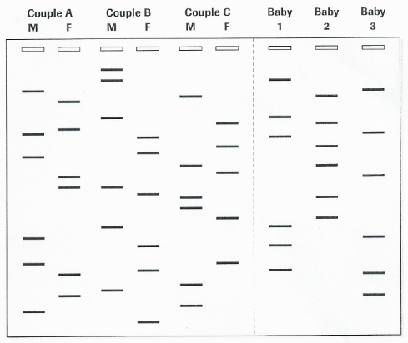
Figure 1. DNA Fingerprinting obtained from three
sets of infants and three sets of parents.

Analysis and Synthesis
- Identify which baby belongs to which parents.

Baby 1: _______ Baby 2: _______ Baby 3: _______

- Explain why all the bands in the mother’s or father’s profile do not have a counterpart in the baby’s DNA profile.

- List at least two other examples where DNA fingerprinting could be used to identify an individual.

- Identify the largest DNA fragment on the gel. Label it on the front side with an “L”. Identify the smallest DNA fragment on the gel. Label it on the front side with an “S”.

- Blood typing is a method to tell what specific type of blood you have. What type you have depends on whether or not there are certain proteins, called antigens, on your red blood cells. Blood is often grouped according to the ABO blood typing system. This method breaks blood types down into four types: A, B, AB, and O. Your blood type depends on the types that are been passed down to you from your parents. Explain why blood typing may not be a viable method of determining which baby belongs to which parent.

