Name _____________________________________ Period _____ Date _________________

THE EAR

All the sounds around you would be meaningless if you were not able to hear. The sense of hearing involves the ears and the brain. In fact, you actually hear with your brain! Your ears just pass on the vibrations from the air to your brain.
On the diagram below, label the parts of the ear listed. Note that the ear is divided into three sections: outer ear, middle ear, and inner ear.

Anvil
Auditory nerve
Auricle
Cochlea
Ear canal
Ear drum
Hammer
Semicircular canals
Stirrup

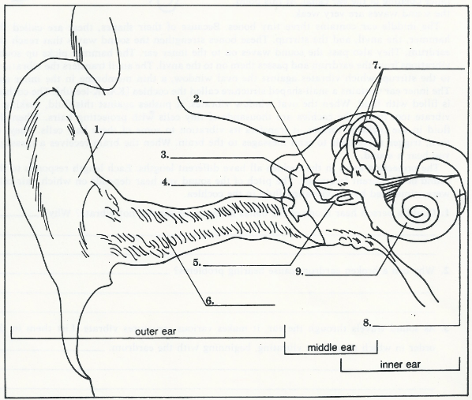

NOW HEAR THIS!

Your outer ear sticks out from the side of your head. It consists of two flaps are cartilage covered with skin. Although it does not look very impressive, it has a job to do. Humans are able to distinguish between some 400,000 intensities, frequencies, and qualities of sound. We can do this because of structures and cells that are specialized to an amazing degree.
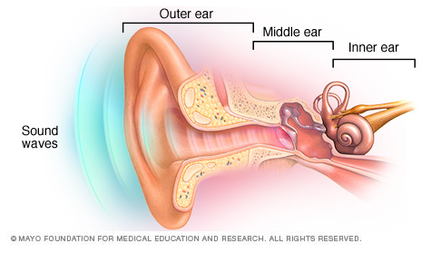
The outer ear receives sound wave and passed them along to the middle ear. The sound waves travel along the ear canal to the ear drum, a membrane stretched across the inner opening of the ear canal. At this point, the sound waves are very weak.
The middle ear consists of three tiny bones. Because of their shapes, these are called the hammer, anvil, and stirrup. These bones strengthen the sound waves that reach the eardrum. They also pass the sound waves on to the inner ear. The hammer picks up sound vibrations from the eardrum and passes them to the anvil. The anvil transfers the vibrations to the stirrup, which vibrates across the oval window, a thin membrane in the inner ear. The inner ear contains a snail shaped structure called the cochlea. The cochlea is filled with fluid. When the oval window vibrates, it pushes against this fluid, making it vibrate too. Inside the cochlea are thousands of tiny cells with projecting hairs. When the fluid in the cochlea vibrates, it transfers its vibration to some of these hair cells. They, in turn, trigger nerve cells to send messages to the brain. When the brain receives a message, you hear a sound.
The projecting hairs in the cochlea all have different lengths. Each length responds to the sound of a different frequency. The pitch of the sound you hear depends on which hair cells were stimulated by the vibrating fluid in the cochlea.
- Could a person hear if one of the bones in the middle ear did not vibrate? Explain.

- Why can a punctured ear drum cause haring problems?

- As sound travels through air, it makes various structures vibrate. List them in the order in which they begin to vibrate, beginning with the eardrum.

