Name _______________________________________ Period _____ Date _______________

COMMON ASSESSMENT
UNIT ONE REVIEW

- Know what motion is and that it is measured by distance and time.
- Know how to calculate speed, velocity, acceleration and their units.
Speed = $\frac{distance}{time}$ velocity = speed in a given direction
Acceleration = $\frac{change in velocity}{change in time}$ = $\frac{final velocity-initial velocity}{final time-initial time}$
- Be able to identify the distance-time graphs for the following:
  - Constant speed c. average speed
  - Acceleration d. deceleration
- Define and explain force.
- Define balanced forces and unbalanced forces. Know the motion involved.
- State Newton’s First Law and be able to identify examples.
- Define Inertia and know the relationship between mass and inertia.
- State Newton’s Second Law and be able to identify examples.
- Be able to solve problems with F = ma.
- Know the unit for force.
- State Newton’s Third law and be able to identify examples.
- Define Friction and know how it affects motion.
- Define weight and be able to calculate it using F_{w} = ma where ‘a’ is 9.8m/s²
- Describe Kinetic and Potential energy and distinguish between them.
- Know the unit for energy.
- State examples of objects with kinetic energy and potential energy.
- Know the definition of work, the unit for work, and how to calculate it.
- Know the two forces involved with simple machines: Effort Force, F_{e}, and Resistance Force, F_{r}.
- Define mechanical advantage and be able to calculate for all the simple machines both with distance and force.
- Compare and contrast thermal energy transfer by conduction, convection, and radiation.
- Be able to calculate changes in thermal energy using specific heat, Q = mΔTC_{p}

MOTION
- A train is travelling 200m/s. Twenty second later, the train is traveling 300m/s. What is the acceleration of the train?

- What is the speed of a car traveling east at 100 meters in 50 seconds?

- What is the velocity of the car in problem 2?

Using the graphs and figures below, answer the questions concerning speed and acceleration.
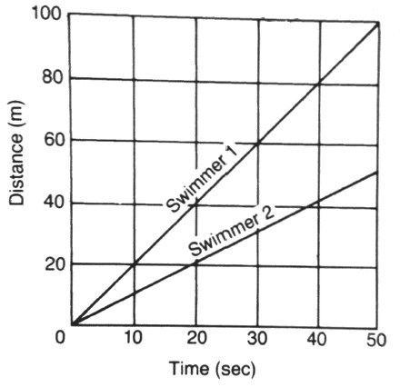
- How many meters can Swimmer 1 cover in 30 seconds?

- How far will Swimmer 2 go in 30 seconds?
- Predict the number of meters that Swimmer 2 can go in 60 seconds.

- Which swimmer has the greater speed?

- Is the graph showing constant speed or changing speed?

FORCES
9. Does the picture at the left show balanced forces or unbalanced forces. How do you know?
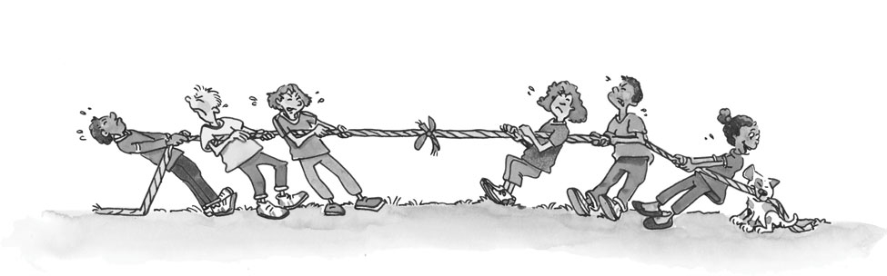
Newton’s Law # Situation
_________ 10. Faster peddling accelerates a bicycle more than slower peddling.
_________ 11. A moving car coasts for long distances.
_________ 12. An airplane moves in an opposite direction to the blast of its jet.
_________ 13. A rock stays in one place unless it is moved.
_________ 14. More force is needed to accelerate a large mass car than a small mass car.
_________ 15. Boat moved forward as the paddles move backward.
_____ 16. Newton’s First Law of Motion describes
  - Why forces act in pairs
  - All aspects of an object’s motion
  - Motion when a balanced force acts on an object.
  - Motion when an unbalanced force acts on an object
_____ 17. A force
  - Is a push or pull c. can cause an object to change its motion
  - Gives energy to an object d. can do all of the above

18. What force is required to accelerate a 15kg object at 20m/s².

19. What is the force/weight of a 50kg object that is accelerating due to gravity?

_____ 20. Sandpaper is harder to pull out from under a mass than wood as a result of
- Inertia b. pressure c. weight d. friction
- Resistance to a change in motion is _______________________________.

ENERGY, WORK, POWER
Classify the following as a type of potential energy or kinetic energy (use the letters KE or PE).

- A bicyclist pedaling up a hill _____
- An archer with his bow drawn_____
- A baseball thrown to second base_____
- The chemical bonds in sugar_____

- You find that 30N is needed to move a chair. You move the chair 8 meters. How much work do you do?

- A 500N skydiver jumps from an altitude of 3000m. How much work does she do?

SIMPLE MACHINES
_____ 25. The mechanical advantage of a machine is the number of times it
  - Multiplies the resistance force.
  - Multiplies the effort force.
  - Changes the direction of the effort force.
  - Changes the direction of the resistance force.
- A force of 11 N is applied to the handle of a screwdriver being used to pry off the lid of a paint can. The screwdriver applies a 22N force on the lid. What is the MA of the screwdriver?

- A 20-N force applied to the handle of a door produces an output force. If the mechanical advantage is 2.2, what is the output or resistance force?

28. What is the MA of the ramp in the figure to the right?
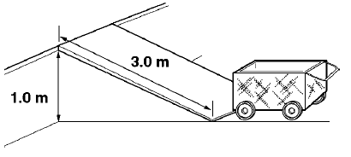

3.1m

THERMAL ENERGY
Conduction CD, Convection CV, or Radiation RD?
29. Hot coffee is stirred with a spoon; the spoon gets hot due to _______________.
30. A chair is placed several feet from a fire in a fireplace. The fireplace has a glass screen. The side of the chair facing the fireplace gets warm because of_______________.
31. A certain type of decorative lamp contains colored liquids. These liquids form globs that break off and rise to the top of the liquid. The globs rise due to _______________.
32. Near the ceiling of a room the air is warmer. The warm air rises because of ______________.
33. A college student holds the back of his hand near an iron to see if it is hot. Heat is transferred to his hand by _______________.
34. A heater is placed under one corner of a water bed mattress. Warm water moves throughout the mattress because of _______________.
35. Calculate the energy change in a copper rod that has a mass of 75g and is heated from 25°C to 100°C. The specific heat of copper is 0.385 J/g °C. Q = mΔTC_{p}

