Name
MID TERM STUDY GUIDE - UNIT ONE
EARTH SYSTEMS

SES1. Students will investigate the composition and formation of Earth systems, including the Earth’s relationship to the solar system.
A
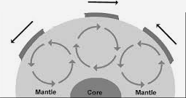
- ____________________ drives plate tectonics.
  - What type of heat circulation is happening in the Figure A to the right?

  - Where does the heat inside the Earth come from?

  - Understand the difference between conduction and convection.
    - ___________________________- the transfer of energy through fluids in which heat rises
and cool material sinks
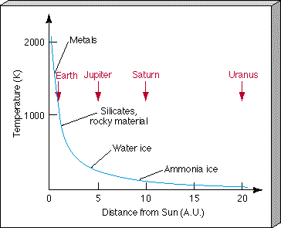
    - ___________________________— the passage of energy, by direct contact
B
- _____________________________ planets are less than (< ) 2 AUs from the Sun.
  - Formed from materials with high condensation temperatures such as ________________, silicates, and __________________ materials
- _____________________ planets are greater than (>)3 AUs from the Sun and are formed from ____________________________.
  - Their average density is ____________ than terrestrial worlds due to composition.
  - Composed of various types of ice
- Use Figure B – explains how temperature of solar nebula influenced planet formation.
  - According to the chart, planets that form at a distance of less than 2.5 AUs from the Sun would most likely be composed of ________________________________________.
  - Planets that form at a distance of 10 AUs from the Sun would most likely be composed of ____________________

SES1b: Explain how the composition of the Earth’s crust, mantle and core is determined and compare it to that of other solar system objects.
C
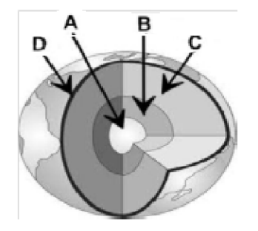
- Look at Figure C: The Earth’s layers include: ______ Inner core, ______ outer core, _____ mantle, and _____ crust
- Scientists have learned about Earth’s composition by:
  - Using ___________________________________ - recordings of seismic waves show waves travel through layers at different speeds.
  - Earth’s ___________________________________ is evidence for its spinning, liquid metal outer core.
- _________________________________– composition similar to Earth – three types of meteorites ________________ the density of Earth’s three layers.
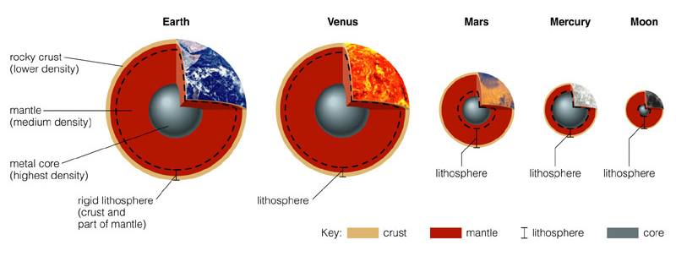
D DdD
- There are ____________ terrestrial planets in our solar system. Look at Figure D.
  - Name them:

  - Which one is most like Earth?

SES1c: Describe how the decay of radioactive isotopes is used to determine the age of rocks, Earth, and solar system.
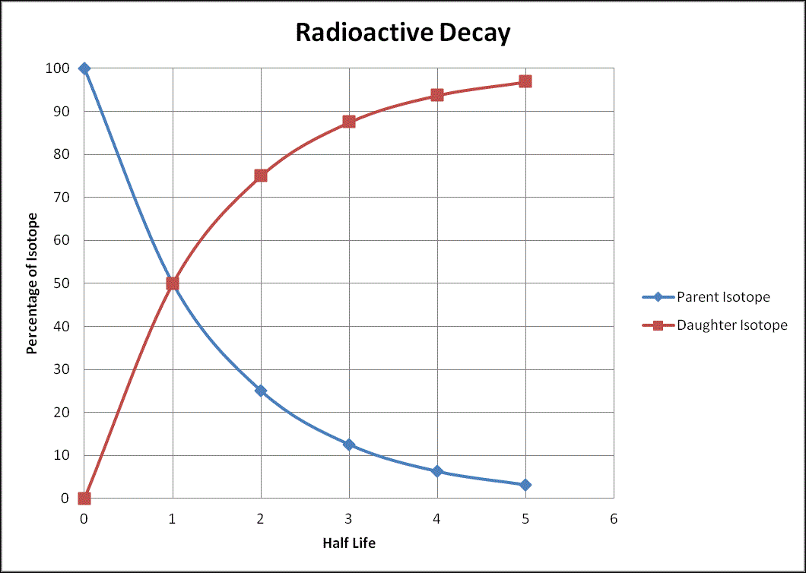
E
- Radioactive decay occurs when the nucleus of an atom is _________________________ and it ___________________________ releasing energy.
- Using the half-life graph (Figure E), answer the following:
    - Sample A is found to have 25% parent and 75% daughter. How many half-lives have gone by?
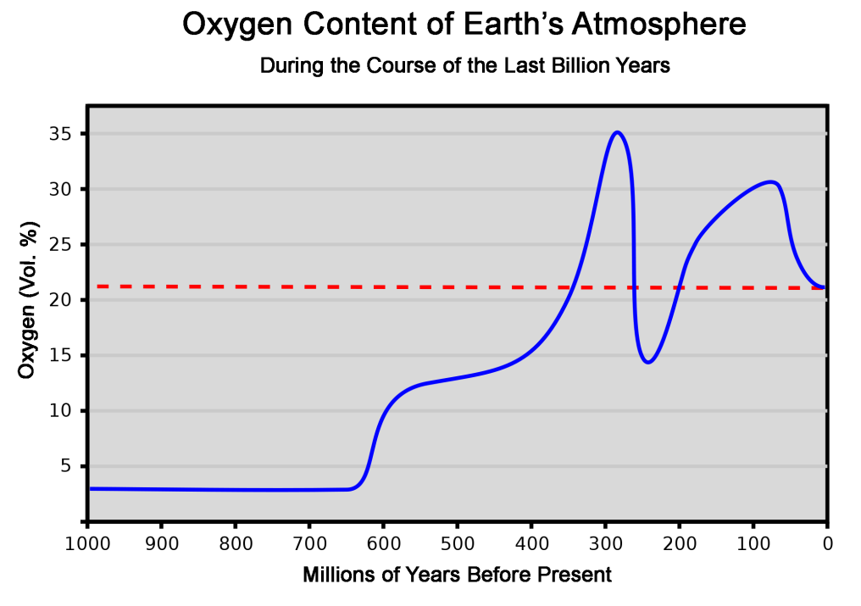
    - At three half-lives, what is the percentage of parent and daughter isotopes?

- Know what percent of a parent / daughter isotope is present for each half life. One ½ life: _____% Parent / _____% Daughter
F
Four ½ lives: _____% Parent / _____% Daughter
SES1d: Describe how the Earth acquired its initial oceans and atmosphere.
- Second atmosphere – _________ from out gassing from ___________________________________________
- Third atmosphere: __________________________________ responsible for buildup of free ________________ (O₂) in Earth’s atmosphere. Now look at Figure F.
  - Increased photosynthesis indicates increased ________________ life.
  - O₂ levels _______________________ as life forms utilizing O₂ _________________________.
- Early fresh water oceans became salty as water carried ________________________ to the deltas and then the oceans.

SCSh8: Students will understand important features of the process of scientific inquiry.
- There are three types of variables in scientific inquiry
- _____________________________ Variable- Variables that are held constant in order to determine the relationship between two other variables
- _____________________________ Variable- the variable in an experiment that is measured
- _____________________________ Variable- the variable in an experiment that changes
- Answer questions about the experiment based on the information in the chart below (Figure G)
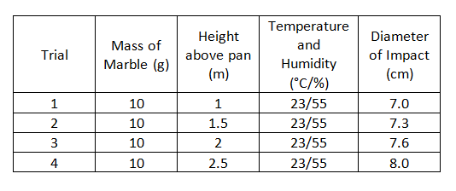
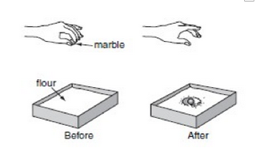

G

- The mass of the marble is the _________________________________ variable.
- The height above the pan is the _______________________________ variable.
- The diameter of the impact is the ______________________________ variable.
- Before reaching any conclusions about the results of this simple experiment, the student repeats the activity several times. Why?

