MID TERM STUDY GUIDE - UNITS TWO and THREE
Name
EARTH SYSTEMS

SES1e: Rock Cycle (Identify the transformations and major reservoirs that make up the rock cycle)
- ____________________________ Rock ______
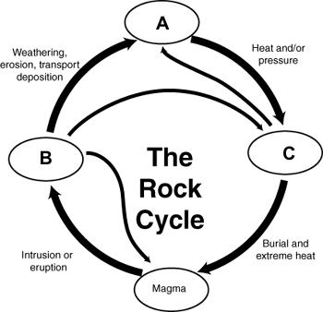
  - Formed by the cooling and hardening of magma or any type of rock.
  - ______________________ – formed above ground.
  - ______________________ – formed below ground.
- ____________________________ Rock ______
  - Occurs when rock is weathered, eroded, transported and cementation occurs.
  - Formed when sediment is deposited and becomes tightly compacted.
  - Fossils found in this type of rock.
  - Can be ________________, _______________________ or ________________________
- ____________________________ Rock ______
  - Formed when igneous, sedimentary, or other metamorphic rocks undergo a physical and/or chemical change due to extreme heat and pressure.
- Large crystals in rocks indicate formations under _________________________ pressure and temperature and a ____________ cool rate.
- Can be ____________________ or _____________________________.

SES2. Students will understand how plate tectonics creates certain geologic features, materials, and hazards. SES2. a. Plate tectonics: convergent, divergent, transform boundaries
- __________________________ Boundary (Figure H)
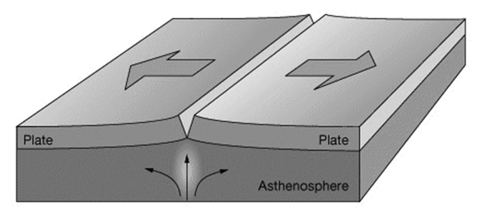
  - Plates are pulling away from each other
H
  - ____________________________ force – new crust forms.
  - ______________________ stress associated with this boundary.
  - Landforms associated with this boundary:
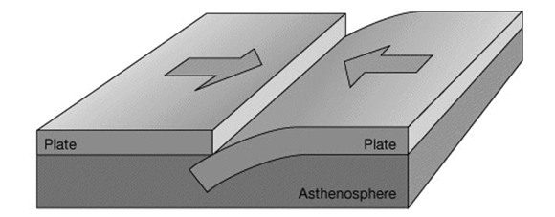
I
- __________________________ Boundary (Figure I)
  - Crust Interactions:
    - Ocean-Continental crust - Oceanic crust subducts under a continental crust.
    - Ocean-ocean crust – one _______________________ under the other.
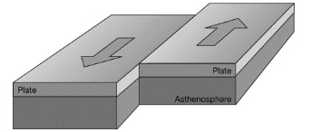
    - Continental-continental crust collide to form _______________________.
  - Landforms associated with this boundary:
J

- _________________________ Boundary Figure J)
  - Two plates ________________ along each other in opposing directions
  - Landform associated with this boundary:

- Identify the four types of mountains in the (Figure K)
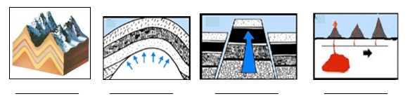
K

SES2b. Relate modern and ancient geologic features to each kind of plate tectonic setting.
- The shape and appearance of mountains are clues to their __________.
  - Appalachian Mountains
    - ______________________ and _____________________________ peaks indicate great age.
    - They formed around 480 million years ago, when ancient plates collided.
  - Rocky Mountains
    - ____________________________ peaks indicate fairly young mountains.
    - Formed between 55-80 million years ago, at divergent boundary.
  - Himalayan Mountains
    - ____________________________ mountain range on planet—still forming.
    - Result of collision of Eurasian Plate and Indo-Australian Plate.

SES2. d. Tectonic settings with production of rocks and mineral resources
- Earth's major ore deposits occur at _____________________________ boundaries.
L
- ___________________________________ most often occurs along a convergent boundary.
- Using figure L, pay attention to the arrows indicating the movement of the plates.
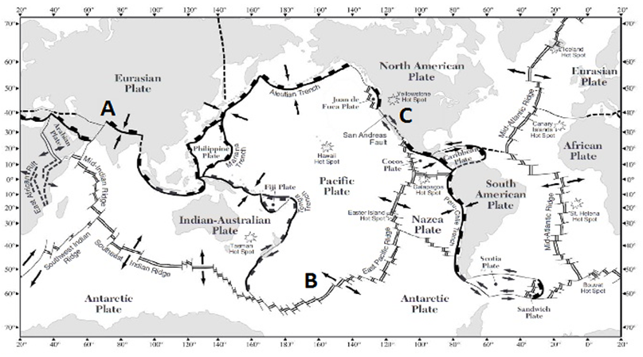
- Convergent Boundaries
  - Most likely place to find gold and __________________ minerals.
- The boundary marked _____ is an example of this type of boundary.
- Divergent Boundaries
  - Most likely place to find sulfur and __________________ minerals.
- The boundary marked _____ is an example of this type of boundary.
- Transform Boundaries
- The boundary marked _____ is an example of this type of boundary.
  - San Andreas Fault in California is an example.

SES2. Students will understand how plate tectonics creates certain geologic features, materials, and hazards. c. Relate certain geologic hazards to specific plate tectonic settings (earthquakes).
M
- Understand the features associated with the structure of a volcano (Figure M) and identify them. Letters will be different on the test.
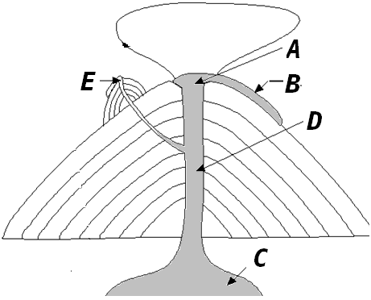

- Magma Dome ______ c. side vent _____ e. lava flow _____
- Crater _____ d. conduit / pipe _____
- __________________ are large depressions formed by the collapse of a volcanic cone
- Most common gases in magma are __________ vapor and _____________________.
- Use the Figure N to answer the following:
  - List the rocks in order from farthest from volcano to closest to volcano:
  - List the rocks in order from hottest to coldest:
N
