MID TERM STUDY GUIDE - UNITS THREE and FOUR
Name
EARTH SYSTEMS

SES2. Students will understand how plate tectonics creates certain geologic features, materials, and hazards. c. Relate certain geologic hazards to specific plate tectonic settings. (earthquakes)
O
- Using Figure O, identify the location of each type of wave.
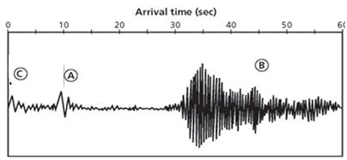
Primary Wave _____ Secondary Wave ______ Surface Waves ________
  - Primary Waves (P Waves)- primary or compression waves. They are the __________________ and ____________________ waves of an earthquake to be detected. They move in a back and forth motion parallel to the waves and can move through ______________________ ____________________ and ________________.
- Secondary Waves (S Waves)- secondary or shear wave. They are the _______________________ fastest of the waves of an earthquake to be detected. They cause rock particles to move in a side-to-side direction perpendicular to the direction the wave is traveling. These travel ONLY through ______________________.
- Surface waves—seismic waves that travel along the surface of a medium and arrive __________________ the P and S waves. Surface waves are the MOST ___________________________.
- Love Waves--Side-to-side - not vertical. Ground twists; Rayleigh Waves-Rolling motion
- A ___________________________ is a gigantic succession of ocean waves formed after a ____________________ eruption, submarine ______________________ or ____________________________—not a tidal wave.
- _________________________________________: the measure of earthquake strength based on the size of the area of the fault that moves, the average distance that the fault block moves, and the rigidity of the rocks in the fault zone is
  - The Moment Magnitude scale increases by ______ for every increase in level.
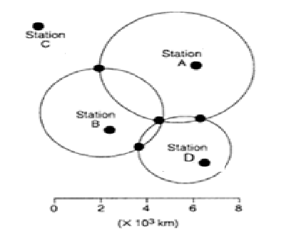
P
In Figure P, which station will most likely feel the earthquake first? _______
  - The ______________________________ is the point on the Earth’s surface directly above an earthquake’s starting point.
- The ______________ is the place within the Earth where the earthquake begins.
- _______________________ -a measurement system that expresses earthquake intensity in Roman numerals and describes the ______________________________.
- Using Figure Q, interpret how seismic waves travel throughout the Earth. Understand where P waves, S waves and Surface waves will travel. Know that every wave is are not recorded everywhere, every time
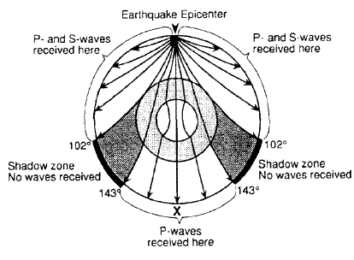
  - Shade the part where both types of body waves are received.
  - Why don’t S waves show up at station X?

  - Can P and S waves be felt everywhere, every time an earthquake happens? Why or why not?
Q

.

SES1e. Identify the transformations and major reservoirs that make up the rock cycle, hydrologic cycle, carbon cycle, and other important geochemical cycles.
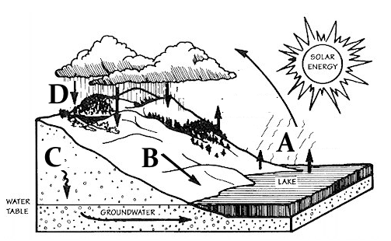
- Correctly label Figure R, the Hydrologic (Water) Cycle
R
  - Precipitation _____ c. evaporation _____
  - Infiltration _____ d. run off _____
- The source of energy for hydrologic cycle is the _________
- Which part of the cycle is NOT affected by gravity?

SES3a. Describe how surface water and groundwater act as the major agents of physical and chemical weathering.
- There are two types of Weathering
  - ________________________________________ - rocks break down into smaller pieces by a physical means; the chemical composition of a rock does not change
  - ________________________________________ - the process by which rock is broken down because of chemical interactions with the environment. This happens most commonly in hot, wet climates.
S
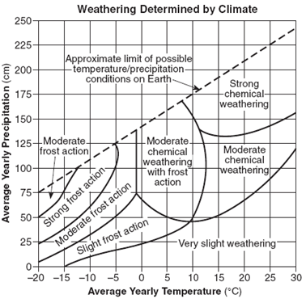
- Understand chalk and limestone dissolve in rainwater because rainwater contains weak _______________________________________.
- ________________________ turns iron minerals a brown-red color because the minerals react with oxygen in the air.
- Using Figure S to determine the weathering most likely to occur in each climate based on precipitation and temperature.
- Chemical weathering is most rapid in _____________________________ climates.
- Mechanical weathering increases the rate of chemical weathering by breaking rocks
into smaller fragments and exposing more ____________________________.
- Cold (0°C) and dry (50cm) ____________________________________________
- Warm (25°C) and 125cm___ __________________________________________
- 15°C and 150cm precipitation __________________________________________
SES3b. Explain how soil results from weathering and biological processes acting on parent rock.
- Understand that characteristics of the ____________________________ has the greatest impact on soil composition. Using Figure I, label the layers properly.
T
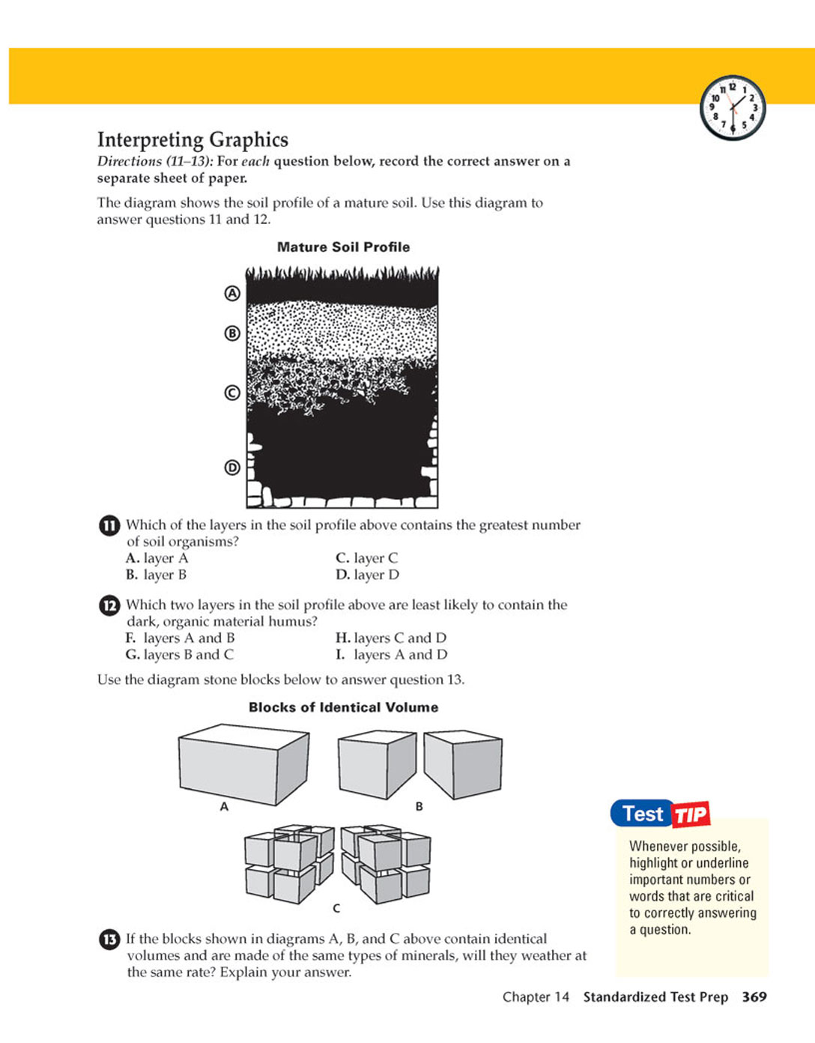
- A Horizon - _______________________ —organic matter and living organisms.
- B Horizon - ___________________________ - zone of leaching.
- C Horizon - ___________________________ - weather bits of bedrock.
- D Horizon - ___________________________ - solid rock layer at the bottom.
SES3d. Relate the past and present actions of ice, wind, and water to landform distribution and landscape evolution.
- In Figure U the most probable reason for the sea cliff erosion is weathering by ___________ and ________________.
U
V
- Understand the term Karst Topography.
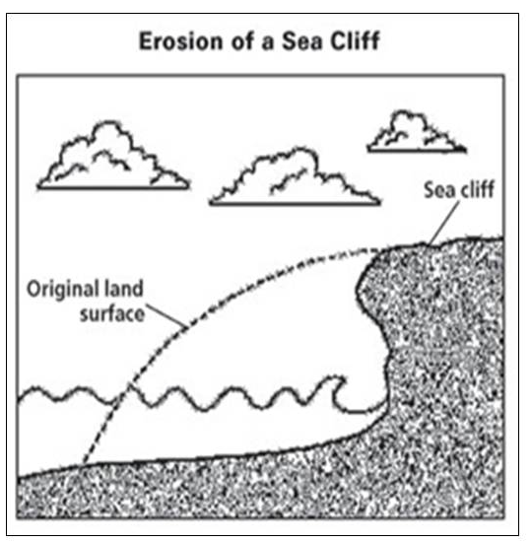
K
- Why does it form?
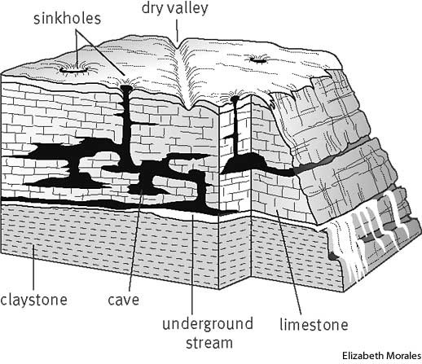

- How is it evident in Figure V?

