MID TERM STUDY GUIDE - UNIT FIVE
Name
EARTH SYSTEMS

SES3c. Describe the processes and hazards associated with both sudden and gradual mass wasting.
- What is Mass Wasting?

- What force is most responsible for landform creation? ____________________________________
- Match the picture of mass wasting to the correct name in Figure W.
_____ Creep _____ Mudslide _____ Rockfall _____Slump _____ Solifluction
W
- Define the term with the correct mass wasting definition.
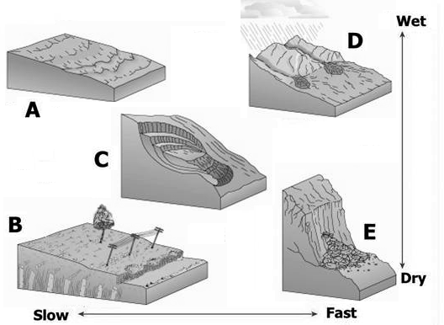
  - ______________________________ is the sliding down of a mass of earth.
  - ______________________________ is the gradual movement downhill of loose soil, rock, gravel, etc.
  - ______________________________ forms a crescent shaped scar.
  - ______________________________ is when a piece of rock on a steep slope becomes dislodged.
  - ______________________________ is permanently frozen subsoil in tundra regions.

SES3d. Relate the past and present actions of ice, wind, and water to landform distribution and landscape evolution.
- Identify the glacial features in Figure E and match them to their correct name.
X
_____ Drumlin _____ Esker _____ Kettle _____ Moraine
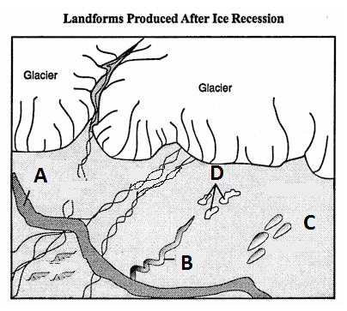
- Define the term with the correct mass wasting definition.
- __________________________ Sediment mounds
- __________________________ depressions – can form lakes
- __________________________ long, winding ridges of gravel and sand - like raised roadways
- __________________________ ridge of deposits – like wall - can be at leading edge of glacier.

- Identify how three types of sedimentary rock are formed – Clastic, Chemical, and Organic
  - _____________________- formed from clay sediments
  - _____________________- formed at the bottom of oceans from the remains of shells and marine organisms
  - _____________________- Formed from the minerals left over from evaporated water.

- Write the order in which sedimentary rocks are formed
____________________________, ____________________________, ____________________________, ____________________________, ____________________________,

- Identify the dunes found in Figure Y
Y
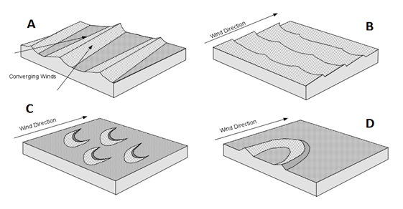

      - ____________________________________
      - ____________________________________
      - ____________________________________
      - ____________________________________

- In Figure Z, SLOWER moving water will occur at points ___________, and the most EROSION will occur at points _____________.
- Using Figure A, the sandbar is located where it is because ________________________________________________________.

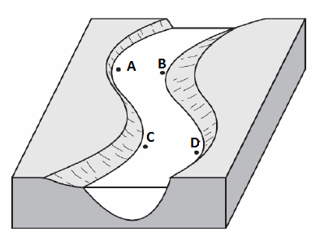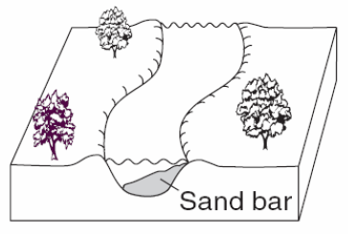
A
Z

