Name _____________________________________________ Period _____

FINAL EXAM REVIEW: KINETICS, CHEMICAL
EQUILIBRIUM, AND ACIDS AND BASES

- SC5. Students will understand that the rate at which a chemical reaction occurs can be affected by changing concentration, temperature, or pressure and the addition of a catalyst.
a. Demonstrate the effects of changing concentration, temperature, and pressure on chemical reactions.
- b. Investigate the effects of a catalyst on chemical reactions and apply it to everyday examples.
- c. Explain the role of activation energy and degree of randomness in chemical reactions.

- Use each of the terms below just once to complete the passage.
- activated complex collision theory reaction rate
- activation energy mol/(L∙s) transition state

- According to the (1)_____________________________ , atoms, ions, and molecules must collide in order to react. Once formed, the (2) ____________________________ is a temporary, unstable arrangement of atoms that may then form products or may break apart to reform the reactants. The site of this physical arrangement is known as the (3) ____________________________. Every chemical reaction requires energy, and the minimum amount of energy that reacting particles must have to form the activated complex is the (4)______________________________ . In a chemical reaction, the (5)___________________________ is the change in concentration of a reactant or product per unit time. It may be expressed using the units of (6)____________________________ .

Complete the following table by indicating whether each of the following scenarios would either increase or decrease the rate of reaction. The first one has been done for you.
Scenario | Increase or Decrease
7. Adding heat. | Increase

8. Removing heat

9. Adding a catalyst

10. Diluting a solution

11. Removing an enzyme

12. Decreasing the surface area

13. Breaking a reactant down into smaller pieces

Complete the following table by indicating which factor would have the greatest impact on the rate of reaction. Choose from concentration, temperature, surface area or catalyst. The first one has been done for you.
Scenario | Factor that has the greatest impact on the rate of reaction.
14. Blowing air on a campfire to help get it going. | concentration

15. Raw carrots are cut into thin slices for cooking.

16. Protein is broken down in the stomach by the enzyme pepsin.

17. A Woolly Mammoth is found, perfectly preserved, near the Arctic circle.

18. More bubbles appear when a concentrated solution of hydrochloric acid is added to a magnesium strip than when a dilute solution of the acid is added.
Answer the following questions using the diagram to the right.
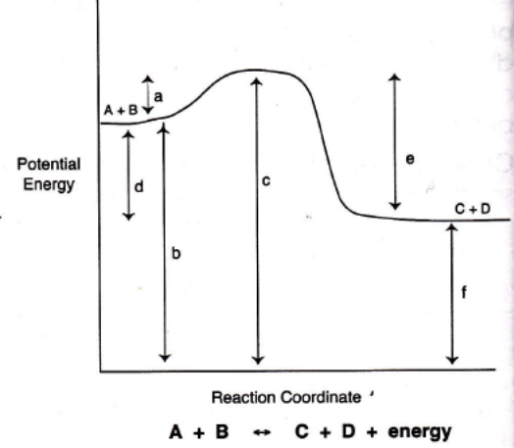

- Is the reaction endothermic or exothermic? ________________

- What letter represents the potential energy of the reactants?

- What letter represents the potential energy of the products?

- What letter represents the heat of reaction (ΔH)?

- What letter represents the activation energy of the forward reaction?

- What letter represents the activation energy of the reverse reaction?

- What letter represents the energy of the activated complex?

- SC2. Students will relate how the Law of Conservation of Matter is used to determine chemical composition in compounds and chemical reactions.
- f. Explain the role of equilibrium in chemical reactions.

- 26. How is a reversible reaction shown in a chemical equation?

27. For the reversible reaction H_{2(g)} + I_{2(g)} ⇌ 2HI_{(g)}, what are the reactants? What are the products?

- 28. What is chemical equilibrium?

- 29. Write the equilibrium expression for each of the equations below.
- H₂O_{(g)} + C_{(s)} ↔ H_{2(g)} + CO_{(g)} b. N_{2(g)} + 3 H_{2(g)} ↔ 2 NH_{3(g)}

30. Calculate the concentration of the missing species. _______________ M
2 NO _{(s)} + O₂ _{(g)} ↔ 2 NO_{2 (g)} Keq = 1.671 x 10⁴ at 723ºC
[NO₂] = ? M [NO] = 6.200 x 10⁻²M [O₂] = 8.305 x 10⁻³M

- For the reaction 2 CO _{(g)} ↔ C _{(s)} + CO₂ _{(g)} , K_{eq} = 7.7 x 10⁻¹⁵. At a particular time, the following concentrations are measured: [CO] = 0.064M, [CO₂] = 2.6 x 10⁻¹¹M.

a. Q = ___________________________ Is this reaction at equilibrium? YES NO
b. If not, in which direction will the reaction proceed? LEFT RIGHT NO SHIFT

- SC7. Students will characterize the properties that describe solutions and the nature of acids and bases.
  - b. Compare, contrast, and evaluate the nature of acids and bases:
  - • Arrhenius, Brønsted-Lowry Acid/Bases
  - • Strong vs. weak acids/bases in terms of percent dissociation
  - • Hydronium ion concentration
  - • pH

- Acids taste _________________ and bases taste __________________, bases also feel ______________________________.
- Acids turn litmus paper __________, bases turn litmus paper ___________ and phenolphthalein ______________________.
- Acids react with metals to form ________________________________ and bases _____________ react.
- The definition of a Brønsted-Lowry base is

- Weak acids are (circle one) strong/ weak electrolytes.
- A weak electrolyte is a (circle one) poor / good conductor of electricity.
- What makes something a strong acid?

- The product of an Arrhenius acid and base neutralization are a/an _________________ and __________________.
- Identify the Brønsted-Lowry acid and base, and the conjugate acid and conjugate base in each reaction:

a. NH_{3(g)} + H₂O_{(l)} ↔ NH₄⁺¹_{(aq)} + OH⁻_{(aq)} b. HClO_{3(aq)} + H₂O_{(l)} ↔ H₃O⁺_{(aq)} + ClO₃⁻_{(aq)}

Indicate the correct name or formula for the acid or base.

- nitrous acid ______________________
- hydrobromic acid _________________
- Chromic acid ____________________
- aluminum hydroxide _________________
- H₂SO₃ __________________________
- H₃PO₄ __________________________
- HCN __________________________
- Cu(OH)₂ ________________________

Complete the following table by filling in the empty spaces. Indicate if the solution is acidic, basic, or neutral.
[H₃O⁺] | [OH⁻] | pH | pOH | Acidc/Basic/Neutral
49. 2.35 x 10⁻³
50. | 4.93 x 10⁻⁸
51. |  | 8.320
52. |  |  | 10.270

53. Give the word equation for the neutralization reaction of an acid and a base.

Complete and balance these equations:

54. HCl + LiOH ↔

55. HC₂H₃O₂ + Mg(OH)₂ ↔

56. Fill in the blanks in the paragraph below about titrations.
A _____________________________ is a laboratory method used to determine the concentration of an acid or a _______________ in solution by performing a_____________________________________ reaction with a standard solution. At the _____________________ of the titration, the indicator changes color, which indicates neutralization. Once neutralized, moles of _______________ and moles of _______________ are equal.

- A substance that can act as both an acid and a base is said to be _________________________
- How many more times acidic is a solution with a pH of 2 than a pH of 5? _____________________
- What is a substance that is one color in an acid and another color in a base? ___________________
- What color does litmus paper turn in the presence of an acid? ____________________
- What color does litmus paper turn in the presence of a base? ____________________
- What color does phenolphthalein turn in the presence of an acid? ____________________
- What color does phenolphthalein turn in the presence of a base? ____________________
- Which 0.1 M solution turns phenolphthalein pink and red litmus blue? (circle the correct choice)

a. HCl(aq) b. CO₂(aq) c. NaOH(aq) d. CH₃OH(aq)

