Name ______________________________________________ Period ______

FINAL EXAM REVIEW: PHASES OF MATTER AND
ENERGY, GASES, and SOLUTIONS

- SC6. Students will understand the effects motion of atoms and molecules in chemical and physical processes.
  - a. Compare and contrast atomic/molecular motion in solids, liquids, gases, and plasmas.
  - b. Collect data and calculate the amount of heat given off or taken in by chemical or physical processes.
  - c. Analyzing (both conceptually and quantitatively) flow of energy during change of state (phase).

- Describe the molecular motion in the following phases.
Phase | Motion at the Molecular Level | Intermolecular Force Strength
Solid
Liquid
Gas

- Know the phase changes between the phases and whether they are exothermic or endothermic
Phase Change | Starting Phase | Ending Phase | Exothermic or Endothermic
Freezing
Melting
Vaporization
Condensation
Sublimation
Deposition

- Use the phase diagram at the right to answer the following questions.
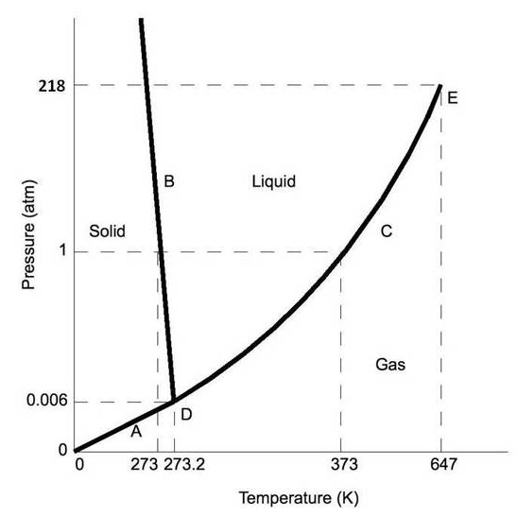
- What is the phase of water at 2.5atm and 350°C?

- What phase change will occur if the temperature is lowered from 640K to 300K at 0.75atm?

- You have water vapor at 350°C and 1atm. What could you do to cause the ice to deposit (not condense)?

- What occurs at letter D?

- Use the heating curve on the next page to answer the following questions.
- a. What is the freezing point of the substance?

- b. Which number represents the gaseous form of the substance?
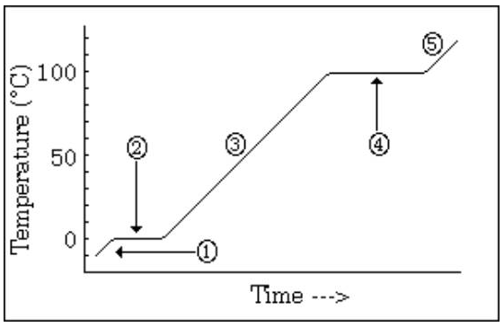

- c. Which number represents the condensation of the substance?

- d. At areas 2 and 4, why doesn’t the temperature change even though heat energy is added?

- Calculate the amount of heat needed to melt a 150.0g sample of ice.

- Calculate the amount of heat needed to lower the temperature of 200.0g of water from 78.0°C to 23°C.

- SC7. Students will characterize the properties that describe solutions.
  - a. Explain the process of dissolving in terms of solute/solvent interactions:
  - • Observe factors that affect the rate at which a solute dissolves in a specific solvent,
  - • Express concentrations as molarities,
  - • Prepare and properly label solutions of specified molar concentration,
  - • Relate molality to colligative properties.

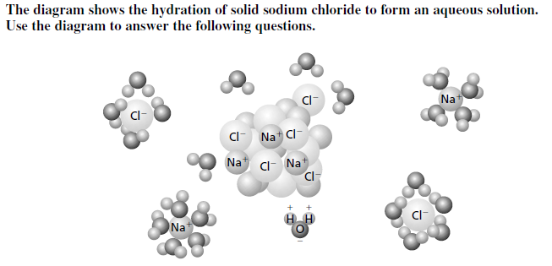

- As sodium chloride dissolves in water, what happens to the sodium and chloride ions? Explain the orientation of the water molecules around the sodium ions and chloride ions.

- How does the strength of the attraction between water molecules and sodium and chloride ions compare with the strength of the attraction between the sodium ions and chloride ions? How do you know?

- What are three things that you could do to speed up the rate of a solution? How do they speed up a reaction?

- Using the solubility curve graph at the right, answer the following questions.
- What is the solubility of KBr at 80°C?
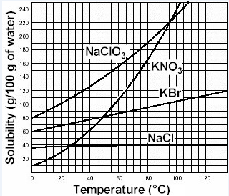

- At what temperature will 130g of NaClO₃ dissolve?

- Which substance is least soluble at 100°C?

- How much KNO₃ solid will precipitate out if the temperature is dropped from 85° to 55°C?

- If I gave you a solution of KBr with 120 grams dissolved at 80°C, what kind of solution is it – saturate, unsaturated, or supersaturated? Explain.

Show all work, units, and correct significant digits.
- 85.0 g of KCl is added to 0.250 L of distilled water. Assuming the volume of the solution is the same as the water, calculate the molarity of the solution. (The molecular mass of KCl is 74.55 g/mol)

- 250.0 g of nitric acid, HNO₃, are added to 5.20 Kg of water. Calculate the molality of this solution. (The molecular mass of HNO₃ is 63.02 g/mol)

- Given 12.0M HCl, what volume of HCl is needed to make 500.0mL of a 0.10M solution?

- Calculate the number of grams needed to make 500.0mL solution that is 0.100M NaOH.

- Calculate the freezing point if 100.0g glycerol, C₃H₅(OH)₃, are dissolved in 0.500 kg water. (The molecular mass of C₃H₅(OH)₃ is 92.11 g/mol and the K_{fp} of water is 1.853°C/m).

