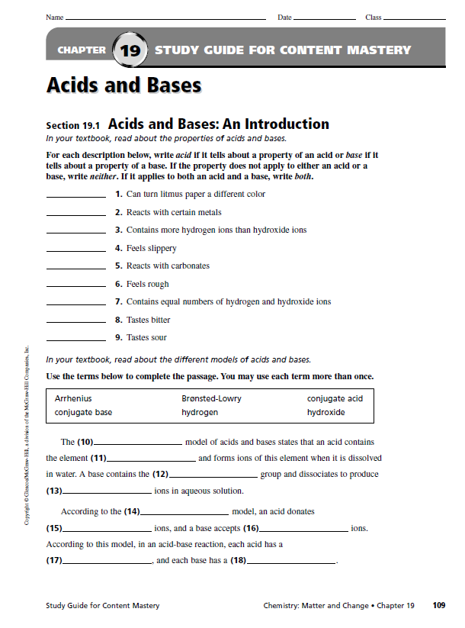

NAMING ACIDS AND BASES PRACTICE

I. Looking at the formulas, name the acids and bases.

HNO₃ __________________________ HNO₂ __________________________

H₂SO₄ __________________________ H₂SO₃ __________________________

HC₂H₃O₂________________________ HCl __________________________

HI __________________________ NH₃ __________________________

Ca(OH)₂ ________________________ KOH __________________________

Looking at the names, write the formulas for the acids and bases.

Hydrochloric ______________ Phosphoric ______________

Chromic ______________ Hydrobromic ______________

Hydrosulfuric ______________ Hydrocyanic ______________

Sodium hydroxide ______________ Barium hydroxide ______________

Chloric ______________ Chlorous ______________

Perchloric ______________ Hypochlorous ______________

Carbonic ______________

