Name ____________________________________ Period _____ Date ______________________

ATOMS, IONS, ISOTOPES, AND RADIATION PRACTICE

- How many protons and electrons are in a vanadium atom?

- What is the name of the element that contains 17 protons?

- What is the name of the element that contains 25 protons?

- What is the name of the element that contains 92 protons?

- Write the chemical symbol for the ion with 12 protons and 10 electrons.

- Write the chemical symbol for the ion with 95 protons and 89 electrons.

- Write the chemical symbol for the ion with 29 protons and 27 Electrons.

- How many protons, neutrons, and electrons are present in ${}_{28}^{59}{Ni}$⁺² ion?

- How many protons, neutrons, and electrons are present in ${}_{58}^{140}{Ce}$⁺³ ion?

- How many protons, neutrons, and electrons are present in ${}_{34}^{79}{Se}$⁻² ion?

- Write the complete chemical symbol for the ion with 27 protons, 32 neutrons, and 25 electrons.

- Write the complete chemical symbol for the ion with 73 protons, 108 neutrons, and 68 electrons.

- What are the three types of radiation we learned? Indicate which are matter and which are energy.

- How do nuclear reactions affect an atom?

- Name the force that holds the nucleus together.

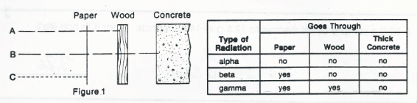
- Using the information in the table above, decide which kind of radiation is represented by each letter. Write the names of the radiation below.

- _______________________ B. _______________________ C. _______________________

- The three kinds of radiation are numbered in the figure to the right. In the spaces below, indicate which type of radiation each number shows.
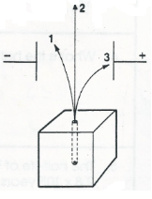

- _____________________________

- _____________________________

- _____________________________

For the half-life problems, show your work and place your final answer in the box provided.
- How much of a 100.0g sample of gold-198 is left after 8.10 days if its half-life is 2.7 days?

- The half-life of potassium-42 is 12.4 hours. How many half-lives have gone by after 62.0 hours?

- A 50.0g sample of nitrogen-16 decays to 12.5g in 14.4 seconds. What is its half-life?

