Name __________________________________________ Period _______

CLIMOGRAPH PRACTICE
Degrees for latitude and longitude look-up:
41.87N, -87.62W

Use the following climographs to answer each of the related questions.

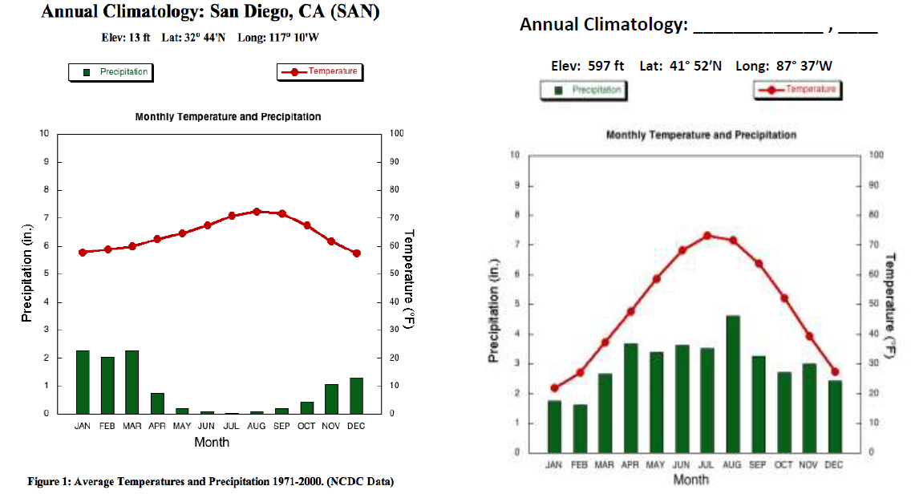

- The data used for the climograph of San Diego, CA. was collected over how many years? _______
- Approximately how many inches of precipitation does San Diego get in January? ________
- In which month would you be least likely to need an umbrella in San Diego? _________________
- Approximately how many inches of precipitation fall in San Diego during an entire year? _______
- Which month has the highest average temperature in the “mystery city”? _____________________
- What is the average temperature in the “mystery city” during its hottest month? __________
- What is the average temperature in the “mystery city” during its coldest month? __________
- What is the temperature difference between the hottest month and the coldest month in the “mystery city”? __________
- What is the temperature difference between the hottest and coldest months in San Diego? __________
- Does it ever snow in the “mystery city”? Explain your answer using information from the climograph.

Turn over for more.

Use the following climographs to answer the questions below:
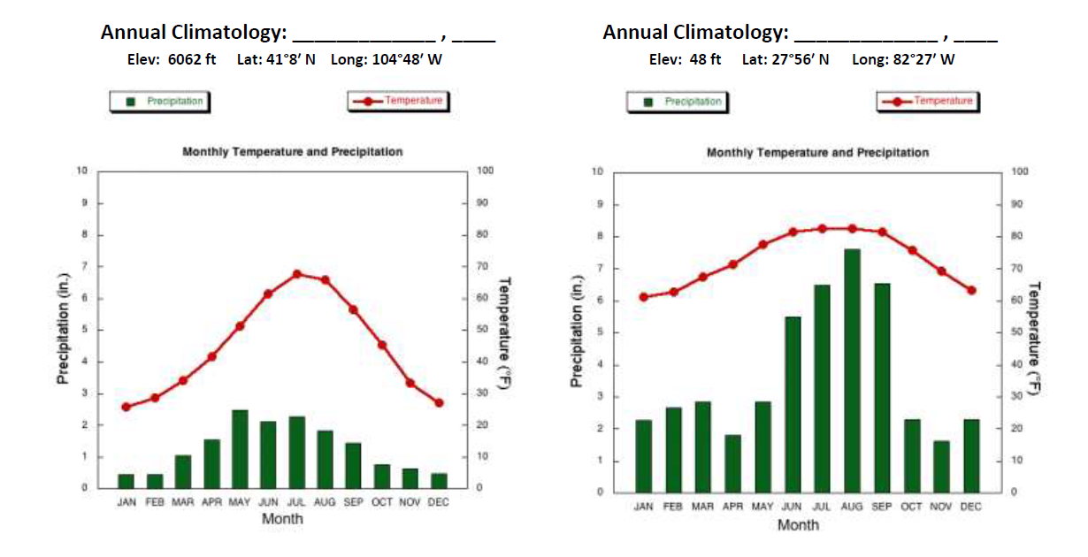
Degrees for latitude and longitude look-up:
41.87N, -82.62W
Degrees for latitude and longitude look-up:
41.13N, -104.8W
B
A
- Use http://www.findlatitudeandlongitude.com/find-address-from-latitude-and-longitude/#.WNRU-SaQyLI and the listed coordinates to identify City A: ___________________________________
- Identify City B: ____________________________________
- Which city has the most precipitation during the year? _______________________________
- How many inches of precipitation fall in this city during an average year?
- For the city on the right, list the type of clothes would you want to have in your closet to wear anytime?

- Explain what type of clothes would you NOT waste your money buying if you planned on living in the city on the right?

- In which city would you expect it to rain during your 4th of July barbecue? ______________________
- In which city would your dreams of having a “white snowy Christmas” most likely come true?
________________________________
- Explain your answer to question #6 using the information from the climograph.

- After studying the climates of the four cities listed on this handout, explain which city you would most like to move to and the reasons why.

°

