Name:____________________________ Period:_____  Cut & Paste The Correct Icon Or Word In Each Box: | Cut & Paste Images
  Boundary | Divergent | Convergent | Transform
  Picture
  Stress
  Landforms
  Fault
  Force
  NORMAL | CONSTRUCTIVE | REVERSE
  NEUTRAL | SLIP-STRIKE | DESTRUCTIVE
  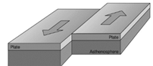 | 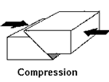 | 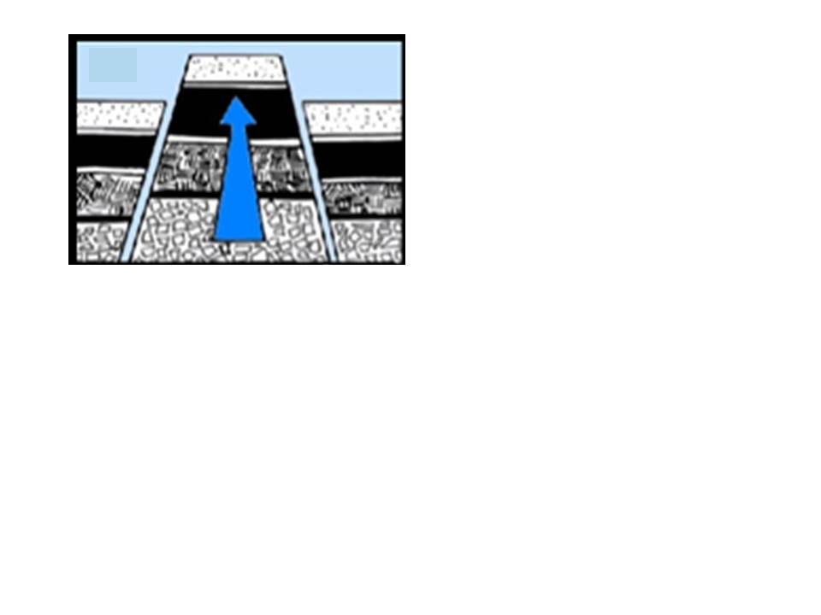
  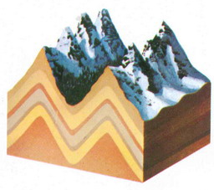 | 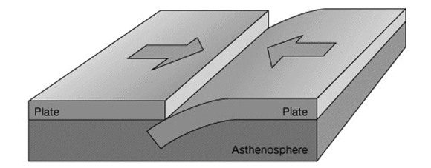 | 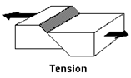
  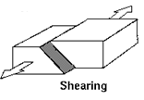 | 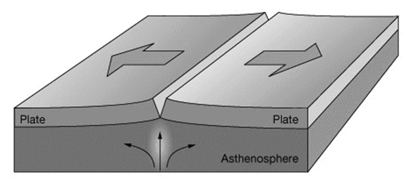 | 