HEATING CURVES AND CALCULATING “Q”
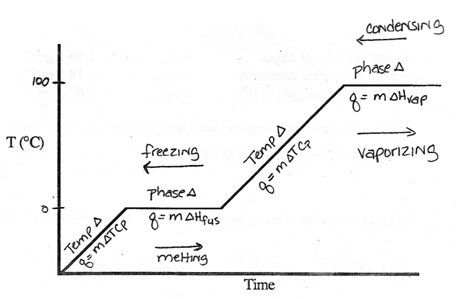

Calculate the heat changes
using the following constants.

Cp_{ice} 2.06 J/g•C°
Cp_{water} 4.18 J/g•C°
Cp_{vapor} 2.02 J/g•C°

ΔH_{fus} 334 J/g
ΔH_{vap} 2260 J/g

1. Calculate the amount of heat (in joules) needed to raise the temperature __________________
of 60.0 grams of ice from –40.0°C to its melting point (0.0°C).

2. Calculate the amount of heat needed to melt this sample of ice at 0.0°C. __________________

3. Calculate the amount of heat in joules needed to raise the temperature __________________
of this sample of water from 0.0°C to 100.0°C

4. Calculate the amount of heat needed to vaporize this sample of __________________
water at 100.0°C.

Name ___________________________________________ Period ______ Date _________________________

CALCULATING HEAT CHANGES

Calculate the heat changes Cp_{ice} 2.06 J/g•C° ∆H_{fus} 334 J/g
using the following constants Cp_{water} 4.18 J/g•C° ∆H_{vap} 2260 J/g
Cp_{vapor} 2.02 J/g•C°

1. Calculate the amount of energy (in joules) needed to melt 100.0 g of ice at 0.0°C.

2. Calculate the amount of energy needed to raise 28g of ice at –56.0°C to 0.0°C.

3. Calculate the energy needed to raise the temperature of 40.0 g of water from 25.0°C to 75.0°C.

4. Calculate the energy needed to vaporize 35 g of water to vapor at 100.0°C.

5. Calculate the amount of energy given off when 40.0 g of water freezes at 0.0°C.

6. How much energy is needed to convert 20.0 g of ice at –15.0°C to liquid water at 50.0°C? Careful, this requires several equations to answer.

