Name ________________________________ Period ______ Date ________________

MENDELEEV’S PERIODIC TABLE

The periodic table below is one of the many versions that Mendeleev designed in 1869. Although Mendeleev’s periodic table looks quite different from the periodic table in use today, the arrangement of elements is actually very similar. Compare Mendeleev’s table to the green class periodic table. Then answers the following questions.
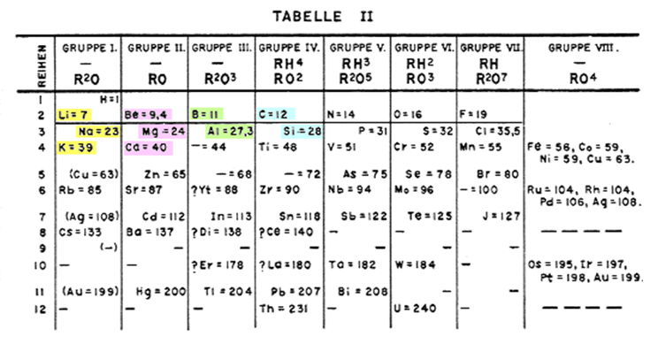

- What do the numbers on Mendeleev’s periodic table represent?

- The current periodic table arranges elements in horizontal rows in order of increasing atomic number. Describe Mendeleev’s table by telling how it is arranged and organized.

- How are elements with similar properties arranged on Mendeleev’s table?

- Name the chemical family of elements that is absent from Mendeleev’s table. Why do you think these elements are not represented in this table?

- Use the class periodic table to identify by name and symbol the four elements marked with question marks on Mendeleev’s table.

  - #45 ____________________________

  - #68 ____________________________

  - #70 ______________________________

d. #180 ______________________________

