Name _________________________________________ Period ____ Date _______________

POTENTIAL ENERGY DIAGRAMS TWO
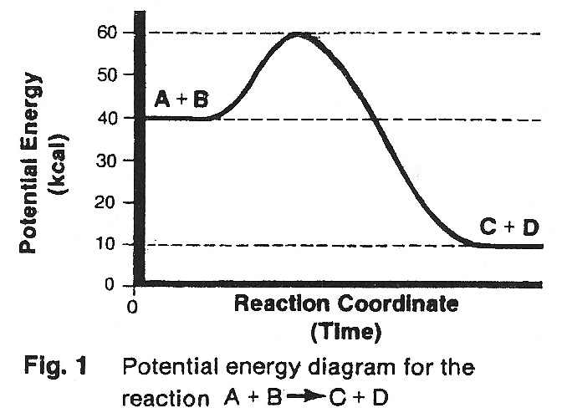
Questions 1-5: These questions refer to the potential energy diagram in Fig. 1.

_____________ 1. Is the reaction exothermic or endothermic?

_____________ 2. What is the value of ΔH?

_____________ 3. What is the value of the activation energy of the reaction?
_____________ 4. What is the potential energy of the products?

_____________ 5. What is the potential energy of the activated complex?

Questions 6-10: These questions refer to the potential energy diagram in Fig. 2.
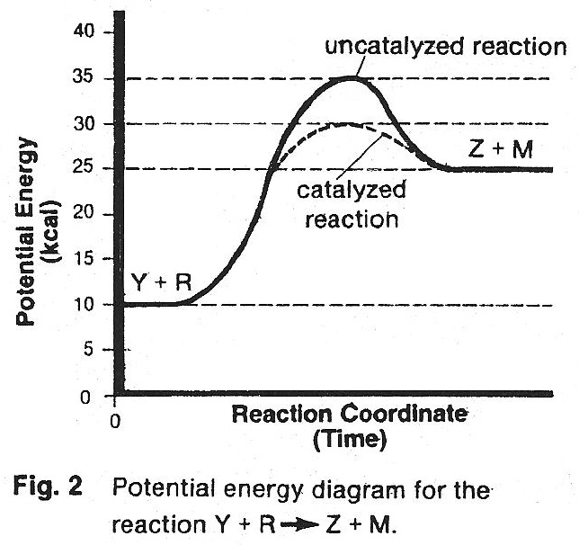
_____________ 6. Is the reaction exothermic or endothermic?

_____________ 7. What is the value of the activation energy of the uncatalyzed reaction?
_____________ 8. What is the value of the activation energy of the catalyzed reaction?
_____________ 9. What is the potential energy of the activated complex of the catalyzed reaction?
_____________ 10. How does the H for the catalyzed reaction compare to the H for the uncatalyzed reaction (same, greater, less)

Questions 11-19: These questions refer to the potential energy diagram in Fig. 3. Give the letter of the arrow that best applies.

_____________ 11. What is the potential energy of the activated complex for the uncatalyzed reaction?
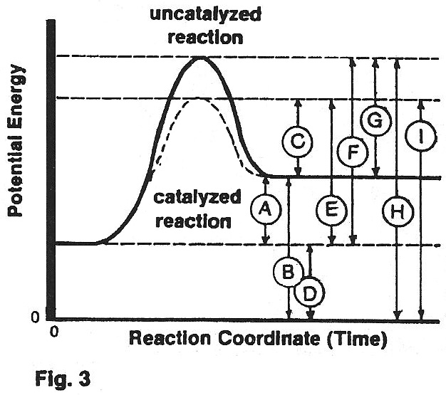
_____________ 12. That is the activation energy for the forward catalyzed reaction?
_____________ 13. What is the potential energy of the products of the forward reaction?
_____________ 14. What is the activation energy of the uncatalyzed reverse reaction?
_____________ 15. What is the potential energy of the activated complex for the catalyzed reaction?
_____________ 16. What is the activation energy of the uncatalyzed forward reaction?
_____________ 17. What is the heat of reaction?

_____________ 18. What is the activation energy of the catalyzed reverse reaction
_____________ 19. What is the potential energy of the reactants for the forward reaction?

