Name(s) ___________________________________________ Period _____
_____________________________________________________

REACTANTS, PRODUCTS, and LEFTOVERS
A Review

You may work by yourself or with one other person. If you work with someone else (groups of two ONLY), you submit only one paper, both should write some of the answers on it, and both get the same grade. Choose wisely.
Today you are going to use the “Reactants, Products and Leftovers” simulation to explore how many products you can make given the initial amounts of two reactants.

A. MAKING SANDWICHES
1. If you have 6 pieces of bread and 4 slices of cheese, predict how many cheese sandwiches of type A you can make. Figure A gives the “equation” for making a sandwich. Then predict how many of type B you can make.
A: 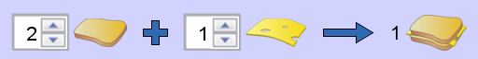 B: 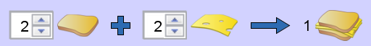

Prediction for A: ___________ How did you figure this out?

Prediction for B: ___________ How did you figure this out?

2. Now check your predictions. Go to https://phet.colorado.edu/en/simulation/reactants-products-and-leftovers (also linked on my website under today’s date), click the play arrow and then the “Sandwiches” tab. Put in the reactant numbers in “A” and “B” and check your answers. You must choose “Custom” at the top right to check “B”. Do the results make sense? Do they match your results? Revise your answers or reasoning as needed.

3. What is the limiting reactant for case B and why? What is leftover when all the sandwiches are made?

4. If you have 6 pieces of bread, three pieces of meat and four pieces of cheese and your sandwich equation is: , how many sandwiches can you make? _______________ Now click on the “Meat and Cheese” radio button at the top right. Put in the following as your reactants. 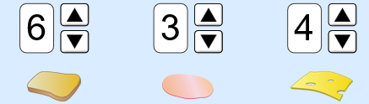. Were you right? _________ What is the limiting reactant(s) ______________________ and what are the excess reactant(s) _____________________?

B. MAKING AMMONIA
5. Consider the chemical equation: 1 N₂ + 3 H₂ → 2 NH₃. For the 3 scenarios below, predict which one will produce the most ammonia, and predict which ones will have leftovers.
A: 2 N₂ + 8 H₂ B: 3 N₂ + 7 H₂ C: 2 N₂ + 6 H₂

Explain your reasoning:

6. Now check your predictions using the “Molecules” tab at the bottom. Choose “Make Ammonia” on the top right. Put in the three options in #5. Do the results make sense? Revise your answers or reasoning as needed.

7. How did the “Molecules” tab relate to the “Sandwich Shop” tab?

8. Choose two more molecules (one “Make Water” and one “Combust Methane”). Put in numbers of your choosing for reactants and indicate what is makes, what is in excess and what is limited.

- Making Water: _____ H₂ _____ O₂ # Products _______and # and type of Leftover __________________
- Combusting Methane: _____ H₂ _____ O₂ # Products _______and # and type of Leftover __________________
C. GAME
9. Play at least one “Game!” at each level with your partner (estimated time = 5 minutes per game). Record your best score for each level in the table below.

Level | Best Score
1
2
3

How did you solve the problems? Write your strategy in the space below. Did your strategy change as you played the game, as you changed levels? If so, write how it changed.

