Name:_______________________________________________ Period:_____

SOIL TRIANGLE PRACTICE
SES3b: Explain how soil results from weathering and biological processes acting on parent rock.
Using the soil texture chart below to determine the soil textures using the percentages given in the chart on the back, then match the descriptions to the correct soil particle. | 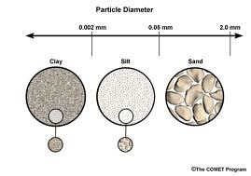

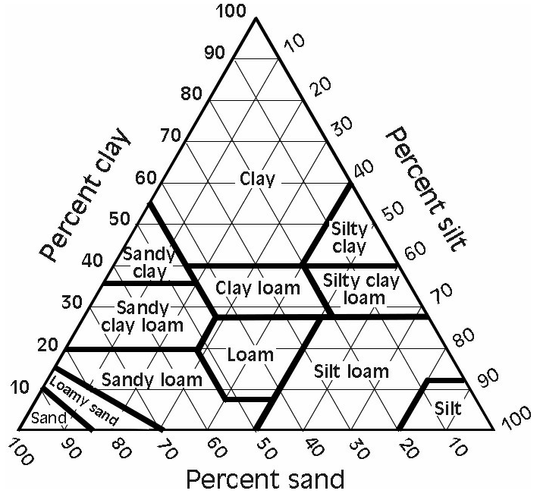

 | % Sand | % Silt | % Clay | Texture Name
Example | 70 | 20 | 10 | sandy loam
 | % Sand | % Silt | % Clay | Texture Name
1 | 10 | 70 | 20
2 | 40 | 40 | 20
3 | 50 | 40 | 10
4 | 60 | 10 | 30
5 | 30 | 40 | 30
6 | 10 | 55 | 35
7 | 80 | 15 | 5
8 | 10 | 45 | 45
9 | 10 | 85 | 5
10 | 20 | 10 | 70

Match the descriptions to the soil particles:

_____ 1. Feels gritty  _____ 2. Feels silky  _____ 3. Makes fertile soil  _____ 3. Smallest grain size  _____ 4. Medium grain size  _____ 5. Largest grain size  _____ 6. Holds water so well it can get waterlogged  _____ 7. Feels smooth & sticky  _____ 8. Very porous  _____ 9. Heats & cools slowly  ____ 10. Heats & Cools quickly | A. Sand  B. Silt  C. Clay

