Name _____________________________________________ Period ______

SOLUBILITY CURVES

Answer the following questions based on the solubility curve below.
- Which salt is least soluble in water at 20°C?
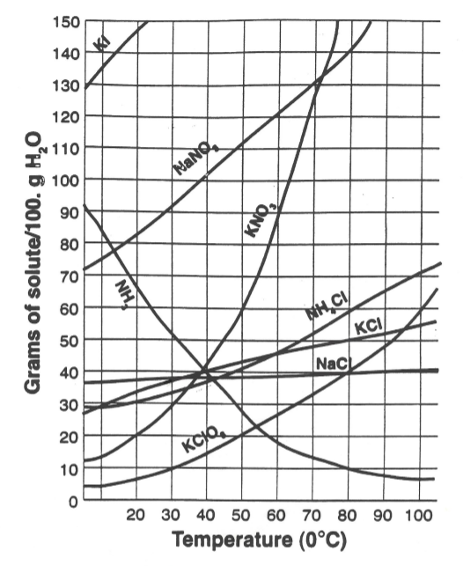

- How many grams of potassium chloride can dissolve in 200g of water at 80°C?

- At 40°C, how much potassium nitrate can be dissolved in 300g of water?

- Which salt shows that least change in solubility from 0° to 100°C?

- At 30°C, 90g of sodium nitrate is dissolved in 100g of water. Is this solution saturated, unsaturated, or supersaturated?

- A saturated solution of potassium chlorate is formed from 100g of water. If the saturated solution is cooled from 80°C to 50°C, how many grams of precipitate are formed?

- What compound shows a decrease in solubility from 0°C to 100°C?

- Which salt is most soluble at 10°C? _______________________________
- Which salt is least soluble at 50°C? _______________________________
- Which salt is least soluble at 90°C? _______________________________

