Name ___________________________________________________ Period ____

SOLUTION PROBLEM SET
WITH SOLUBILITY

For each problem, write the formula, write what you know and where you are going, show your work with units, and write the correct answer with sigfigs and units. Show work on a separate piece of paper.
- What is the molarity of a solution formed by mixing 10.0g H₂SO₄ with enough water to make a 100.0mL solution?

- 64.2 g of KCl is added to 0.250 L of distilled water. Assuming the volume of the solution is the same as the water, calculate the molarity of the solution.

- How many grams of bromine are needed to prepare 0.500L of a 0.100M solution of bromine in water?

- How many liters of water must be added to 5.50 moles of sugar to make a 2.00M solution?

- What is the molality of a solution containing 125g iodine, I₂, and 750.0g carbon tetrachloride, CCl₄?

- Determine the volume of 12.0M hydrochloric acid needed to make 500.0mL a 0.10M solution.

- How many grams of NaOH do you need to make 500.0mL of 0.10M of NaOH?

SOLUBILITY GRAPH QUESTIONS
Use the graph to answer the following questions. Remember units.
8. What mass of solute will dissolve in 100mL of water at the following temperatures?
a. KNO₃ at 70°C = ____________
b. NH₄Cl at 90°C= ____________
c. NaCl at 100°C = ____________
d. Which of the above three substances is most soluble in water at 15°C? ____________
9. a. What is the solubility of KCl at 5°C? ____________
b. What is the solubility of KCl at 25°C? ____________
c. What is the solubility of Ce₂(SO₄)₃ at 10°C? ____________
d. What is the solubility of Ce₂(SO₄)₃ at 50°C? ____________
10. At 90°C, you dissolved 10 g of KCl in 100. g of water. Is this solution saturated or unsaturated? How do you know?

11. A mass of 100 g of NaNO₃ is dissolved in 100 g of water at 80ºC. Is the solution saturated or unsaturated? As the solution is cooled, at what temperature should solid first appear in the solution? Explain.

12. A mass of 80 g of KNO₃ is dissolved in 100 g of water at 50 ºC. The solution is heated to 70ºC. How many more grams of potassium nitrate must be added to make the solution saturated? Explain your reasoning.
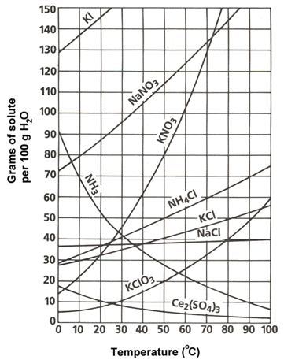

13. Which compound is most soluble at 20 ºC?

14. Which is the least soluble at 40 ºC?

15. Which substance on the graph is least soluble at 10°C?

