SOLVATION AND SOLUBILITY

Use each of the terms below just once to complete the passage.
Immiscible Insoluble Liquid Miscible

Soluble Solute Solvent Solution

Air is a(n) 1. ___________________________________ of oxygen gas dissolved in nitrogen gas. The oxygen in air is the 2. __________________________ and the nitrogen is the 3. __________________________________. Because oxygen gas dissolves in a solvent, oxygen gas is a(n) 4. ___________________________ substance. A substance that does not dissolved is 5. _______________________________. 6._____________________ _____________ solutions are the most common types of solutions. If one liquid is soluble in another, such as acetic acid in water, the two liquids are 7. ___________________________. However, if one liquid is insoluble in another, the liquids are 8. ___________________________.

The diagram below shows the hydration of solid sodium chloride to form an aqueous solution. Use the diagram to answer the questions.
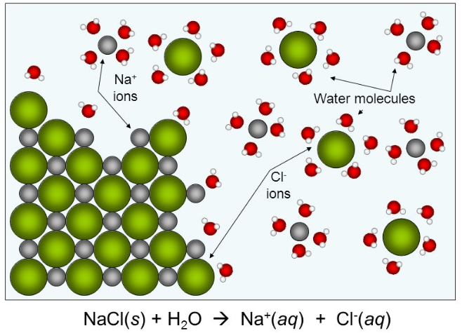

9. Hydration is solvation in which the solvent is water. What is solvation?

10. As sodium chloride dissolves in water, what happens to the sodium and chloride ions?

11. Explain the orientation of the water molecules around the sodium and the chloride ions.

12. How does the strength of attraction between water molecules and sodium and chloride ions compare with the strength of the attraction between the sodium ions and chloride ions? How do you know?

