Name:_________________________________________________ Period: _____

PRACTICE: STRATIGRAPHY

Stratigraphy is the analysis of different rock formation through time and changing environments. The sequence of both the rocks and fossils provides information on changing environments through time.

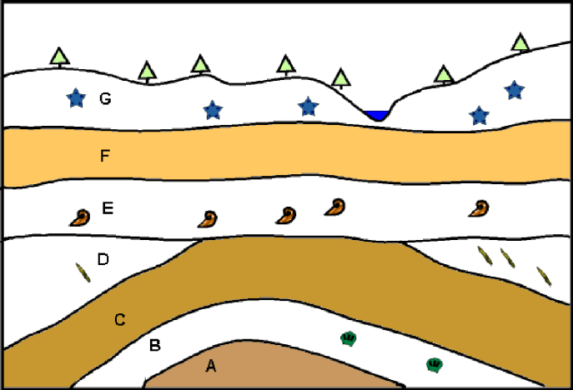 | This drawing shows a cross-section, or a side view, of the rock layers below the Earth’s surface. The trees and water show where the surface is. Each rock layer is identified by a letter. Some of the rock layers contain fossils. Using the principles of stratigraphy, answer the following questions about the cross section.

1. Which rock layer is the oldest? ____________

2. Which rock is the youngest? ___________

3. What type of unconformity is shown? ________________________________________

What layers is it between? ___________and ___________

4. Which type of fossil is the oldest (name the shape)? _____________________________

For each of the following cross sections, determine the relative age sequence of the rock layers, intrusions and faults.

