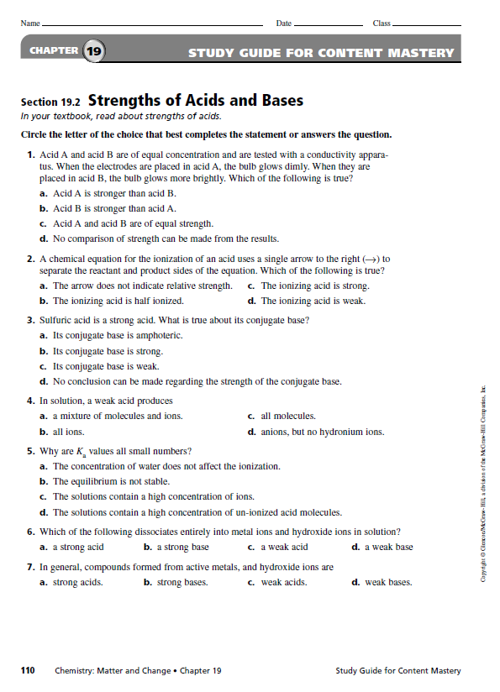

Bronsted-Lowry
Acid-Base Theory

For the following equilibria, pick out and label the acid (A), base (B), conjugate acid (CA) and conjugate base (CB). Number one is done for you.

1. CH₃COO⁻ + H₃O⁺ ↔ CH₃COOH + H₂O

2. HCl + H₂O ↔ H₃O⁺ + Cl⁻

3. NH₂⁻ + H₂O ↔ NH₃ + OH⁻

4. H₃O⁺ + OH⁻ ↔ H₂O + H₂O

5. CN⁻ + H₂O ↔ HCN + OH⁻

6. HClO₄ + CH₃COOH ↔ ClO₄⁻ + CH₃COOH₂⁺

7. HCN + H₂O ↔ H₃O⁺ + CN⁻

8. NH₃ + H₃O⁺ ↔ NH₄⁺ + H₂O

9. CH₃OH + NH₂⁻ ↔ CH₃O⁻ + NH₃

10. C₆H₅OH + H₂O ↔ H₃O⁺ + C₆H₅O⁻

