Know Your Climates

Research and present the following information using PowerPoint or Prezi. This will be shared through your Google Drive.

- There will be a slide per “Climate” (3) outlining the climate zones included in that climate
- There will be a slide that depicts the three climates shaded on a world map.
- There will be a slide per climate zone that includes:
  - Temperature and precipitation information;
  - Description of plants and animals found here;
  - A picture that represents the climate zone.

Tropical Climates

- Rain Forest climate zone
  - temperature & precipitation
  - description of plants and animals found here
  - a picture that represents the climate zone
- Desert climate zone
  - temperature & precipitation
  - description of plants and animals found here
  - a picture that represents the climate zone
- Savanna climate zone
  - temperature & precipitation
  - description of plants and animals found here
  - a picture that represents the climate zone
Middle-Latitude Climates
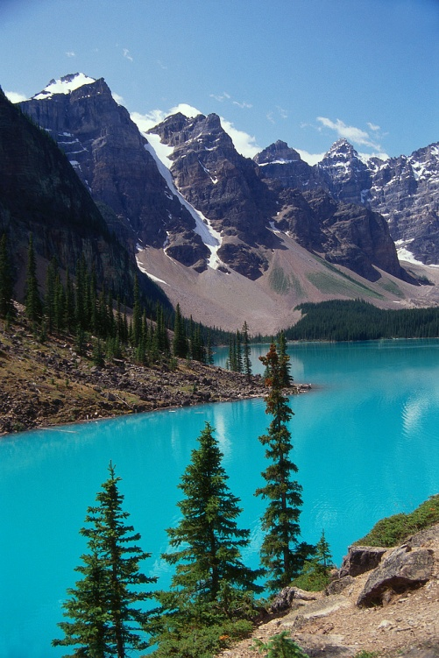
- Marine West Coast climate zone
  - temperature & precipitation
  - description of plants and animals found here
  - a picture that represents the climate zone
- Steppe climate zone
  - temperature & precipitation
  - description of plants and animals found here
  - a picture that represents the climate zone
- Mediterranean climate zone
  - temperature & precipitation
  - description of plants and animals found here
  - a picture that represents the climate zone
Polar Climates

- Subarctic climate zone
  - temperature & precipitation
  - description of plants and animals found here
  - a picture that represents the climate zone
- Tundra climate zone
  - temperature & precipitation
  - description of plants and animals found here
  - a picture that represents the climate zone
- Polar Icecaps climate zone
  - temperature & precipitation
  - description of plants and animals found here
  - a picture that represents the climate zone

GRADING RUBRIC
Criteria | Not Evident | Partly Evident | Fully Evident
Prezi or PowerPoint Climate Slides – 20%
Three climate slides with appropriate information
World map with depiction of three main climates shaded in.
Prezi or PowerPoint Climate zone slides – 65%
Each climate zone has its own slide with its name.
Each climate zone has a picture that represents the climate zone.
Each climate zone has temperature and precipitation information.
Each climate zone has a description of plants and animals found there.
Written Communication – 10%
You write using complete and meaningful sentences
The material you present is well developed
You use proper language mechanics, spelling and grammar
You write in your own words using information provided
PLAGIARISM = A GRADE OF ZERO
Work Habits – 5%
Your work is neat and represents your best efforts
Your work is colorful
Your work is completed and turned in on time
You stay on task and use your time wisely

