Name _________________________________________________ Period _______

EARTH SYSTEMS LAB
AQUIFER SIMULATION

Drawings and Data

Scenario and Questions | Scenario and Questions
Draw the water level that you see in the gravel in the aquarium with your BLUE colored pencil.  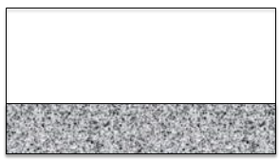 | Label the zone of saturation and the unsaturated zone in your drawing to the left by placing arrows from the words to the correct part of your drawing. DO NOT BE MESSY!  Unsaturated Zone  Saturated Zone.
Draw in the lake with a BLUE colored pencil.  Draw in the well.  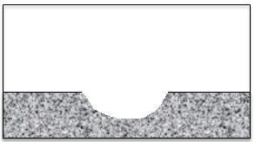 | Show where the contaminant was added with a RED colored pencil using an arrow.
This is draw from the top looking down. Draw in the contamination plume and show the area of contamination with your RED colored pencil.  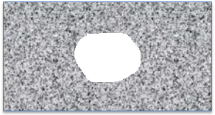 | Define Contamination Plume here:

Analysis
- Define groundwater.

- Where does the water come from that fills an aquifer?

- Describe why the dry well pictured below cannot get water and why the other well can still get water.
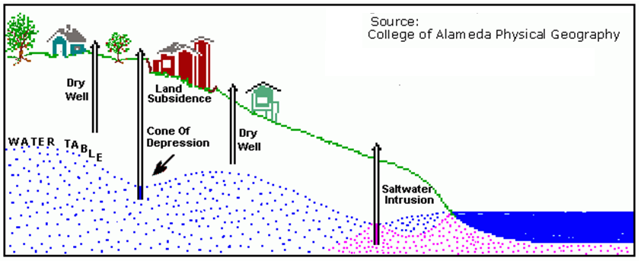

- What are four common sources of groundwater pollutants (contaminants)?

- Which of the following would be the most likely type of material in the confining layer in Figure #2?
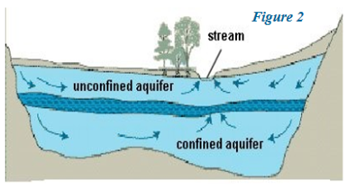

  - Sandstone
  - Gravel
  - Topsoil
  - Granite

