EARTH SYSTEMS LAB:
Using Data to Explore Climate Patterns

For this activity, you will use the website: www.usclimatedata.com/ to explore climate patterns. This website provides daily weather data as well as historical weather data. To complete this assignment, you will:
- Find the average high and low temperatures for summer and winter at different locations.
- Compare data for different cities to find out how latitude, oceans and topography affect climate
- Compare weather data to identify trends
On the back is a map of the United States. Use the website to find the average high and low temperatures for both summer and winter for the cities listed below and write them on the map. Use January for the winter data, and July for the summer data. Data for Commerce, GA has already been done for you. The approximate location of each city is shown with a . Note that the cities are along similar lines of latitude. The correct way to put the temperatures is:
W: Low temp/high temp
S: Low temper/high temp

An example would be the one listed for Commerce, GA:
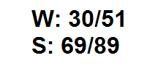

The cities you will look up are below:

Part of USA | West Coast | East of Rocky Mtns | Central US | East Coast
Northern | Seattle, Washington | Bozeman, Montana | Minneapolis, Minnesota | Bangor, Maine
Mid USA | Eureka, California | Salt Lake City, Utah | St. Louis, Missouri | Washington, DC
Southern | San Diego, California | Phoenix, Arizona | Houston, Texas | Orlando Florida

HOW TO LOOK UP DATA:
- Go to www.usclimatedata.com/
- Select the state you want. Washington DC will be listed under “District of Columbia”.
- Click on the city you want.
- Write down the temperatures.
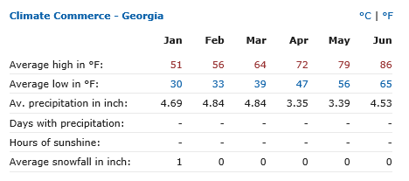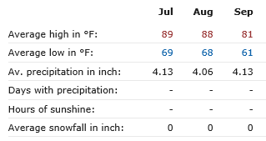

Name:_________________________________________________ Period:____

EARTH SYSTEMS LAB:
Using Data to Explore Climate Patterns

After you finish with plotting the data on the map, answer the following questions. You will be expected to EXPLAIN using data to support your response.
- Which location has the greatest temperature range during the summer? How much is it?

- Which location has the greatest temperature range during the winter? How much is it?

- How do cities along the West Coast compare to the cities along similar lines of latitude that are east of the Rocky Mountains? EXPLAIN.

- How do cities along the West Coast compare to the cities along similar lines of latitude that are on the East Coast? EXPLAIN.

- What effect does latitude have on the average summer and winter temperatures? EXPLAIN.

- Based on your observations, does location near an ocean appear to influence the temperature of a city? EXPLAIN YOUR ANSWER PROVIDING SUPPORTING DATA.

- The United States is in at Mid-Latitudes and has several Mid-Latitude Climate Zones. The Marine West Coast climate zone is characterized by small temperature ranges. Based on the data you collected, would you classify these any of these cities as belonging in the Marine West Coast climate zone? Why or why not? Provide data to support your conclusion.

