Name _______________________________________________ Period ______

EARTH SYSTEMS LAB:
CUPCAKE CORE SAMPLING

Objective: To demonstrate how geologists can discover mineral deposits that are buried in the Earth’s crust and determine what their distribution is by collecting and analyzing cores.
Materials:
Paper plate Cupcake Plastic knife toothpick plastic transparent straw

Procedure:
- In Section A in your lab sheet data table, draw what you think the inside of the cupcake looks like if there were three different layers present. The layers are white, red, blue, and yellow
- Once you have done it, have your teacher initial your drawing – do not make ANY changes to this drawing after your teacher initials it.
- Use your straw to take a core sample in the dead center of the cupcake. Rotate and push the straw at the same time to “drill” into your cupcake. Pull out the sample core.
- In Section B of your data table, draw what you think the inside of your cupcake looks like now based on the information from the core sample. This represents the first exploration drill hole.
- Take two additional core samples on either side of the center hole (line up the drill holes across the cupcake like this: O O O.)
- In Section C of your data table, draw what you think the inside of your cupcake looks like now based on the information from additional core samples.
- Using the plastic knife, cut open your cupcake, bisecting the drill holes.
- In Section D of your data table, draw what the cross section inside your cupcake looks like. Compare it to your previous drawings.
Data Table:

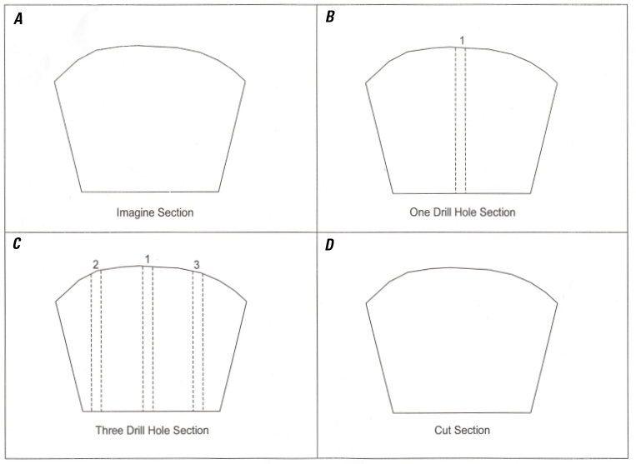
Evaluation and Discussion:
- How are your cross sections different from the initial cross section you made (A) before collecting core samples (B and C)?

- Does the collection of additional information help determine where the various layers are?

- Were the mineral deposits—red layers for zinc, blue layer for copper, and yellow layer for gold—evenly distributed in the cupcake?

- If you could collect two, three, or four cores from the cupcake, where would you drill your cores (show in the circle to the right – pretend it is the top of your cupcake) and why?

- Can the cores tell you how deep the various layers are?

- If you could not collect cores, discuss one other method for collecting data to determine what the subsurface material would be like.

