Names:______________________________________________ Period:_______
Earthquake Depth Lab

The vast majority of earthquakes occur at plate boundaries. The deepest earthquakes occur at subduction boundaries where lithosphere is plunging down into the mantle. Deep focus earthquakes are defined as those with foci occurring deeper than 300 kilometers. Shallow earthquakes have foci less than 70 km deep, while intermediate focus earthquakes occur at depths between 70 and 300 km. The behavior of the subducting plate is determined by the age of the rocks comprising the plate. Older crust is cooler and denser than younger crust and subducts faster and at a steeper angle than younger, warmer and less dense crust. In this activity you will plot and compare actual earthquake foci data from two areas where subduction is occurring. One area includes the Tonga Islands in the southwest Pacific Ocean, the other is along the coastline of Chile in South America.
Tonga Trench |  | Chile Trench
Longitude  (degrees West) | Focus Depth  (km) | Longitude  (degrees West) | Focus Depth  (km)
176.2 | 270 | 67.5 | 180
173.8 | 35 | 66.9 | 175
175.8 | 115 | 68.3 | 130
174.9 | 40 | 69.3 | 60
175.7 | 260 | 62.3 | 480
175.9 | 190 | 70.8 | 35
175.4 | 250 | 61.7 | 540
174.7 | 35 | 68.4 | 120
176 | 160 | 69.8 | 30
175.7 | 205 | 66.5 | 220
173.9 | 60 | 69.8 | 55
177.7 | 580 | 67.3 | 185
174.9 | 50 | 67.7 | 120
178.5 | 505 | 69.5 | 75
177.9 | 565 | 68.3 | 110
179.2 | 650 | 67.9 | 140
178.7 | 600 | 69.1 | 95
173.8 | 50 | 69.2 | 35
178.3 | 540 | 63.8 | 345
177 | 350 | 68.6 | 125
174.6 | 40 | 66.7 | 210
178.8 | 580 | 68.1 | 145
176.8 | 340 | 66.7 | 200
177.4 | 420 | 65.2 | 285
173.8 | 60 | 67.5 | 170
178 | 520 | 69.7 | 50
177.7 | 560 | 68.2 | 160
174.1 | 30 | 67.1 | 230
177.7 | 465 | 66.2 | 230
179.2 | 670 | 66.3 | 215
178.8 | 590 | 68.6 | 180
178.1 | 510 | 66.4 | 235
175.1 | 40 | 68.5 | 140
178.2 | 550 | 65.5 | 290
176 | 220 | 68.1 | 130
178.6 | 615
174.8 | 35
178.2 | 595
179.1 | 675
177.8 | 460
177 | 380

Earthquake Data

Procedures:
- Look at the Earthquake Data Table (right). Determine the number of shallow (<70 km), intermediate (70-300 km) and deep (>300 km) earthquakes and record them all on the summary table below for both the Tonga and Chile Trench.
- Add the numbers in both columns of the Summary Table. Totals should equal the total number of quakes.
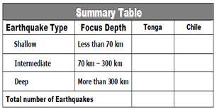
- On the graph on the next page, plot the highlighted pieces of data for the Tonga Trench from the table. Do NOT connect the dots.
- Complete the second graph for the Chile Trench. Do NOT connect the dots.
- Draw a “best fit” trend line for the data points. A “best fit” line does not go through the points, but shows the trend of the data. This trendline will represent the upper surface of a subducting plate.
- Using the tectonic map, label the name of the two converging plates on each graph.
- Using the map, draw arrows to show the relative movement of each plate on both graphs.
Analysis - You will need to use your map to answer some of these questions.
1. Using the map, identify the following as a convergent, divergent or transform boundary:
a. Mid Atlantic ridge ________________________________
b. Tonga Trench ________________________________
c. Aleutian Trench ________________________________
d. East Pacific Ridge ________________________________
e. East African Rift ________________________________
f. San Andres Fault ________________________________
2. Which tectonic plate is being subducted at the Tonga trench? __________________

And at the Chile Trench? ___________________

3. Compare the distances of the Tonga and Chile trench from the East Pacific Ridge, which is closer and which is farther?

4. If the East Pacific Ridge is the source of new rock, which trench (Tonga or Chile) would contain the oldest rock? Why?

5. Look at the summary data. Compare the depth of the majority of the earthquakes at the Tonga trench and the Chile trench. Describe the pattern you find:

6. Which type of plate boundary creates new ocean crust?

7. From looking at your reference tables, where do we usually find divergent boundaries?

8. Which geographic feature is associated with subduction zones?

9. What is the relative movement of the plate along the San Andreas Fault?

10. What did you learn about plate boundaries by exploring the depth of earthquakes along these trenches?
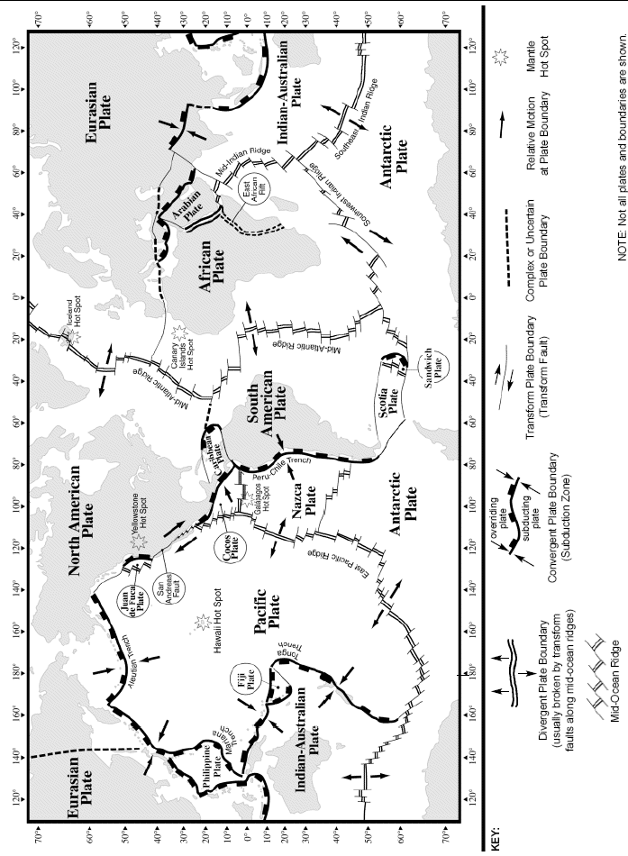

Earthquake Depth Lab (continued)

