Names ___________________________________ Period ____ Date _____________

___________________________________________________________

FELT TIP ELECTRON DISTRIBUTION

Purpose: To demonstrate a probable distribution of locations around a central point.

Discussion: The position of an electron in an atom at any given moment cannot be predicted. The region of space in which an electron can probably be found, however, is predictable. This region is often called the “electron cloud” and is represented by a fuzzy shape with a nucleus in the center. The shape is determined by mathematical calculations using the quantum-mechanical or wave models of the atom. Infrequently, the electron may be found outside the electron cloud.

Objectives: To observe the region of highest probability of marks.
To graph the distribution of marks on a target

Materials: Felt-tip pen paper target graph paper

Procedure: 1. Place your target on a notebook or book on the floor. (It should be flat.)
- Drop your marker from a height of about one meter (hip height) onto the target so that it makes a mark. Try to hit the center of the target. If there is a double bounce, put an “X” through the second mark. Repeat for a total of 100 times.
- Count the number of marks in each numbered region and record the numbers in your data table.

Data and Observations:

AREA | 1 | 2 | 3 | 4 | 5 | OUTSIDE
NUMBER OF MARKS

Analysis: Plot your results on the graph paper provided by your teacher. The number of marks should be on the “X” axis and the numbers from the target on the “Y” axis. Be sure to label the axes and put a title on the graph. Connect the dots with a curved line. Start your curved line at zero.

Staple your graph and target to this sheet and answer the questions on the back.
Conclusion: (The person who writes the answer should put their initials next to the answer.)

- Determine from your graph which target area had the highest probability of a hit.

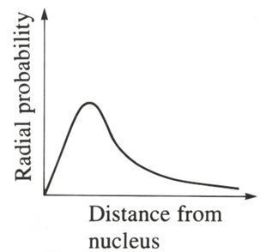
- How does the shape of your graph compare with the shape of the graph shown to the right? Explain your answer.

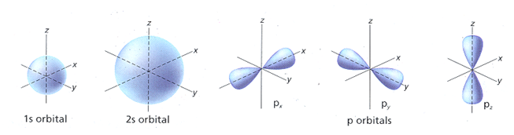

- How are pictures of the s and p orbitals (above) similar to your target?

- How are pictures of the s and p orbitals (above #3) different from your target?

- Explain why a photo of a blur of fast moving fan blades is a better analogy to an electron cloud picture than your target with its marks.

